CHAPTER ONE:

**GENERAL INTRODUCTION**

1. **GENERAL INTRODUCTION**
   1. **BACKGROUND**

The first Comprehensive Land Use Plan (CLUP) and Zoning Ordinance(ZO)of the City of San Carlos was prepared in 1977 and approved on July 31, 1980 thru Human Settlements Regulatory Commission (HSRC) Resolution No. 39-4. A second CLUP and ZO was prepared in 2000 and this plan and ordinance were enacted only after the approval of Sangguniang Panlalawigan. After more than 10 years of implementation of the second CLUP and ZO, the need to manage the continued growth of the City’s population, rehabilitate the environment and improve basic services call for the revisitation and revalidation of the plan. The study shows that the City’s outdated CLUP has been outpaced by the rapid urbanization and development for the past years. Currently, on the basis of the updated CLUP for San Carlos, it sets out a plan vision and associated assumptions and objectives to be incorporated in the Comprehensive Development Plan (CDP). A long-term 30 year framework was used in setting-out the vision for development and in the assessment of land requirements for housing and other infrastructure development. The planning period used for the land use plan and zoning ordinance is, however, for a shorter 10 years period in anticipation of the probable need to re-visit the CLUP within that time frame. This 10-year planning period is particularly applied in forecasting the demand for urban land.

Rapid economic and population growth exerts enormous pressure on the use of limited land resources often resulting in congestion, poverty concentration, and environmental degradation. Increasing demand for residential, industrial, commercial and institutional areas also leads to the conversion of agricultural land to non-agricultural uses. Utilizing land according to its “highest and best” use without depriving the rural sector of its basic productive and social resources and at the same time rehabilitating and protecting the physical environment is a major challenge. At the local level, this can be addressed through City Land Use Plans where more precise locations for land-using activities are defined. The local government of San Carlos, given increased authority and power, takes an active role in developing its respective areas by updating its CLUP. This allows the City to generate and mobilize resources to provide for their needs, build a stable economic base, and protect and manage the environment. The community is given the opportunity to participate in the development process in close coordination with local leadership with the end view of coming up with plans and implementing development programs.

* + 1. *RATIONALE*

Republic Act 7160 of 1991, otherwise known as the Local Government Code (LGC), has given autonomy to Local Government Units (LGUs) regarding the development of their territorial jurisdictions. Section 20(c) of the Code states “… local government units shall, in conformity with existing laws, continue to prepare their respective comprehensive land use plans enacted through zoning ordinances which shall be the primary and dominant bases for the future use of land resources: Provided, That the requirements for food production, human settlements, and industrial expansion shall be taken into consideration in the preparation of such plans.”

This document, the updated CLUP, is a product of the many undertakings of the City Government of San Carlos brought about by its desire to upgrade its old CLUP of 2000-2020. There was a felt need to update the CLUP because of the changes of times and events, in order to be more substantial, accommodating and realistic with the flow of events and with the current and extrapolated volume of demand for the next 30 years. While the previous CLUP served to bring San Carlos to where it is today, there is a need to plan for the rapid changes coming in the future based on the perceived changes of the approaching years.

The preparation of this revised CLUP comes at a time when the old document (previous CLUP) needs to be revised to suit the new kinds of demand in consonance with the new environment. There are therefore significant differences between the old and the new set of plans in terms of the approaches and methodology, as well as on its spatial strategies and the scope of policy coverage.

* + 1. *GENERAL OBJECTIVES*

In response to economic growth in the City, social objectives have to be met which include ensuring sufficient housing land that can be accessed by the community in response to the forecast demand; providing the conditions and incentives for improved housing conditions for the urban poor, either through in-situ-upgrading, urban resettlement and/or rural decentralization incentives; and improve and develop education, health, recreation and other community facilities in response to forecast population growth levels. By taking a preventive approach, it likewise aims to reduce the incidence of poor health conditions through improved potable water supply and sanitation. It also aims to provide conditions for a socially stable community and reduce out-migration of the young through the provision of employment opportunities, together with the essential capability support programs as well as community and recreation facilities.

The Economic development aspect aims for the optimization of the natural resource potential of San Carlos, primarily through the intensification and diversification of agriculture and through reforestation and agro-forestry schemes by identifying market opportunities for more productive agriculture relevant to the circumstances of San Carlos; identify the potential to establish an agro-processing industry in San Carlos and the means to optimize the potential for reforestation and agro-forestry in the upland areas; to identify the market opportunity for inward investment in (non-agricultural) industry and identify the market potential and focus for the exploitation of the areas for visitor and tourism development.

For Environmental sustainability, the protection of vulnerable environments and implementing proper pollution control and prevention schemes are aimed at. As such, it involves defining an appropriate strategy for the collection and treatment of liquid wastes, which will meet the needs of new development and improve conditions in the existing urban area (Poblacion).

Improving the existing integrated solid waste management program, increasing the efficiency of the existing sanitary landfill site capable of meeting forecast demand, developing an appropriate and affordable program on flood control and land drainage particularly in the affected existing and planned urban areas; ensuring non-buildable areas are clearly defined; prioritizing the need for the approval of the Coastal Resource Management Plan (CRMP), which will ensure protection of the mangrove areas and corals, that will come under pressure from planned development of the lowland corridor, for instance new airport construction; ensuring adequate protection of the watershed areas. (i.e. the Bago River Watershed Area) and lastly, taking an integrated and comprehensive approach to land use planning and land management, through the implementation of a CLUP and Zoning Ordinance, which ensures sustainable land development and development control; these are being prioritized under the new formulated CLUP in the context of environmental sustainability.

* 1. **APPROACH AND METHODOLOGY**

San Carlos City employed a participatory and consultative approach among the public sector for governmental and non-profit agencies, and in the private sector for businesses related to land, community, and economic development. Through research, design, and analysis of data, a plan can be created for some aspect of a community. This process typically involves gathering public input to develop the vision and goals for the City and its community. A six (6)-month workshop on CLUP preparation was facilitated that involved a diverse set of stakeholders in the planning process including government and private sectors to ensure that the final plan comprehensively addresses the study area. A combination of quantitative and qualitative research techniques was adopted to generate more comprehensive and accurate data. Geographic Information Systems, or GIS, was utilized as a very useful and important tool in land-use planning particularly for quantitative methods. On the other hand, qualitative methods dealt more on the analysis of the City’s strengths, weakness, opportunities and threats or what we call the SWOT. The results of the quantitative and qualitative methods served as basis for policy recommendations put forward in the revised plan. Furthermore, the series of workshops conducted also enabled stakeholders to assess and evaluate all aspects of the plan.

* + 1. *MAJOR PROCEDURAL STEPS*

Data Collection and Review

The orientation and series of workshops for CLUP formulation started in June 2012. This involved a participatory process with full teams from the staff representing the different departments of the San Carlos City Government and organized into five (5) sectors comprised of Social, Economic, Environment, Institutional and Infrastructure tasked for data gathering and inputting of information leading to the development of the CLUP. Each of the above groups met to provide inputs for questions and data for the development of the plan and each group reported during a plenary session. At the initial stages of the process, the sectors reviewed the existing CLUP document, revisited the City’s vision and goals and developed new plans and strategies in a participatory and consultative approach.

Goal Formulation and Visioning

The first objective of the CLUP workshop involved goal formulation and visioning. The goals were based on the national vision for LGUs as stipulated in Section 2(a) of RA 7160: “…that (LGUs) attain their fullest development as self-reliant communities and become more effective partners in the attainment of national goals.” Consideration was also given to regional and provincial development objectives and the City’s role within them. The identified goals by the sectors are properly analyzed to serve as an *end* toward which all future actions specified in the plan are directed. They act as *criteria* for evaluating alternative strategies, approaches and policies and as *standard* against which success of each action are measured. These goals and vision were then compared with the results of the data gathered to determine if such vision is attainable.

Designing and characterizing alternative spatial strategies

A spatial strategy is an abstract conception of the desired pattern of physical development of the City which is realized through the creative combination of built-up areas and open spaces. It is the organizing concept that guides the location and allocation of spaces for different land-use activities, the regulation of public and private investments, and the preservation of resources that ought to be protected against unscrupulous and inimical human intrusion and other agents of destruction. Designing and selecting appropriate spatial strategies for the City of San Carlos with its continuous advocacy for, and being a long-time practitioner of, environmental conservation has been a major challenge to planning the City's physical development.

Detailing the preferred spatial strategy

The preferred spatial strategy is a multi-dimensional framework, a conceived skeletal frame that defines the desired scope of future development. Additional detailed elements and components are included in this updated CLUP. To wit, are the proposed and detailed plans for the Coastal and territorial waters of the City from the municipality of Vallehermoso in Negros Oriental which is located at its southern portion and up to the north, the demarcation line between the City and the Municipality of Calatrava then from the coastline of this stretch it goes outward for seven and a half (7.5) kilometers on Tañon Strait facing the island of Cebu. This distance of outward lay-out is the quotient of dividing the total distance between the island of Cebu and the City of San Carlos. This lay-out describes the extent of development that the City has been tasked to improve. This not only includes the surface of the sea but also beneath its surface (the seafloor). As a product of this plan, the City was able to produce a Coastal Waters Zoning Plan.

**FIGURE 1.1: SIMPLIFIED CLUP - CDP – LDIP- AIP PROCESS**

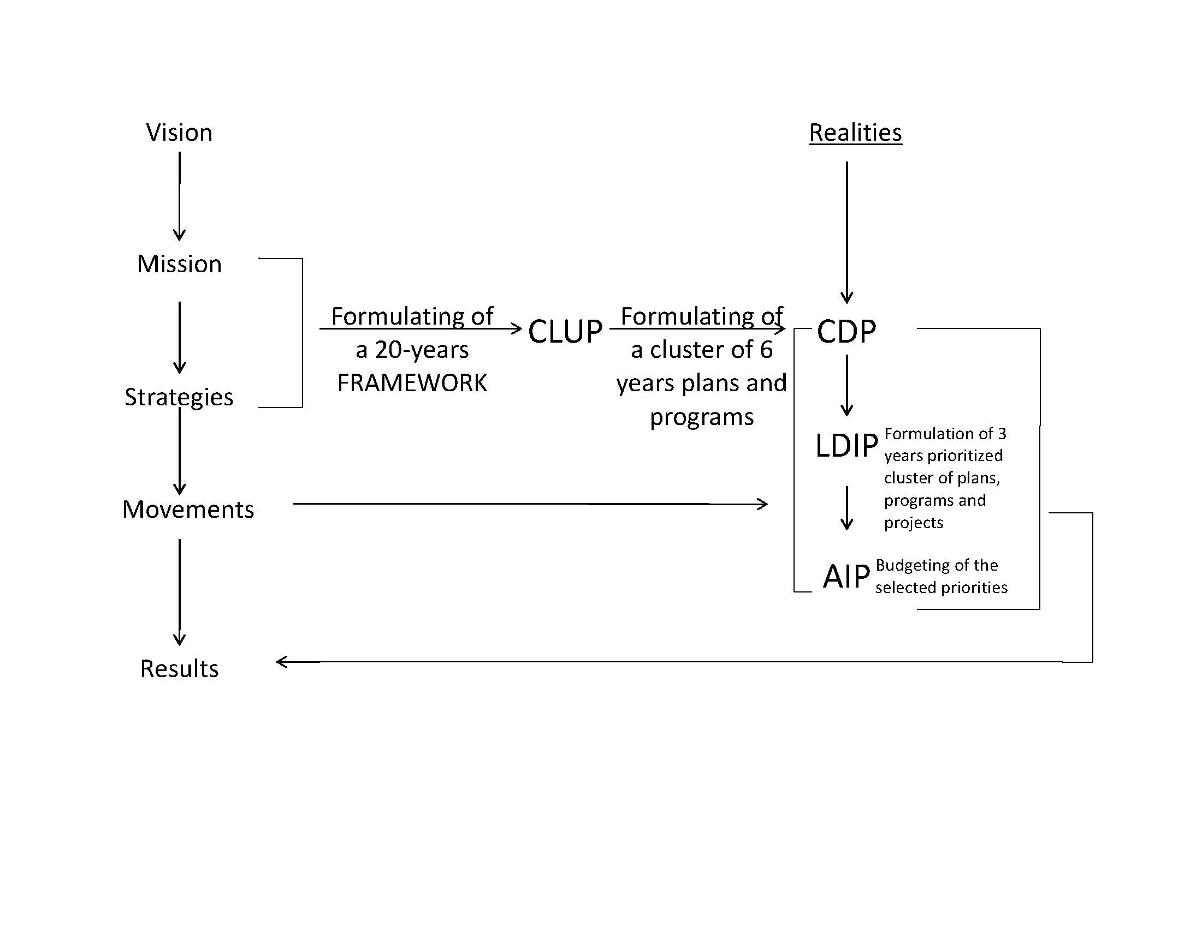

Formulation of land and water use policies

For effective land use regulation, the CLUP must be comprehensive in terms of territorial and policy coverage. In order that every portion of the City's territory is covered with appropriate policies, the four (4) land use policy areas adopted by the National Land Use Committee (NLUC) namely, settlements, infrastructure, production and protection, were used to organize all proposed policy interventions. These policy proposals were generated from the application of various analytical techniques in the course of the planning process notably the Problem-Solution Matrix; map overlay analysis, and the Upstream-Downstream Impact analysis. The local implications of relevant national laws and other administrative issuances were likewise taken into account in the formulation of these policies. To facilitate their implementation the proposed policies are further classified into programs and projects, services or non-projects, and regulatory measures. The proposed programs and projects of the City are to be reflected generally in the CDP and specifically in the Local Development and Investment Program (LDIP) and finally in the Annual Investment Program (AIP) for funding by the development funds under the annual budget. The identified services needed to carry out aspects of the plan are incorporated into the regular functions of existing local government departments or offices of the City, or will serve as basis for the creation of new executive bodies. The services or non-project components of the proposed policy interventions may also guide the crafting of capability building programs for personnel of the executive branch of the City Government.

Amendments to the Zoning Ordinance

The 2000 – 2020 Zoning Ordinance (ZO) was amended in light of the updated CLUP. The salient features of the amended ZO include the integration of Disaster Risk Reduction and Climate Change Adaptation (DRR-CCA) considerations, Assumed Environmentally Critical Areas Network (AECAN) Zoning, Coastal Water Zoning and revised Urban Land Zoning. Another important feature of the amended ZO is the consideration it gives to the total catchment concept wherein policies for certain upstream areas are tested for the sensitivity to their potential impact on downstream areas. A necessary extension of the total catchment concept is the incorporation of the municipal waters under one use regulatory regime. Since the National Government has devolved its authority to the LGU to manage its off-shore areas of up to 15 km from the shoreline, coastal LGUs like the City of San Carlos is expected to manage and protect their respective portions of the national territorial sea for the benefits of small fisherfolks and coastal communities.