**CHAPTER TWO:**

**BRIEF PROFILE**

1. **BRIEF PROFILE**
2. **INTRODUCTION**

This chapter presents a brief situational summary of the various development sectors such as Human Resource, Physical Features, and Physical/ Infrastructure Resources (Social Service Facilities and Public Utilities). Development needs for each sector, in both quantitative and qualitative terms, are also presented. Consideration is likewise given to the national goals for physical planning as well as the development directions at the regional and provincial levels that have implications to San Carlos, particularly on the functional role that the City is envisaged to perform in the Western Visayas Region and in Negros Occidental. A review of the predecessor CLUP 2000 – 2020, particularly in terms of land use strategies and policies is also provided.

These inward and outward-looking information serve as the platform in determining the consolidated development issues and concerns that have to be addressed, as well as the City’s competitive/ comparative advantages that may be capitalized on by the updated CLUP.

1. **BRIEF HISTORY**

San Carlos traces its history from being a small Negrito settlement named Nabingkalan. This settlement was later bought by Carlos Apurado who developed it into a thriving Christian village. The place was renamed San Carlos in 1856 when it was made a “pueblo” by the Spanish government. When Negros Island was divided into Occidental Negros and Oriental Negros in 1890, San Carlos was recorded as an “arrabal” or barrio of Calatrava, which is now a separate municipality on the southern side of San Carlos.

San Carlos acquired its status as a town in late 1898 when Gen. Juan Araneta of the Revolutionary Philippine Republic officially proclaimed it as a municipality. This was confirmed by the American Military Administration in 1901. It was then occupied by the Japanese Imperial Forces in May 1942 and liberated on March 1, 1945 by the First Combat Team, 7th MD (Negros) Guerilla Forces, under Major Uldarico Baclagon.

San Carlos became a city on July 1, 1960 with the passage of Republic Act No. 2643. Its ideal geographical location and financial stability has made San Carlos City the center of the Panay-Negros-Cebu economic zone. It has also since become one of the most livable cities in the world, an award accorded in 2011 by the United Nations-sponsored International Awards for Livable Communities.

1. **HUMAN RESOURCE**
2. ***EXISTING POPULATION***

Population size and growth rate

The latest Census on Population and Housing conducted by the National Statistics Office in 2010 recorded that San Carlos City had a total population of 129,981. This represents approximately 5.42% of the total population of the province for the same census year.

The number and historical growth of total population of San Carlos City and Negros Occidental are shown in the following table:

Table 2.1: HISTORICAL GROWTH OF POPULATION,

SCC and Neg Occ (1960-2010)

|  |  |  |  |  |
| --- | --- | --- | --- | --- |
| **DATE** | **POPULATION** | | **GROWTH RATE** | |
| **SCC** | **NEG. OCC.** | **SCC** | **NEG. OCC.** |
| 1960 | 124,756 | 1,332,323 | 2.55 | 2.10 |
| 1970 | 90,058 | 1,503,782 | -3.26 | 1.21 |
| 1975 | 90,982 | 1,785,792 | 0.20 | 3.44 |
| 1980 | 91,627 | 1,930,301 | 0.14 | 1.56 |
| 1990 | 105,713 | 2,256,908 | 1.44 | 1.56 |
| 2000 | 118,259 | 2,565,723 | 1.33 | 1.05 |
| 2010 | 129,981 | 2,396,039 | 0.95 | -6.01 |

Source of basic data: National Statistics Office[1]

Population by barangay

Barangay Rizal was the most populated barangay. The highly commercialized Barangay IV was the least populated. The following table presents the City’s population by barangay.

|  |  |  |
| --- | --- | --- |
| **TABLE 2.2: POPULATION BY BARANGAY (2010)** | | |
| **BARANGAY** | **POPULATION 2010** | **SHARE TO TOTAL** |
| I | 10,376 | 7.98% |
| II | 6,833 | 5.26% |
| III | 3,501 | 2.69% |
| IV | 1,136 | 0.87% |
| V | 5,233 | 4.03% |
| VI | 6,268 | 4.82% |
| Bagonbon | 5,474 | 4.21% |
| Buluangan | 11,752 | 9.04% |
| Codcod | 12,846 | 9.88% |
| Ermita | 2,150 | 1.65% |
| Guadalupe | 10,765 | 8.28% |
| Nataban | 4,465 | 3.44% |
| Palampas | 9,246 | 7.11% |
| Prosperidad | 5,163 | 3.97% |
| Punao | 5,943 | 4.57% |
| Quezon | 11,530 | 8.87% |
| Rizal | 14,398 | 11.08% |
| San Juan | 2,902 | 2.23% |
| **Total** | **129,981** | **100.00%** |
| *Source: National Statistics Office* | | |

Population density

The City’s gross population density is about three persons per hectare. Density is highly skewed towards the urban core, comprising Poblacion barangays, which is about 101 persons per hectare or 35 times that of the City’s gross density. Population density outside the urban core is two persons per hectare, which is lower than the City’s average.

Considering the NSCB’s new definition of urban barangays, then the City’s urban area density is calculated at 2.85 persons per hectare. The average density in the rural barangays is calculated at 3.38 persons per hectare, implying denser concentrations of population. The lower density figure in the City’s urban barangays is attributed to the large territorial area of barangays outside the Poblacion which have been classified urban in the new NSCB definition.

Among the barangays, density is highest in Barangay VI at 461 persons per hectare. The other five Poblacion barangays ranked second to sixth which further indicating the compaction of growth in the City’s urban core. It is notable that population densities in the island barangays of Ermita and San Juan ranked next to the Poblacion barangays. This indicates incipient population pressure in the small island of Refugio (Sipaway).

Table 2.3: Gross population density, per barangay (2010)

|  |  |  |  |  |  |  |  |  |  |
| --- | --- | --- | --- | --- | --- | --- | --- | --- | --- |
| **BARANGAY** |  | **AREA IN HECTARES \*** | **RANK** |  | **POPULATION** | **RANK** |  | **GROSS DENSITY** | **RANK** |
|
| *URBAN* |  |  | |  |  | |  |  | |
| I |  | 162.32 | 13 |  | 10,376 | 6 |  | 63.92 | 5 |
| II |  | 73.33 | 14 |  | 6,833 | 8 |  | 93.18 | 4 |
| III |  | 9.60 | 18 |  | 3,501 | 15 |  | 364.68 | 2 |
| IV |  | 19.51 | 16 |  | 1,136 | 18 |  | 58.24 | 6 |
| V |  | 50.74 | 15 |  | 5,233 | 11 |  | 103.12 | 3 |
| VI |  | 13.60 | 17 |  | 6,268 | 9 |  | 460.87 | 1 |
| Bagonbon |  | 2,561.92 | 8 |  | 5,474 | 12 |  | 2.14 | 13 |
| Buluangan |  | 4,682.16 | 4 |  | 11,752 | 3 |  | 2.51 | 11 |
| Codcod |  | 8,622.84 | 1 |  | 12,846 | 2 |  | 1.49 | 17 |
| Guadalupe |  | 4,654.61 | 5 |  | 10,765 | 5 |  | 2.31 | 12 |
| Palampas |  | 5,254.51 | 3 |  | 9,246 | 7 |  | 1.76 | 15 |
| Prosperidad |  | 3,357.87 | 6 |  | 5,163 | 13 |  | 1.54 | 16 |
| Punao |  | 1,729.18 | 10 |  | 5,943 | 10 |  | 3.44 | 10 |
| Quezon |  | 8,199.42 | 2 |  | 11,530 | 4 |  | 1.41 | 18 |
| Rizal |  | 2,944.28 | 7 |  | 14,398 | 1 |  | 4.87 | 9 |
| **Subtotal** |  | **42,335.88** | |  | **120,464** | |  | **2.85** | |

Table 2.3: Gross population density, per barangay (2010)(cont’d)

|  |  |  |  |  |  |  |  |  |  |
| --- | --- | --- | --- | --- | --- | --- | --- | --- | --- |
| **BARANGAY** |  | **AREA IN HECTARES \*** | **RANK** |  | **POPULATION** | **RANK** |  | **GROSS DENSITY** | **RANK** |
| *RURAL* |  |  | |  |  | |  |  | |
| Ermita |  | 176.21 | 12 |  | 2,150 | 17 |  | 12.20 | 7 |
| Nataban |  | 2,392.45 | 9 |  | 4,465 | 14 |  | 1.87 | 14 |
| San Juan |  | 245.46 | 11 |  | 2,902 | 16 |  | 11.82 | 8 |
| **Subtotal** |  | **2,814.12** | |  | **9,517** | |  | **3.38** | |
| **TOTAL** |  | **45,150.00** | |  | **129,981** | |  | **2.88** | |

Source: Office of the City Planning and Development Coordinator

* There is an ongoing Survey for Barangay Boundaries by LGU and DENR which will be adopted

upon approval of the Map.

Household distribution

The data on the number of households per Barangay is taken from the 2010 Census individual barangay population divided by the average family size which is the result of total population over the number of total household to see how they are distributed among the City’s barangays. Based on this, it may be observed that the Poblacion Barangays I – VI had the most number of households that accounted for 25.65% of the total. Individually, however, barangays with the most number of households are Barangay Rizal, Codcod, Buluangan, Quezon, Guadalupe and Barangay I.

Table .4: POPULATION and NUMBER OF HOUSEHOLDS PER BARANGAY (2010)

|  |  |  |
| --- | --- | --- |
| **BARANGAY** | **NUMBER OF HH** | **SHARE TO TOTAL (%)** |
| I | 2,306 | 7.98% |
| II | 1,518 | 5.26% |
| III | 778 | 2.69% |
| IV | 252 | 0.87% |
| V | 1,163 | 4.03% |
| VI | 1,393 | 4.82% |
| Bagonbon | 1,216 | 4.21% |
| Buluangan | 2,612 | 9.04% |
| Codcod | 2,855 | 9.88% |
| Ermita | 478 | 1.65% |
| Guadalupe | 2,392 | 8.28% |
| Nataban | 992 | 3.44% |
| Palampas | 2,055 | 7.11% |
| Prosperidad | 1,147 | 3.97% |
| Punao | 1,321 | 4.57% |
| Quezon | 2,562 | 8.87% |
| Rizal | 3,200 | 11.08% |
| San Juan | 645 | 2.23% |
| **TOTAL** | **28,885** | **100.00%** |

*Source: NSO and CPDCO*

1. ***POPULATION PROJECTIONS***

Doubling time

Based on the 0.95% average annual growth rate from 2000 to 2010, it is estimated that the City’s population will double in 73 years, i.e. reaching a figure of 259,962.

Geometric growth

The City’s population is estimated to be about 134,991 at the start of the planning period, 2014. It is expected to reach 146,981 after ten years, i.e., 2023, which is the recommended CLUP timeframe of the Housing and Land Use Regulatory Board (HLURB). The total population is estimated to reach 177,578 by 2043 or 30 years after start of plan implementation.

**TABLE 2.5: PROJECTED TOTAL POPULATION**

|  |  |  |  |  |  |  |  |
| --- | --- | --- | --- | --- | --- | --- | --- |
| **Year** | 2014 | 2018 | 2023 | 2028 | 2033 | 2038 | 2043 |
| **Number** | 134,991 | 140,194 | 146,981 | 154,097 | 161,557 | 169,378 | 177,578 |

Population projection by barangay

The following table presents population projection by barangay assuming that their current shares to the City’s total population are maintained for the next 30 years.

|  |  |  |  |  |  |
| --- | --- | --- | --- | --- | --- |
| **TABLE 2.6: POPULATION PROJECTION BY BARANGAY** | | | | | |
| **Barangay** | **Year** | | | | |
| **2013** | **2014** | **2023** | **2033** | **2043** |
| I | 10,675 | 10,776 | 11,733 | 12,897 | 14,176 |
| II | 7,030 | 7,096 | 7,727 | 8,493 | 9,335 |
| III | 3,602 | 3,636 | 3,959 | 4,351 | 4,783 |
| IV | 1,169 | 1,180 | 1,285 | 1,412 | 1,552 |
| V | 5,384 | 5,435 | 5,917 | 6,504 | 7,149 |
| VI | 6,448 | 6,510 | 7,088 | 7,791 | 8,563 |
| Bagonbon | 5,631 | 5,685 | 6,190 | 6,804 | 7,478 |
| Buluangan | 12,088 | 12,203 | 13,217 | 14,605 | 16,053 |
| Codcod | 13,216 | 13,341 | 14,526 | 15,967 | 17,550 |
| Ermita | 2,212 | 2,233 | 2,431 | 2,672 | 2,937 |
| Guadalupe | 11,075 | 11,180 | 12,173 | 13,380 | 14,707 |
| Nataban | 4,593 | 4,637 | 5,049 | 5,550 | 6,100 |
| Palampas | 9,512 | 9,602 | 10,455 | 11,492 | 12,632 |
| Prosperidad | 5,312 | 5,362 | 5,838 | 6,417 | 7,054 |
| Punao | 6,114 | 6,172 | 6,720 | 7,387 | 8,119 |
| Quezon | 11,862 | 11,974 | 13,038 | 14,331 | 15,752 |
| Rizal | 14,816 | 14,957 | 16,285 | 17,901 | 19,676 |
| San Juan | 2,985 | 3,014 | 3,282 | 3,607 | 3,965 |
| **Total** | **133,721** | **134,991** | **146,981** | **161,557** | **177,578** |

Population projection by age group

The following table presents population projection by age-group for the next year assuming that their respective participation rates are maintained.

|  |  |  |  |  |  |
| --- | --- | --- | --- | --- | --- |
| **TABLE 2.7: POPULATION PROJECTION BY AGE GROUP** | | | | | |
| **Age Group** | **Year** | | | | |
| **2013** | **2014** | **2023** | **2033** | **2043** |
| **All ages** | **133,721** | **134,991** | **146,981** | **161,557** | **177,578** |
| Under 1 | 2,947 | 2,974 | 3,239 | 3,560 | 3,913 |
| 1-4 | 12,857 | 12,979 | 14,132 | 15,534 | 17,074 |
| 5-9 | 17,108 | 17,271 | 18,805 | 20,670 | 22,719 |
| 10-14 | 17,851 | 18,021 | 19,622 | 21,567 | 23,706 |
| 15-19 | 15,039 | 15,182 | 16,530 | 18,170 | 19,971 |
| 20-24 | 10,109 | 10,205 | 11,111 | 12,213 | 13,424 |
| 25-29 | 8,971 | 9,056 | 9,860 | 10,838 | 11,913 |
| 30-34 | 8,072 | 8,148 | 8,872 | 9,752 | 10,719 |
| 35-39 | 7,941 | 8,016 | 8,728 | 9,594 | 10,545 |
| 40-44 | 7,210 | 7,278 | 7,925 | 8,711 | 9,575 |
| 45-49 | 6,608 | 6,671 | 7,264 | 7,984 | 8,776 |
| 50-54 | 5,453 | 5,505 | 5,994 | 6,589 | 7,242 |
| 55-59 | 4,132 | 4,172 | 4,542 | 4,993 | 5,488 |
| 60-64 | 2,868 | 2,895 | 3,152 | 3,465 | 3,809 |
| 65-69 | 2,671 | 2,696 | 2,936 | 3,227 | 3,547 |
| 70-74 | 1,961 | 1,980 | 2,155 | 2,369 | 2,604 |
| 75-79 | 1,078 | 1,089 | 1,185 | 1,303 | 1,432 |
| 80 and over | 844 | 852 | 928 | 1,020 | 1,121 |

*Source: City Planning and Development Office, SCC*

1. **PHYSICAL FEATURES**

Location

San Carlos City is located in the Province of Negros Occidental in the Western Visayas Region of the Philippines. San Carlos is located at 123º06’00” to 123º30’00” longitude and 10º22’00” to 10º36’00” latitude northeast of Negros. The Municipality of Calatrava defines its boundaries at the north, Municipality of Salvador Benedicto and City of Bago at the west, the Municipality of Vallehermoso (Negros Oriental) and City of Kanlaon at the south, and the 12 fathoms deep Tañon Strait at the east.

Land Area and Barangay Subdivision

San Carlos City is a 2nd Class Component City with a total land area of 45,150 hectares and a population size of 129,981 (as of May 1, 2010). It has eighteen (18) barangays, of which fifteen (15) may be classified as urban and three (3) as rural barangays. The respective land areas of these barangays are shown in the following table.

Table 2.8: land area by barangay (2013)

|  |  |  |
| --- | --- | --- |
| **Barangay** | **Area** | **% of Total** |
| **(in hectares)** | **Area** |
| URBAN AREAS | | |
| Barangay I | 162.32 | 0.36% |
| Barangay II | 73.33 | 0.16% |
| Barangay III | 9.60 | 0.02% |
| Barangay IV | 19.51 | 0.04% |
| Barangay V | 50.74 | 0.11% |
| Barangay VI | 13.60 | 0.03% |
| Bagonbon | 2,561.92 | 5.67% |
| Buluangan | 4,682.16 | 10.37% |
| Codcod | 8,622.84 | 19.10% |
| Guadalupe | 4,654.61 | 10.31% |
| Palampas | 5,254.51 | 11.64% |
| Prosperidad | 3,357.87 | 7.44% |
| Punao | 1,729.18 | 3.83% |
| Quezon | 8,199.42 | 18.16% |
| Rizal | 2,944.28 | 6.95% |
| **Subtotal** | **42,335.88** | **93.77%** |
| RURAL AREAS | | |
| Ermita | 176.21 | 0.39% |
| Nataban | 2,392.45 | 5.30% |
| San Juan | 245.46 | 0.54% |
| **Subtotal** | **2,814.12** | **6.23%** |
| **Total Area** | **45,150.00** | **100%** |
| *Source: City Planning and Development Office, SCC* | | |

Topography

The topography of the City of San Carlos is predominantly level to undulating along the coastline and rolling to very steep along its north-western and south-western portions. Parts of Mount Kanlaon Volcano and the Balabag Mountain Ranges are within the jurisdiction of San Carlos. The Mount Kanlaon National Park, which has a geographical spread across Negros, reaches into the southwestern portion of the City. Mount Kanlaon National Park in Barangay Codcod has an elevation of 2,455 meters from the peak down, and is 1,800 meters above sea level.

1. **PHYSICAL/ INFRASTRUCTURE RESOURCES**
2. ***TRANSPORTATION NETWORK***

Situationer

* Roads

The City Engineer’s Office (CEO) classifies local roads into City, Island and Secondary Roads. These have a total length of about 238.6 kms. Serving the rural areas of the City, the most extensive of these are the Secondary Roads which represent 75% of the total length of local roads. About 69.6% of the length of these secondary roads is paved with either concrete or asphalt. The Poblacion and vicinity are served by City Roads and about 78% of their total length is concrete-paved. Refugio (Sipaway) Island is, in turn, served by fully concreted Island Roads.

Transport Facilities

* Land Transport

Land-based modes of transport in the City provide access throughout Negros Island and to all its barangays. These include buses, jeepneys, for-hire-vans and tricycles.

The City also has a multi-modal San Carlos Transport Terminal located along the National Road in Barangay Palampas.

* Water Transport

There are two (2) ports in the City: one is national government-owned and the other is privately-owned (San Carlos Bio-Energy Corporation). The government-owned port, the San Carlos City Port is maintained by the Philippine Ports Authority (PPA). The port hosts ferries that transport people and goods to and from Toledo City in Cebu Province as well as commercial pump boats going to barangays Ermita and San Juan on Refugio (Sipaway) Island.

The San Carlos Bio-Energy Corporation’s port is the oldest industrial port in the whole of Negros. It was built in 1946 at a time when foreign and domestic vessels docked for molasses and brown sugar and, lately ethyl alcohol.

The City’s main Fishport is located in Barangay Buluangan while there are also barangay ports in Ermita and San Juan on Refugio (Sipaway) Island.

* Air Transport

The San Carlos City Community Airport has been earmarked for development on a 40 hectare site in Barangay Punao. Nearly 10 hectares of land has already been donated by Negros Fisheries Corporation. The airport is mainly oriented towards enhancing the City’s national and regional linkages as well as to support the development of the San Carlos Eco-Zone. Plans for the initial stage indicate the construction of a 30 meter wide by 1,000 meter long concrete runway on a 75 meter airstrip. This was designed to accommodate small to medium passenger aircraft having 12 to 30 persons seating capacities. It was also designed to handle freight aircraft up to an all-up-weight of 12,500 pounds.

Development Needs

* Roads

The most common parameters for determining adequacy of the circulation network are road density and connectivity. Road density is indicated by the ratio of the total length of roads regardless of class or construction standards to the population with regards to urban areas and to land area with regards to rural areas. This is then compared with the standard provided by HLURB national standard of 2.4 kilometers for every 1,000 population for urban roads and 1.5

kilometers for every 100 hectares of arable land for rural roads. It should be noted that figures derived from these density standards are used as benchmarks to gain a broad indication of whether roads are adequate or not. Such density figures are then compared to connectivity conditions observed from existing and projected land use patterns. It may be that the final configuration of the road network becomes the product of iterations between quantitative density measures and qualitative connectivity observations.

*Urban Roads*

The City’s major urban area may be categorized into the City Proper and its Urban Expansion Area, the latter comprising Barangays Palampas and Rizal. Using road density standards, it may be calculated that there is a year 2013 backlog of about 35.3 kms of urban roads in the City Proper. With a ten-year planning horizon, this backlog will become 43.5 kms by year 2023. The backlog obviously increases along with population, and it is estimated that the City Proper will need an additional 62.3 kms of roads by 2043. The following table presents the estimated requirements for the City Proper:

|  |  |  |  |  |  |  |  |  |
| --- | --- | --- | --- | --- | --- | --- | --- | --- |
| **TABLE 2.9: URBAN ROAD REQUIREMENTS - CITY PROPER** | | | | | | | | |
| **Parameter** | | | | **Year** | | | | |
| **2013** | **2014** | **2023** | **2033** | **2043** |
| City Proper Population | | | | 34,308 | 34,633 | 37,709 | 41,448 | 45,558 |
| Urban Road Requirements (km) | | | | 82.3392 | 83.1192 | 90.5016 | 99.4752 | 109.3392 |
| Current Length (km) | | | | 47.0520 |  |  |  |  |
| Backlog (km) | | | | 35.2872 | 36.0672 | 43.4496 | 52.4232 | 62.2872 |
| *Note: HLURB Standards for urban roads is 2.4km/ 1000 population* | | | | | | | | |
|  |  |  |

Connectivity observations, on the other hand, point out that the road network within the City Proper appears to be fairly adequate already. It may not be necessary to fully meet the calculated backlogs. What are needed are the following:

* Completion of the planned Interim and Long-Term By-Pass Roads to improve the City Proper’s connectivity to the rural barangays
* Completion of the planned Boulevard that will provide direct access from the National Road to the San Carlos City Port
* Appropriate road design (introducing service roads and ensuring appropriate pedestrian walkways), traffic management (such as designating limited access roads) and property parking and access regulations to minimize roadside friction

Except for heavily-built up areas in locations adjacent to the City Proper Barangays, there are still wide greenfield areas in Barangays Guadalupe, Palampas, Punao and Rizal that were identified in CLUP 2000 – 2020 as part of the Special Development Area with uses ranging from residential to industrial. To estimate urban road requirements with population as reference, it may be assumed that 80% of residents are within these barangays’ designated urban areas. It is may also be roughly assumed that 85% of existing roads in these barangays are within these portions. The present backlog in the Urban Expansion Area is thus calculated at 27.64 kms which is expected to reach 36 kms in 2023 and almost 52 kms in 2043. The following table presents the estimated road backlog in the Urban Expansion Area:

|  |  |  |  |  |  |
| --- | --- | --- | --- | --- | --- |
| **TABLE 2.10: URBAN ROAD REQUIREMENTS - URBAN EXPANSION AREA** | | | | | |
| **Parameters** | **Year** | | | | |
| **2013** | **2014** | **2023** | **2033** | **2043** |
| Urban Expansion Area Population (no) | 30,742 | 31,033 | 33,790 | 37,141 | 40,824 |
| Urban Road Requirements (km) | 73.7798 | 74.4787 | 81.0950 | 89.1379 | 97.9776 |
| Current Length (km) | 46.1395 |  |  |  |  |
| Backlog (km) | 27.6403 | 28.3392 | 34.9555 | 42.9984 | 51.8381 |
| *Notes:* | | | | | |
| 1. *Urban Expansion Area Population is 80% of total barangay population* | | | | | |
| 1. *Current length of roads is 85% of total.* | | | | | |
| 1. *HLURB Standards for urban roads is 2.4km/ 1000 population* | | | | | |

*Rural Roads*

* Mainland

An indication of the rural road requirements may be obtained by applying the rural road density standard to the areas designated for agriculture in CLUP 2000 – 2020 which remains the present classification. The estimated backlog is about 145 kms as of planning year (2013) as presented in the following table:

|  |  |
| --- | --- |
| **TABLE 2.11: RURAL ROAD REQUIREMENTS - MAINLAND** | |
| **Parameter** | **2013** |
| Arable Lands (has) | 18,433.50 |
| * Agricultural Production Area (has) | 15,898.34 |
| * SAFDZ (has) | 2,535.16 |
| Rural Road Requirements (km) | 276.5025 |
| Current Length (km) | 131.7171 |
| Backlog (km) | 144.7854 |
| *Notes:*   1. *HLURB Standards for rural roads is 1.5 hectares or arable lands or those suitable for agricultural purposes.* 2. *85% of the length of rural roads in Barangays Guadalupe, Punao, Palampas and Rizal were deducted respectively to as these are ascertained to be within the Urban Expansion Area (previous table).* | |

* Island

It is estimated that there is a surplus of about 7.5km of rural roads on Refugio (Sipaway) Island if the rural road density standard is applied. The formulation of transportation improvement plans, such as roads, should consider this apparent oversupply as well as the environmental sensitivity of the island. The following table presents the estimated rural road requirements for Refugio (Sipaway) Island during the planning year 2013 using density standards for arable lands.

|  |  |
| --- | --- |
| **TABLE 2.12: RURAL ROAD REQUIREMENTS – REFUGIO (SIPAWAY) ISLAND** | |
| **Parameter** | **2013** |
| Arable Lands |  |
| * Coastal Management Zone | 419.89 |
| * Urban Road Requirements | 6.29835 |
| Current Length (km) | 13.83 |
| Backlog | (7.53165) |
| Notes:   1. *HLURB Standards for rural roads is 1.5 hectares or arable lands or those suitable for agricultural purposes.* 2. *The area used above was that calculated for the Coastal Management Zone in CLUP 2000 – 2020. This is not too far from the total declared area of the two barangays which is 421.67 has.* | |

* Water Transport

The following outlines the development needs for water transport:

* There is a need to address the difficulty in transporting basic commodities and emergency services, such as medical, to the island barangays in times of bad weather
* There is a need to increase the capacity of the San Carlos City Port in anticipation of increased passenger and cargo traffic
* Air Transport

Following are the development needs for air transport:

* At the short-term, there is a need to complete the acquisition of the remaining 30.55 hectares of land to complete the initial target of 40 hectares for the airport site.
* At the medium-to long-terms, the phased construction of the community airport has to be programmed to include, among others, a 30 meter wide by 1,000 meter long concrete runway on a 75 meter airstrip for stage 1 and a 450 meter extension of the runway during stage 2.

1. ***SOCIAL SERVICE FACILITIES/ UTILITIES/ AMENITIES***

Housing and Settlements

* Situationer

Latest housing data from the National Statistics Office (NSO) indicate that there were about 23,721 housing units in the City. A great majority of these (96%) are of the single house (detached) type. In terms of the tenure status, most houses occupy lots with the consent of the lot owner and without paying any rent. About a fourth of the number of lots were owned/ being amortized by the house owners.

* Development Needs

The following table presents the City’s projected new housing requirements assuming a constant average HH size of four & 5/10 (4.5):

|  |  |  |  |  |  |  |  |
| --- | --- | --- | --- | --- | --- | --- | --- |
| **TABLE 2.13: PROJECTED NEW HOUSING REQUIREMENTS** | | | | | | | |
| **Year** | **2014** | **2018** | **2023** | **2028** | **2033** | **2038** | **2043** |
| **Total Population** | 134,991 | 140,194 | 146,981 | 154,097 | 161,557 | 169,378 | 177,578 |
| **Projected HH** | 26,998 | 28,039 | 29,396 | 30,819 | 32,311 | 33,876 | 35,516 |
| **Projected Housing Requirements** | 3,277 | 4,318 | 5,675 | 7,098 | 8,590 | 10,155 | 11,795 |

Health and Sanitation

* Situationer
* Health facilities

The Health Sector of the City is overseen by two (2) health facilities, which are owned and operated by the City Government. These are the City Health Office (CHO) and the San Carlos City Hospital (SCCH). These are supported by several privately-owned health care facilities most notable of which is the 50-bed secondary grade San Carlos Doctor’s Hospital located in Barangay I.

The SCCH is categorized as a primary to secondary hospital with a fifty (50) bed capacity. It is the only government hospital in the City and is entirely locally funded. It serves patients not only from San Carlos City but also from neighboring towns and cities like Calatrava, Toboso and Escalante in the north as well as Vallehermoso, Guihulngan and Canlaon from the south.

* Access to safe drinking water and sanitary toilet facilities

Most (93%) households have access to improved or safe water supply. About 39% of these are served by Level III (piped to water taps in houses) water. Most of these are located in City Proper. Households served by Level II (piped water in communal taps) represent about 46% of the total.

About 80% of households have sanitary toilets. Those who satisfactorily dispose their solid waste represent 84% of the total while 80% have access to complete basic sanitation facilities.

* Burial grounds

Cemeteries in the City are located in Barangay Rizal and Barangay 4. The City Cemetery has nearly 3,300 niches following the provision of additional blocks in recent years.

* Solid waste facilities

All barangays have already established their own Materials Recovery Facilities (MRFs). The City has also established an Eco-Center where an integrated waste management system is installed. The Eco-Center is a one stop shop disposal and recycling option for San Carlos City residents and businesses. The facility includes state-of-the-art 6,600 sq.m. Sanitary Landfill for municipal solid waste, Centralized Material Recovery Facility, Office and Motorpool, Perimeter Fence, Composting Area and Waste Water Treatment Facility.

* Wastewater facilities

The existing wastewater management system consists mainly of individually installed septic vaults whose outfall is the storm drainage system. Only the Poblacion has a piped collection system. A monitoring canal may be found at the Old Public Market area which cleanses wastewater from the market area before draining to San Carlos Bay. In many other parts of the urban area, open canals and creeks serve as drainage/sewage outfall. No treatment process is introduced before the sewage in finally thrown out to the sea.

Initiatives have already been undertaken towards the development of an appropriate wastewater management system. In 2009, the City Government, together with the DENR and ECOGOV2, signed a Memorandum of Agreement to jointly develop and implement Waste Water Management (WWM) interventions for the City. The ECOGOV2 or the Philippine Environmental Governance Project Phase 2 aims to improve the basic conditions for the development of the water sector, to introduce sustainable wastewater management and to develop and distribute customized and low cost technological solutions in order to protect the City’s ground water and marine resources along Tañon Strait and to fulfill the legal requirements of the RA 9275. To date, the City is already in a strategic position towards full blown implementation of wastewater management related projects in various pilot areas such as; city hospital, public market, city abattoir and city’s major resettlement sites.

* Development Needs
* Health facilities

The following table presents the projected requirements for key health personnel and facilities according to the requirements of the Department of Health (DOH) as cited in HLURB’s planning guidelines.

|  |  |  |  |  |  |  |  |
| --- | --- | --- | --- | --- | --- | --- | --- |
| **TABLE 2.14: PROJECTED HEALTH FACILTIES & PERSONNEL REQUIREMENTS** | | | | | | | |
| **Facilities/ Personnel** | **Year** | | | | | | |
| **2014** | **2018** | **2023** | **2028** | **2033** | **2038** | **2043** |
| **Facilities** |  |  |  |  |  |  |  |
| City Health Center | 3 | 3 | 3 | 3 | 3 | 3 | 4 |
| Barangay Health Center | 28 | 29 | 31 | 32 | 33 | 34 | 36 |
| **Personnel** |  |  |  |  |  |  |  |
| Doctors | 5 | 6 | 6 | 6 | 6 | 7 | 7 |
| Nurses | 11 | 11 | 12 | 12 | 13 | 14 | 14 |
| Midwives | 11 | 11 | 12 | 12 | 13 | 14 | 14 |
| Sanitary Inspectors | 8 | 8 | 9 | 9 | 10 | 10 | 11 |

|  |  |  |  |  |  |  |  |
| --- | --- | --- | --- | --- | --- | --- | --- |
| **TABLE 2.15: PROJECTED BHS REQUIREMENTS PER BARANGAY** | | | | | | | |
| **Barangay** | **Year** | | | | | | |
| **2014** | **2018** | **2023** | **2028** | **2033** | **2038** | **2043** |
| I | 2 | 2 | 2 | 2 | 3 | 3 | 3 |
| II | 1 | 1 | 2 | 2 | 2 | 2 | 2 |
| III | 1 | 1 | 1 | 1 | 1 | 1 | 1 |
| IV | 1 | 1 | 1 | 1 | 1 | 1 | 1 |
| V | 1 | 1 | 1 | 1 | 1 | 1 | 1 |
| VI | 1 | 1 | 1 | 1 | 2 | 2 | 2 |
| Bagonbon | 1 | 1 | 1 | 1 | 1 | 1 | 1 |
| Buluangan | 3 | 3 | 3 | 4 | 4 | 4 | 4 |
| Codcod | 3 | 3 | 3 | 3 | 3 | 3 | 4 |
| Ermita | 1 | 1 | 1 | 1 | 1 | 1 | 1 |
| Guadalupe | 2 | 2 | 2 | 3 | 3 | 3 | 3 |
| Nataban | 1 | 1 | 1 | 1 | 1 | 1 | 1 |
| Palampas | 2 | 2 | 2 | 2 | 2 | 2 | 3 |
| Prosperidad | 1 | 1 | 1 | 1 | 1 | 1 | 1 |
| Punao | 1 | 1 | 1 | 1 | 1 | 1 | 2 |
| Quezon | 2 | 3 | 3 | 3 | 3 | 3 | 3 |
| Rizal | 2 | 3 | 3 | 3 | 3 | 3 | 3 |
| San Juan | 1 | 1 | 1 | 1 | 1 | 1 | 1 |
| Total | 28 | 29 | 31 | 32 | 33 | 34 | 36 |

* Access to safe drinking water and sanitary toilet facilities

The development needs are the following:

* Upgrade access of HH from Level I to Level II or Level III water sources
* 100% of HH should have access to sanitary toilet facilities
* 100% of HH should satisfactorily dispose their solid waste
* Burial grounds

Considering the distances between barangays, it is probably more sensible to allow every rural barangay to own and manage its own public cemetery. Another challenge for the City Government is to look into the feasibility of developing and managing a public memorial park with crematorium facility that will cater to all income classes.

The following table presents the estimated land area requirements for cemeteries. This assumes a conservative arrangement of single-level burials.

|  |  |  |  |  |  |  |  |
| --- | --- | --- | --- | --- | --- | --- | --- |
| **TABLE 2.16: ESTIMATED LAND AREA REQUIREMENTS FOR CEMETERIES** | | | | | | | |
| **Year** | **2014** | **2018** | **2023** | **2028** | **2033** | **2038** | **2043** |
| **Population** | 134,991 | 140,194 | 146,981 | 154,097 | 161,557 | 169,378 | 177,578 |
| **Deaths** | 611 | 634.20 | 664.90 | 697.09 | 730.84 | 766.22 | 803.32 |
| **Plot Size (sq.m)** | 1,490.02 | 1,547.45 | 1,622.36 | 1,700.91 | 1,783.25 | 1,869.58 | 1,960.09 |
| **Circulation (sq.m)** | 447.01 | 464.24 | 486.71 | 510.27 | 534.98 | 560.87 | 588.03 |
| **Total Cemetery Area (sq.m)** | 1,937.03 | 2,011.69 | 2,109.07 | 2,211.18 | 2,318.23 | 2,430.46 | 2,548.12 |

* Solid waste management

The following outlines the development needs for solid waste management:

* Sustained implementation of the City’s solid waste management ordinance to prevent, among others, the dumping of waste into drainage canals
* Expand coverage of the City’s solid waste management system to meet increased requirements
* Ensure appropriate solid waste management system on Refugio (Sipaway) Island
* Wastewater facilities

There is clearly a need to prepare a master plan for a sewerage system that serves both the north and south sectors of the urban area considering the volume of storm water that will be collected and the domestic waste water that will be generated .There is also a need to adopt an appropriate low cost facility on domestic waste water treatment before disposal to public drainage.

Education

* Situationer

The Schools Division of San Carlos City was established on July 1, 1960 by virtue of Republic Act No. 2643. It is one of the seventeen (17) Schools Divisions of Region VI- Western Visayas and is also one of the high-performing divisions in terms of basic education.

Addressing the educational needs of its populace, the Division is composed of five (5) elementary school districts with fifty-nine (59) elementary schools, five (5) national high schools and seventeen (17) private schools. The latter is composed of nine (9) pre-schools, two (2) elementary with pre-schools and six (6) secondary schools. There are also four (4) colleges, one (1) computer vocational school and one (1) technical-vocational (Tech-voc) with TESDA accreditation.

The Offices of the six (6) School Districts, including public secondary schools, are found in the City with one central school. One district is composed of seven (7) to sixteen (16) schools comprising different far-flung schools on the mountain and three (3) island schools.

As of end SY 2012, the teacher: student ratio at the elementary and secondary levels was calculated at 1:31 and 1: 59, respectively. The teacher: student ratio at the elementary level was within the 1:35 target of the DepEd cited in the HLURB planning guidelines. The ratio at the secondary level fell short of the targeted 1:40 ratio. The same trend may be observed at the secondary level with respect to classroom: student ratios. The ratio at the elementary level was 1:31, well within the 1:35 target of DepEd. The ratio at the secondary level was 1:71, which was short of the targeted 1:40 ratio.

* Development Needs

The following tables present the projected requirements for teachers and classrooms:

|  |  |  |  |  |  |
| --- | --- | --- | --- | --- | --- |
| **TABLE 2.17: PROJECTED TEACHER REQUIREMENTS** | | | | | |
| **Level** | **Year** | | | | |
| **2013** | **2014** | **2023** | **2033** | **2043** |
| **Elementary** |  |  |  |  |  |
| Projected population | 34,959 | 35,292 | 38,427 | 42,237 | 46,425 |
| Participation rate | 70% | 70% | 80% | 85% | 90% |
| Projected no. of enrollees | 24,471 | 24,704 | 30,742 | 35,901 | 41,783 |
| Total Requirement | 699 | 706 | 878 | 1026 | 1194 |
| No. of Teachers (SY 2012) | 722 |  |  |  |  |
| Backlog | -23 | -16 | 156 | 304 | 472 |
| **Secondary** |  |  |  |  |  |
| Projected population | 15,039 | 15,182 | 16,530 | 18,170 | 19,971 |
| Participation rate | 70% | 70% | 80% | 85% | 90% |
| Projected no. of enrollees | 10,527 | 10,627 | 13,224 | 15,445 | 17,974 |
| Total Requirement | 263 | 266 | 331 | 386 | 449 |
| No. of Teachers (SY 2012) | 140 |  |  |  |  |
| Backlog | 123 | 126 | 191 | 246 | 309 |

|  |  |  |  |  |  |
| --- | --- | --- | --- | --- | --- |
| **TABLE 2.18: PROJECTED CLASSROOM REQUIREMENTS** | | | | | |
| **Level** | **Year** | | | | |
| **2013** | **2014** | **2023** | **2033** | **2043** |
| **Elementary** |  |  |  |  |  |
| Total Requirement | 699 | 706 | 878 | 1,026 | 1,194 |
| No. of Rooms (SY 2012) | 723 |  |  |  |  |
| Backlog | (24) | (17) | 155 | 303 | 471 |
| **Secondary** |  |  |  |  |  |
| Total Requirement | 263 | 266 | 331 | 386 | 449 |
| No. of Rooms (SY 2012) | 118 |  |  |  |  |
| Backlog | 145 | 148 | 213 | 268 | 331 |

Protective Services

* Situationer

The City’s Police and Fire Stations are both located in the City Proper. The City’s Disaster Risk Reduction and Management Office (DRRMO), on the other hand, has its Disaster Operation Center at the City Hall compound also within the City Proper. The DRRMO has 36 Primary Evacuation Areas located in all barangays. These consist of multi-purpose courts, barangay halls, health centers, and day care centers. There are also 275 public elementary and high school classrooms spread all over the 18 barangays which may be used as Secondary Evacuation Areas. Five private schools were also identified as suitable for use as Tertiary Evacuation Areas.

* Development Needs

The following table presents the projected requirements for protective services personnel:

|  |  |  |  |  |  |  |  |
| --- | --- | --- | --- | --- | --- | --- | --- |
| **TABLE 2.19: PROJECTED REQUIREMENTS FOR PROTECTIVE SERVICE PERSONNEL** | | | | | | | |
| **Year** | **2014** | **2018** | **2023** | **2028** | **2033** | **2038** | **2043** |
| **Total Population** | 134,991 | 140,194 | 146,981 | 154,097 | 161,557 | 169,378 | 177,578 |
| **Policemen** | 135 | 140 | 147 | 154 | 162 | 169 | 178 |
| **Firemen** | 67 | 70 | 73 | 77 | 81 | 85 | 89 |

Sports and Recreation

* Situationer

Major sports and recreation facilities include the Center Mall which has landscaped boulevards, open spaces, restaurants and areas for football, biking and tennis. The People’s Park, which was built from reclaimed land in the City Proper, is another major recreational center. Its facilities and amenities include a watchtower, freshwater swimming pool, children’s playground, kiosks, gazebos, promenades, picnic areas, pavilions, outdoor café and miniatures of the City’s main establishments.

Other recreational facilities in the City include, among others, multi-purpose covered courts, tennis court, boxing gyms and concrete pavements with basketball goals in the City.

* Development Needs

Using the recommended standards of HLURB, the projected requirements for city parks and playfield/ athletic fields are presented in the following table:

|  |  |  |  |  |  |  |  |
| --- | --- | --- | --- | --- | --- | --- | --- |
| **TABLE 2.20: PROJECTED REQUIREMENTS FOR SPORTS & RECREATION FACILITIES** | | | | | | | |
| **Year** | **2014** | **2018** | **2023** | **2028** | **2033** | **2038** | **2043** |
| **Total Population** | 134,991 | 140,194 | 146,981 | 154,097 | 161,557 | 169,378 | 177,578 |
| **City park (has)** | 6.74955 | 7.0097 | 7.34905 | 7.70485 | 8.07785 | 8.4689 | 8.8789 |
| **Playfield/ Athletic Field (has)** | 67.4955 | 70.097 | 73.4905 | 77.0485 | 80.7785 | 84.689 | 88.789 |

Social Welfare Services

* Situationer

The Social Welfare of the citizens of San Carlos City is being managed by the City Social Welfare and Development Office (CSWDO). The main objective of the CSWDO is to provide a comprehensive program of social services designed to enhance the social and economic development of individuals, groups and families particularly the most disadvantaged, the economically needy, the socially needy and the handicapped, to obtain a more meaningful, productive and satisfying way of life and ultimately enable them to become self-reliant and participate in national development.

The City’s Social Welfare facilities include Day Care Centers in all barangays, a Women’s Center, and a Senior Citizens Center, among others.

* Development Needs

It is essential that the delivery of appropriate social welfare services is sustained in light of expanding requirements brought about by population growth and economic development.

1. ***UTILITIES***

Irrigation System

* Situationer

The irrigation system of the City is handled by the Local Government through a cooperative. It covers the area of Brgy Quezon, Codcod, Prosperidad, Nataban and Bagonbon which are all within the local watershed.

* Development Needs

The proper maintenance of irrigation facilities should be ensured in order to further enhance crop productivity.

Flood Control and Drainage

* Situationer

The City’s flood control system comprises a network of water channels that drain into Tañon Strait. The City Government, in coordination with the Regional Office of the Department of Public Works and Highways (DPWH), undertakes riverbank stabilization projects at key segments to prevent the overflow of river channels onto settlement and agricultural areas.

The drainage system within built-up areas, particularly the City Proper, is a combination of concrete box culverts and open canals. These also drain into Tañon Strait.

* Development Needs

Following are the development needs for Flood Control and Drainage:

* To protect and/ or relocate coastal settlements located in areas highly susceptible to flooding
* To address flooding issues in the City Proper particularly during prolonged and heavy rains
* To relocate settlements or remove structures that have encroached into river easements and mangrove forests

Domestic Water Supply

* Situationer

Sources of water supply in the City include Level I (direct from source such as springs, creeks, rain, etc.), II (communal faucet), and III (individual household taps). The type of source enjoyed by most urban households is level III which is characterized by piped water directly supplied inside the household. Rural barangays, including those on Refugio (Sipaway) Island, on the other hand are supplied by level II systems wherein water is piped from the source to a common stand pipe serving a cluster of households without individual connections. To date, the most far-flung barangays in the north and in the south depend on level I.

The distinct advantage of level III over level II and level I is that the availability of flowing water inside the household is highly correlated to improved sanitation due to the ease of washing, bathing, and toilet flushing, assuming that the quality of water supplied through the three systems is the same. If the quality is not the same, level III and level II have the advantage over level I in that they allow treatment before water is distributed to the final consumers.

Domestic water supply is provided by the San Carlos Waterworks Department (SCWD) operated by the City Government. The water system of San Carlos City provides Level I, II and III services to its consumers. The SCWD’s services vary from one place to another depending on the availability of the water source.

* Development Needs

The challenge for San Carlos is how to upgrade all level I to level II and some level II systems to level III for purely domestic use purposes. It is noted that where the water is partly used for agricultural purposes, level I is the preferred mode of delivery system because of the absence of chemical treatment in the latter system which might prove inimical to the growth of some plants.

Energy

* Situationer

The City’s need for electricity is served by the Victorias-Rural Electric Service Cooperative (VRESCO) for 24-hours daily with its geothermal power source in Palinpinon in Negros Oriental. All barangays are presently provided with electric power. Only remote and sparsely populated sitios, especially in the upland rural areas, remain unserved. Households in those areas are too few and far between to justify extension of distribution lines to them.

San Carlos is a leader in renewable energy production. It hosts the first Bio-Ethanol Plant in the country located in the 400 hectare PEZA-approved Economic Zone. Developments are also underway for a PHP3.5 billion 18-megawatt, bagasse-fired power plant adjacent to the said Bio-Ethanol Plant.

* Development Needs

Following are the development needs for Energy:

* To ensure that proper environmental and social protection measures are in place during the development and operation of power generating facilities
* To provide adequate and reliable power supply throughout the City, including the upland and island barangays

Telecommunications

* Situationer

Telecommunications firms such as PLDT, SACATEL, Smart, Globe and SUN have been operating in the City such that subscribers enjoy easy and quick communication services. Cellular phones are so popular among the communication gadgets available and these are used by almost all members of the middle and upper class groups of individuals in the City. Smart, Globe and SUN cell sites can be found in the City that provides better services to its subscribers. The telephone density in the City is estimated at 20 lines per 380 people. Further, Smart and Globe brings Broadband Services (SmartBro and GlobeBroadband) for faster and easier internet connection.

* Development Needs

While telecommunications are largely within the domain of the private sector, the City Government should ensure that services are adequately provided. The coordination of plans of the government and various telecommunications service providers should be ensured.

1. **THE ECONOMIC STRUCTURE**
2. ***REVENUE SOURCES***

Majority of the City’s source of income is from the General Fund comprising taxes, permits and regulatory fees, among others. The next largest income earners are the City Hospital and the City Waterworks Department. The following table presents a breakdown of the City’s sources of income in 2012:

|  |  |
| --- | --- |
| **TABLE 2.21: SOURCES OF INCOME (2012)** | |
| **SOURCE** | **AMOUNT** |
| General Fund | P 457,500,000.00 |
| City Hospital | 38,000,000.00 |
| Market & Slaughterhouse | 11,995,000.00 |
| Public Transport Terminal Division | 5,500,000.00 |
| City Waterworks Department | 31,990,000.00 |
| Special Education Fund | 18,275,000.00 |
| **T O T A L** | **P 573,834,449.00** |
| *Source: City Budget and Management Office* | |

1. ***MAJOR ECONOMIC ACTIVITIES***

Primary Sector

The major economic activities in the City are crop production and fishing with all barangays having extensive crop production areas while seven barangays, outside of the six in Poblacion, having coastal areas. The major crop is sugarcane the volume production of which is almost nine times that of rice, the second ranking key crop. Fishery activities are limited to inland and municipal fishing. The major fishery products in the City are prawns, shrimps, bangus and tuna.

Tertiary Sector

The Tertiary or Services Sector is the second most significant economic activity in the City. Based on employment profile, this sector is being led by Public Administration (employment in government agencies), Transportation (pedicab and motorcab driving), and Retail Trade (employment in retail stores).

Secondary Sector

An upcoming coming source of economic activity in the Secondary or Manufacturing Sector is Electricity. This is due to the full operations of the Bio-Ethanol Plant which is perhaps already the largest single source of employment in the City, generating 350 jobs in 2012. Activity in the sector is expected to further accelerate with the start-up development of the 18-megawatt, PHP3.5 billion bagasse-fired power plant in Barangay Punao.

Informal Sector

While there is no quantitative information on the size of the informal sector, it can arguably be considered as constituting a significant portion of the local economy. Informal economic activities may be found at the City Proper in the form of hawking, vending and similar activities as well as in the other barangays where informal rural-based transactions remain common. Some are also found in the transportation sector such as those providing vehicles-for-hire.

1. ***LABOR FORCE***

The estimated labor force of the City in 2012 is about 74, 304. This is expected to reach more than 100,000 in year 2043. The following table presents an estimate of the City’s labor force.

|  |  |  |  |  |  |
| --- | --- | --- | --- | --- | --- |
| **TABLE 2.22: PROJECTED LABOR FORCE** | | | | | |
| **Year** | 2013 | 2014 | 2023 | 2033 | 2043 |
| **Labor Force** | 76,403 | 77,128 | 83,978 | 92,309 | 101,462 |

1. **EXISTING LAND USE AND LAND USE TRENDS**
2. ***GENERAL LAND USE PATTERN***

On the overall, the general land use pattern of the City is characterized by the predominance of vast agricultural lands at the valley of the MKNP and NNNP, along the coastline and on Refugio (Sipaway) Island. Forest lands are the next prevalent and are distinctly evident on the upland portions of the MKNP at the east and on NNNP at the center of the City. The main built-up area is at the City Proper, along the coast, which hosts a variety of mixed urban uses. From here, settlements may be observed following major roads and at the barangay centers.

1. ***SETTLEMENT PATTERN***

The City Proper

The Poblacion (consisting of Barangays I, II, III, IV, V and VI) is the City’s major urban settlement area. Having an aggregate land area of about 641.26 hectares, Poblacion represents about 1.4% of the City’s total land area. Settlement expansion follows a westward direction towards Barangays Rizal and Palampas, an in a northeast and southwest direction following the National Road. These areas are collectively called as the City Proper.

Commercial and institutional uses are most prevalent in the old center, comprising Barangays III, IV and VI. Residential expansion is evident in Barangay I, II and Rizal. Barangay Palampas is also experiencing urban growth anchored on the City Hall and the city’s envisaged central business district.

Rural Settlement Areas

Minor settlements are scattered in the lowland barangays outside of Poblacion. These are observably clustered and are wedged between the National Road and the coastline. Notable clusters are found in the barangay centers of Buluangan and Guadalupe as well as in the eastern coastal portion of Punao.

Settlement clusters may also be found along the coastline of Refugio (Sipaway) Island, such as in barangay San Juan at the east and barangay Ermita at the west.

Upland settlement areas are, on the other hand, sporadically located along farm to market roads. Settlement concentrations may be found in the northern barangay centers of Bagonbon, Punao and Palampas. Significant clusters are also found in the western barangays of Prosperidad and Nataban as well as in the southwestern barangays of Codcod and Quezon. Small settlements may also be found within the Protection Forest areas. These are located in areas served by old logging roads.

Per the IEMF, settlements within the BRWFR reportedly “occupy the A & D lands that are titled to private individuals.” It was further reported in the IEMF that about 42.21 hectares of land, with about 18 farmer beneficiaries, within the watershed have reportedly been included in the Comprehensive Agrarian Reform Program (CARP).

1. **PLANNING CONTEXT**
2. ***NATIONAL CONTEXT***

All local government units are enjoined by the National Land Use Committee (NLUC) to carry on physical planning goals in their respective physical development plans as follows:

* 1. *Access to social services and economic opportunities.* This goal is achieved if appropriate social services are provided in adequate amounts at reasonable proximity to the intended users and if jobs and livelihood opportunities exist to enable the people to earn sufficient income to pay for the goods and services they need, and where opportunities are open to all regardless of race, ethnicity, gender, or political and religious affiliation.
  2. *Sustainable utilization of resources*. Resources are sustainably utilized if food security is assured for all, when production processes are cost effective, when there is waste minimization and all forms of wasteful practices carefully avoided, and when every household, firm or establishment practices recovery, reuse and recycling of waste.
  3. *Maintenance of environmental integrity*. This goal is attained through:

a) The rational distribution of the population

b) Access by the population to social services and economic opportunities

c) Sustainable utilization of resources all combined and orchestrated well.

*Rational population distribution.* This goal of physical planning can be pursued at different levels. At the national level, this goal is being implemented through the long-running policy of “national dispersion through regional concentration”. This entails the development of the cities of Cebu and Davao as counter-magnets to Metro Manila and the re-population of sparsely populated regions through agricultural resettlement programs. At the regional and provincial levels, rational population distribution is achieved by maintaining a functional hierarchy of urban centers, ranging from major to minor and satellite centers. Through these urban centers government services and economic opportunities are being delivered more efficiently to the regional population.

Rational distribution of the population can be achieved at the city or municipal level, through a properly conceived and designed urban form where there is a clear balance between the built and unbuilt environments, minimized impervious surfaces in the built-up areas, maximized use of renewable energy, when public and private places are litter free, and high level of biodiversity in flora and fauna is maintained.

* + 1. ***REGIONAL CONTEXT***

The Western Visayas region is composed of the provinces of Aklan, Antique, Capiz, Guimaras, Iloilo, and Negros Occidental as well as the highly urbanized cities of Iloilo and Bacolod. The region has a land area of approximately 2,022,311 hectares and had a population of about 6,843,643[2] as of the year 2007 census of the NSO. The total population of the 16 cities in the region during the same year was about 3.79 million which was about 55% of total regional population. San Carlos City may be considered as a medium-sized city in the region, ranking eighth in terms of population size. The following table presents the population, shares and relative rank of the various cities in Region VI.

|  |  |  |  |
| --- | --- | --- | --- |
| **TABLE 2.23: POPULATION SHARE OF CITIES IN REGION VI** | | | |
| **City** | **Number** | **Share** | **Rank** |
| Roxas City | 147,737 | 5.87% | 6 |
| Passi City | 74,045 | 2.94% | 14 |
| Iloilo City | 418,710 | 16.63% | 2 |
| Bago City | 159,933 | 6.35% | 4 |
| Cadiz City | 150,750 | 5.99% | 5 |
| Escalante City | 92,035 | 3.66% | 12 |
| Himamaylan City | 102,014 | 4.05% | 10 |
| Kabankalan City | 166,970 | 6.63% | 3 |
| La Carlota City | 63,584 | 2.53% | 16 |
| Sagay City | 140,511 | 5.58% | 7 |
| **San Carlos City** | **129,809** | **5.16%** | **8** |
| Silay City | 120,365 | 4.78% | 9 |
| Sipalay City | 67,211 | 2.67% | 15 |
| Talisay City | 96,444 | 3.83% | 11 |
| Victorias City | 88,149 | 3.50% | 13 |
| Bacolod City | 499,497 | 19.83% | 1 |
| **Totals** | **2,517,764** | **100.00%** |  |
| *Source: Western Visayas RDP, 2011 - 2016* | | |  |

Regional Development Framework

The Regional Development Council – VI approved the Western Visayas Regional Development Plan for 2011 – 2016 in February 4, 2011. The vision for the region is as follows:

*“Western Visayas is home to an empowered and happy people who are protective of their rights, proud of their culture, and committed stewards of their heritage and natural resources.*

*It is a region thriving on innovation and excellence in a globally-competitive and diversified agri-based, tourism-led economy.”*

The above vision was anchored on development plan framework that seeks an “improved quality of life in Western Visayas” that will be driven by infrastructure support, research and development and good governance and rule of law. The Regional Development Plan Framework is presented in **Figure 2.1.**

**Improved Quality of Life in Western Visayas**

**EMPOWERED PEOPLE**

**knowing what they want and how to attain them**

**GLOBALLY-COMPETITIVE ECONOMY**

**driven by diversified agri-business and tourism sectors**

* **Macroeconomy and Poverty Alleviation**
* **Human Resource Development**
* **Peace and Security**
* **Environment and Natural Resources**
* **Competitive Industry and Services Sector**
* **Sustainable Agriculture and Fisheries Development**
* **Tourism Development**
* **Biofuels and Renewable Energy Development**
* **Infrastructure Support**
* **Research and Development**
* **Good Governance and Rule of Law**

**FIGURE 2.1: REGIONAL DEVELOPMENT PLAN FRAMEWORK**

Development Goals and Targets

The development goals and targets were made consistent with the Millennium Development Goals and the Philippine Development Plan. These are the following:

1. Sustain the region’s annual Gross Regional Domestic Product (GRDP) at 6.2 percent.
2. Increase agricultural productivity for rice to 4.2 mt/ ha and for corn to four mt/ ha and sustain self-sufficiency rate from the current 123 percent for rice and 75 percent for yellow corn.
3. Reduce poverty incidence from 23.8 percent in 2006 to 18 percent by 2016.
4. Increase public-private partnership collaborations.
5. Reduce maternal mortality rate from 162 per 100,000 live births in 2006 to 50 per 100,000 live births in 2016.
6. Reduce infant mortality rate from 39 per 1,000 live births in 2008 to 18 per 1,000 live births in 2016.
7. Reduce under-five mortality rate from 43 per 1,000 live births 2008 to 25 per 1,000 live births in 2016.
8. Increase new investments, including foreign direct investments, by 35 percent.
9. Increase tourist arrivals to 2.81 million and tourist receipts to P51 billion by 2016.

Strategies and Policies

Some of the strategies and policies that have direct bearing to San Carlos’ CLUP include the following, among others:

* Competitive Industry and Services Sector: “Local government units will prepare the stage for attracting more foreign direct investments in their areas to speed up the establishment of more industries and ensuring more employment opportunities for their constituents.” The priority investment areas in Negros Occidental include Business Process Outsourcing, Tourism, Mining and Agri-business.
* Competitive and Sustainable Agriculture and Fisheries: The RDP called for the development of “farm to market road projects that strategically link production and consumption areas … to provide greater access of farmers, growers, fisherfolk and agri-based traders.” It likewise mentioned the rehabilitation and restoration of irrigation systems and the development of potentially irrigable areas
* Tourism Development: The RDP called for the strict implementation of built heritage laws and establishment of “tourism enterprise zones to attract foreign investors and tourists to visit places rich in history and culture.” Attention was likewise given to the improvement of access to tourism destinations.
* Infrastructure Support: The RDP prioritized the development of the San Carlos City Community Airport, along with that of Kabankalan City. It also called for the exploration of “other sources of local indigenous and renewable energy” and the promotion of “investments in renewable energy…” The construction of new road networks, along with the improvement of major seaports and airports, to interconnect production and market areas were also mentioned as priority activities.
* Human Resource Development: The RDP called for the construction, rehabilitation and repair of classrooms to improve access to basic education. Government-owned and operated health facilities will, in turn, “be upgraded to expand capacity and provide quality service.”
* Bio-fuels and Renewable Energy Development: The RDP also prioritized supporting “biomass power generation (where) marginal lands for feedstock and fuel wood production will be optimized providing additional income to local communicates and fueling the rural economy.”
* Environment and Natural Resources: The RDP aims to “increase forest cover, prepare and implement Forest Land Use Plans, and establish forest plantations,” among others. Priority activities include the development and rehabilitation of forest areas “through the establishment of forest plantations under different modalities” and the preparation of Integrated Coastal Management Plans.
  + 1. ***PROVINCIAL CONTEXT***

Negros Occidental is composed of one highly urbanized city, 12 component cities and 19 municipalities. It has a total land area of about 792,607 hectares or 7,926.07 sq.km and a population of almost 2.9 million[3] in the year 2007 census.

Similar to its regional context, San Carlos City may be considered as a medium-sized city at the provincial level. Data from the Negros Occidental Provincial Development and Physical Framework Plan (PDPFP) 2008 – 2013 showed that the City ranked fifth in terms of land area and seventh in terms of population among the 12 cities in Negros Occidental. It is considered a fast growing city along with the cities of Kabankalan, Sagay, Sipalay, Silay and the municipalities of Murcia and Binalbagan.

In terms of its position within the province’s hierarchy of settlements, the City was considered a Large Town (population ranging from 100,000 to 400,000). At this level, the City was ranked along with Kabankalan City, Bago City, etc. The Large Town category is the second tier in the hierarchy, the first being the Regional (Metropolitan) Center which is the level of Bacolod City. The following table presents information on the land area and population of the various LGUs within the Province at the time of PDPFP preparation.

|  |  |  |
| --- | --- | --- |
| **TABLE 2.24: LAND AREA OF CITIES AND MUNICIPALITIES**  **IN NEGROS OCCIDENTAL** | | |
| **District/ City/ Municipality** | **Land Area (sq. km.)** | **Population (2007)** |
| **Bacolod City** | **156.10** | **499,497** |
| First District |  |  |
| Escalante City | 125.00 | 92,035 |
| Toboso | 123.40 | 41,358 |
| Calatrava | 439.60 | 78,452 |
| DSBenedicto | 170.60 | 22,979 |
| San Carlos City | 384.00 | 129,809 |
| **Sub-Total** | **1242.60** | **364,633** |
| Second District |  |  |
| Cadiz City | 516.50 | 150,750 |
| Manapla | 112.90 | 52,428 |
| Sagay City | 389.60 | 140,511 |
| **Sub-Total** | **1019.00** | **343,689** |
| Third District |  |  |
| Murcia | 284.60 | 71,289 |
| Talisay City | 173.40 | 96,444 |
| Silay City | 214.80 | 120,365 |
| EBMagalona | 113.30 | 57,424 |
| Victorias City | 133.90 | 88,149 |
| **Sub-Total** | **920.00** | **433,671** |
| Fourth District |  |  |
| Bago City | 402.10 | 159,933 |
| La Carlota City | 137.30 | 63,584 |
| Pontevedra | 112.50 | 46,768 |
| Pulupandan | 23.00 | 27,072 |
| San Enrique | 21.00 | 22,987 |
| Valladolid | 48.00 | 34,895 |
| **Sub-Total** | **743.90** | **355,239** |
| Fifth District |  |  |
| Hinigaran | 160.80 | 80,528 |
| Binalbagan | 185.40 | 64,747 |
| Himamaylan City | 384.20 | 102,014 |
| La Castellana | 216.50 | 70,838 |
| Moises Padilla | 143.70 | 39,239 |
| Isabela | 177.40 | 58,819 |
| **Sub-Total** | **1268.00** | **416,185** |
| Sixth District |  |  |
| Kabankalan City | 726.40 | 166,970 |
| Cauayan | 519.90 | 93,569 |
| Sipalay City | 432.70 | 67,211 |
| Hinobaan | 424.10 | 53,894 |
| Ilog | 281.70 | 53,460 |
| Candoni | 191.70 | 21,748 |
| **Sub-Total** | **2,576.50** | **456,852** |
| **Total - Negros Occidental** | **7,926.10** | **2,869,766** |
| *Source: PDPFP, 2008 - 2013* |  |  |

The development vision for the province guided PDPFP 2008 – 2013:

*“An empowered and healthy Negrense in a globally-competitive, ecologically balanced and peaceful Negros Occidental serving as the organic food capital of Asia under a responsive and accountable governance.”*

The PDPFP provided an overall framework to guide the planning and development of the province’s component LGUs. In terms of the envisaged Settlements Framework, the highest level was accorded to Metro Bacolod, the city being the “highly urbanized capital, communication, trade and service center of Negros Occidental” as well as being “the Information Technology and Business Process Outsourcing Hub of Western Visayas.” LGUs at the Third District were classified as Metro Third, anchored primarily on growth spurred by the new airport of international standards in Silay City. The PDPFP suggested that Metro Bacolod may eventually coalesce with Metro Third thus forming a relatively large urban agglomeration.

San Carlos City belonged to the third level of settlements, called Other Urban Centers, along with Victorias City and Sagay City. The PDPFP recognized these three as the three fastest urbanizing cities in the northern part of the province. Developments were to be anchored on the distinct endowments of each city, such as Victorias with its famous Victorias Milling Company, Sagay with its Marine Reserve, New City Hall, Mueso Pambata and Export Processing Zone and San Carlos with its pristine Refugio (Sipaway) Island, Clean Sea Port and the firs Ethanol Plant in the province. The Provincial Framework Plan is presented in **Figure 2.2.**

The PDPFP’s Protection Framework called for the strict enforcement of Zoning Ordinances in protection lands particularly in buffer zones and embankments. It also called for the formation and strengthening of “various alliance for coastal resources ….. to address other concerns of the LGUs to include waste management, environmental issues, social and economic concerns.” Since the City has significant Protection Lands such as MKNP and NNNP, careful attention has to be given to ensure that its land use policies properly consider environmentally sensitive locations.

The Production Framework, in turn, envisioned Negros Island to be the organic food capital of Asia. It aims that 10% of the province’s agricultural farms should already have been converted to organic agriculture at the end of the planning period. It also gave directions to address the exploration of alternative sources of energy such as water, biomass, wind, solar, ethanol, etc. This is an aspect that could be taken advantage of by San Carlos in terms of Provincial-level support, the City being a leader in renewable energy development.



**FIGURE 2.2: PROVINCIAL PHYSICAL FRAMEWORK PLAN**

In terms of the PDPFP’s Transport/ Infrastructure Development Framework, some of the aspects that have direct implications to the City’s CLUP include the prioritization of the development of the San Carlos Community Airport. The need to improve the City’s transportation and other infrastructure system was deemed a priority in order to encourage more investments and tourism traffic in the area.

1. **CLUP 2000 – 2020**
   * 1. ***SPATIAL STRATEGY OF THE PREDECESSOR CLUP***

* The Structure Plan – Land Use Development Concept

The spatial strategy adopted in the previous Comprehensive Land Use Plan is quoted from Chapter 5 of the document and reproduced below.

“The Development Concept optimizes the opportunity for urban growth in the coastal lowland corridor and the development of growth centers in the upland rural area. The bulk of the development in the lowland corridor will be in the form of three villages/districts, separated by green buffers worked around the rivers, which naturally dissect the area in a west-east direction. At the same time, the Concept ensures the retention of a mainly open landscape in the center/south of the lowland corridor. The intention here is to provide an appropriate context for visitor/tourism development in the Buluangan area and to avoid a totally urban concept for the coastal lowland. It also provides long-term flexibility in land management.

As a response to the City government’s objective of decentralization it is envisaged that the proposed urban growth will take on a second long-term phase through the development and expansion of the Rural Growth Center in Prosperidad. Once the Trans-Link Highway to Bacolod is complete, this community will form a nodal point in the upland plateau area. There is already evidence of its growth potential through unregulated development alongside the Trans-Link Highway.

Elsewhere, the Concept supports the City government’s objectives of rural growth through a strong emphasis on a program of agricultural and forestry development and the development of the Rural Growth Center concept.

Recreation and Tourism development is also proposed through a triangular development strategy based on three interlinked areas, namely, Hacienda Fortuna (Brgy. Buluangan), the Rizal-Palampas upland area and on Refugio (Sipaway) Island.

Critical factors in developing the Concept have been locations for the proposed cargo Port and the proposed Airport. In the short-term, improved facilities at the existing port location will be used for both passenger and cargo traffic. The area will be served by the proposed new port access road, which avoids the main built-up areas of the Poblacion. In the longer term, as a response to the development of the Special Economic Zone (SEZ), it is envisaged there will be a need for a separate cargo port, which is recommended to take advantage of a good deep-water location at San Antonio. The airport is recommended to be located mainly on abandoned fishponds north of the Poblacion. The location of the proposed power plant is yet to be designated.

The increased traffic loads in the lowland corridor will be accommodated initially on a dedicated primary transport corridor utilizing the existing planned road west of City Hall. In the longer term it is expected that a north-south by-pass will be required outside of the built-up area and a preliminary alignment is provided for this on plan. It is absolutely essential that both roads are of limited access nature.

Finally, the Concept acknowledges the need for the conservation of attractive landscapes and environmentally sensitive areas. Mt. Kanlaon National Park and Northern Negros Forest Reserve (NNFR) will not be affected by the development proposals. Sensitive coastal environments will be protected.”

* The San Carlos Development Corridor

The key development area in the previous CLUP is the San Carlos Development Corridor. The previous CLUP’s concept for the San Carlos Development Corridor is also presented below:

“The San Carlos Corridor Development Plan illustrates several key land use principles and urban design principles, for subsequent interpretation in the preparation of detailed plans and development of the urban area.

* Urban development in the Corridor will be in the form of three *villages*, each with a distinct character and separated by a parkland environment, built around the rivers which traverse the area in a west-east direction.
* The planning of the residential areas should accommodate an appropriate mix of *housing types*, including sufficient provision for the low-income market. The City government has already allocated some 20hectares in Palampas for this purpose and in anticipation of immediate needs.
* The residential areas will be sub-divided into a series of *neighborhoods*, which will be developed to a scale and population that will encourage community spirit. Each neighborhood may be appropriate for barangay status.
* There will be a *hierarchy* in the provision of commercial, community and open space provision. The Core Village will contain the Central Business District (CBD) and the associated commercial and community facilities serving the entire City. The other two villages will contain District Centers, … structured with an appropriate range of commercial and community facilities. Each of the neighborhoods will also have centers, containing local shopping and community facility provision.
* *Open space* provision will also be provided on the basis of a legible hierarchy, stepping down from provision to serve the whole City to neighborhood and street level provision. Open space should ideally be located around the CBD, the district and neighborhood centers. Provision will be supplemented by the City government’s waterfront park and the river-parks which will serve as landscape buffers between the villages and will be integral to the development of the floodways.
* There should be clear *road hierarchy* and maximization of the potential for *vehicular and pedestrian segregation.* Pedestrian priority should be an integral part of the planning of the residential areas, and particularly in the district and neighborhood centers.
* Strategic roads, including the proposed western by-pass route, the interim by-pass and the port access road, should have restricted access in the interests of reducing traffic congestion and vehicular/pedestrian conflict.”
* Rural Growth Centers

Three Rural Growth Centers (RGCs) were also identified in CLUP 2000 – 2020. The envisioned developments for these are also quoted below:

“The Plan proposes the prioritization of three of the Rural Growth Centers (RGC) proposed in the City’s Comprehensive Land Use Plan for priority development and expansion in association with other projects. These are *Prosperidad, Quezon-Codcod* and *Bagonbon.* It is envisaged, that in addition to their existing function as centers for community facilities and local housing, the RGCs will serve as centers for the proposed Agricultural Priority Areas and will therefore house the Agri-business Centers.

The future of Prosperidad is seen in the light of both agricultural and subsequently a wider range of uses. Its long-term future is as a secondary growth point to the main urban core in the lowland corridor. At Quezon, there is an opportunity to combine the RGC concept with the implementation of the proposed Upland Agriculture Project.At Bagonbon, there is the opportunity to make a similar linkage to the proposed Forestry Project.

Further farm-to-market road improvement will be an important support initiative to the proposed RGC initiatives. In this respect the current initiatives of the City government to upgrade the Prosperidad-Quezon and the Quezon-Kanlaonroutes to a standard for inclusion in the national highway network is endorsed. The potential of the RGCs will be enhanced by sealed surface road connections to the coastal lowland and the Trans-Link highway. This will improve the movement of agricultural produce and open the potential for regular public transport services to the Poblacion”.

* + 1. ***LAND USE CLASSIFICATION***

The overall land use development concept was translated into a “comprehensive and integrated land use structure” which entailed the classification of proposed land uses into broad Policy Areas. As necessary, some Policy Areas were further divided into Secondary Policy Areas. This classification structure became the bases of land use regulations provided in the Zoning Ordinance that implemented CLUP 2000 – 2020. The land use classification in CLUP 2000 – 2020 is presented in the table below:

|  |  |  |  |
| --- | --- | --- | --- |
| **TABLE 2.25: LAND USE CLASSIFICATION IN CLUP 2000 - 2020** | | | |
| **LAND USE CLASSIFICATION** | **AREA (HA)** | | **SHARE %** |
| **I. FOREST PROTECTION AREA** |  | **9,400.00** | **20.82** |
| **a.** Mt. Kanlaon National Park | 2,165.00 |  |  |
| b. North Negros Forest Reservation | 7,235.00 |  |  |
| **II. FOREST AND MULTIPLE AGRICULTURE PRODUCTION AREA** |  | **10,668.00** | **23.63** |
| a. Mt. Kanlaon National Park | 4,965.00 |  |  |
| b. North Negros Forest Reservation | 5,703.00 |  |  |
| **III. AGRICULTURE PRODUCTION AREA** |  | **15,898.34** | **35.21** |
| a. Rice | 5,000.00 |  |  |
| b. Corn | 3,000.00 |  |  |
| c. Cassava | 2,000.00 |  |  |
| d. Various Crops | 5,898.34 |  |  |
| **IV. STRATEGIC AGRICULTURE AND FISHERIES DEVELOPMENT ZONE** |  | **2,535.16** | **5.62** |
| a. Barangay Codcod | 400.62 |  |  |
| b. Barangay Quezon | 1,713.55 |  |  |
| c. Barangay Prosperidad | 342.19 |  |  |
| d. Barangay Bagonbon | 78.80 |  |  |
| **V. RURAL SETTLEMENT AREA** |  | **505.89** | **1.12** |
| a. Barangay Codcod | 49.25 |  |  |
| b. Barangay Quezon | 153.96 |  |  |
| c. Barangay Nataban | 94.12 |  |  |
| d. Barangay Prosperidad | 176.83 |  |  |
| e. Barangay Bagonbon | 31.73 |  |  |
| **VI. SPECIAL DEVELOPMENT AREA** |  | **5,631.22** | **12.47** |
| a. Growth Management Zone 1 | 362.63 |  |  |
| b. Growth Management Zone 2 | 237.36 |  |  |
| c. Growth Management Zone 3 | 3,315.37 |  |  |
| d. Urban Management Zone | 687.36 |  |  |
| e. Special Economic Zone | 1,028.5 |  |  |
| **VII. COASTAL MANAGEMENT AREA** |  | **419.89** | **0.93** |
| **VIII. SOCIALISED HOUSING AREA** |  | **91.50** | **0.20** |
| **TOTAL** |  | **45,150.00** | **100.00** |
| *Source: San Carlos City Comprehensive Land Use Plan, 2000 - 2020* | | | |

Each Policy Area and Secondary Area were briefly characterized and provided with respective Policy Directions and broad descriptions of Preferred Uses. These facilitated the translation of the CLUP into zoning regulations**. Figure 2.3** presents the Proposed General Land Use Plan 2000 – 2020 while the succeeding **Figures 2.4 to 2.9** show the breakdown of each Policy Area

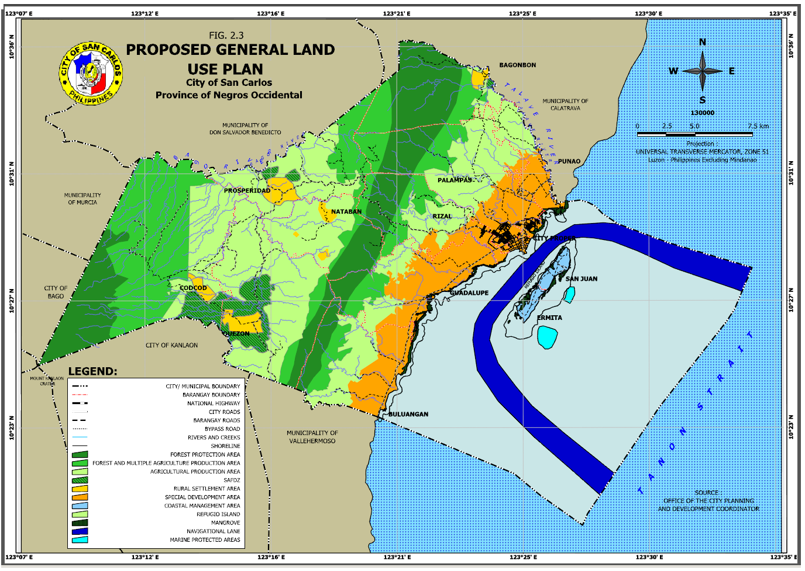

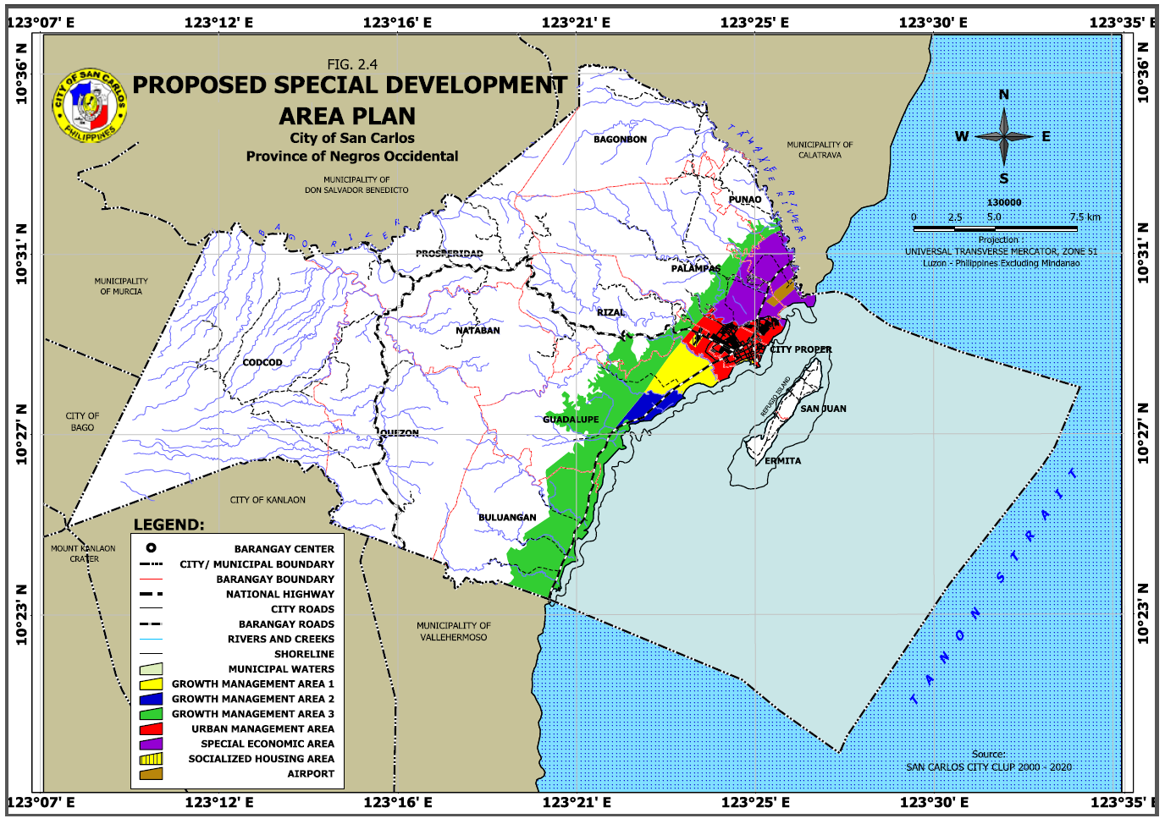

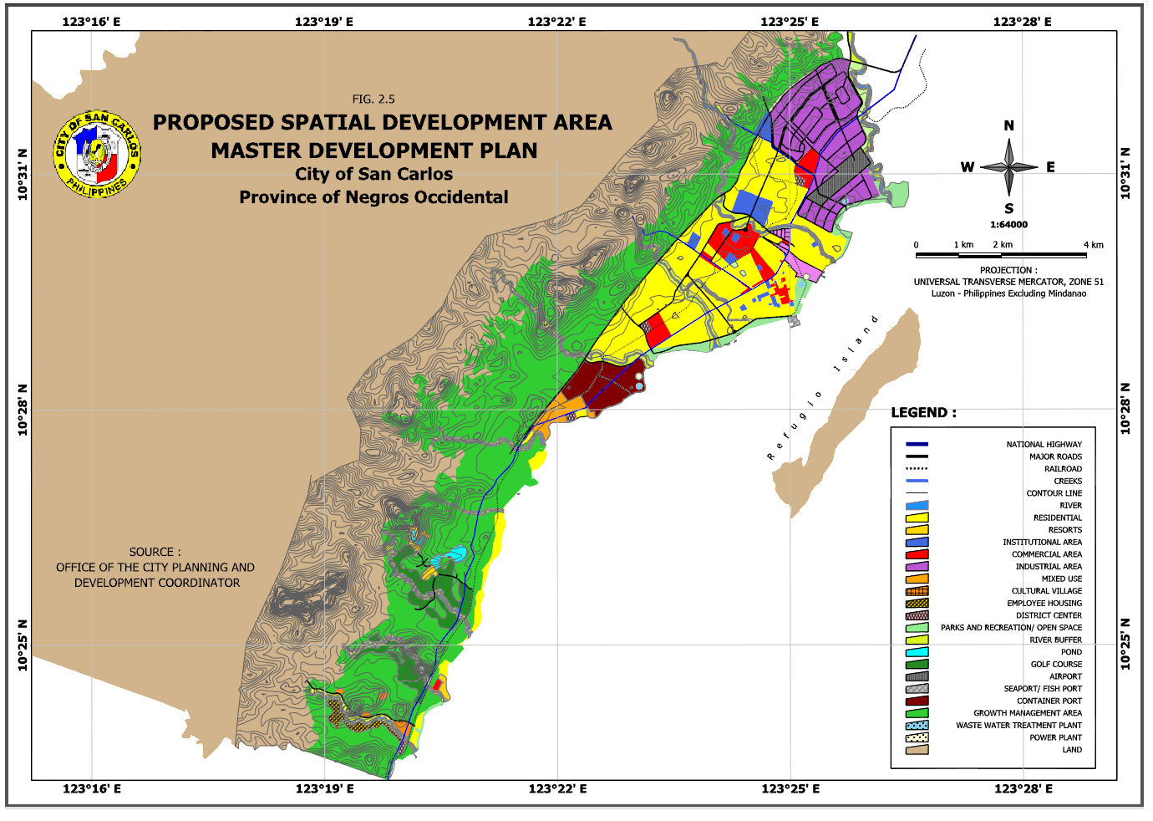

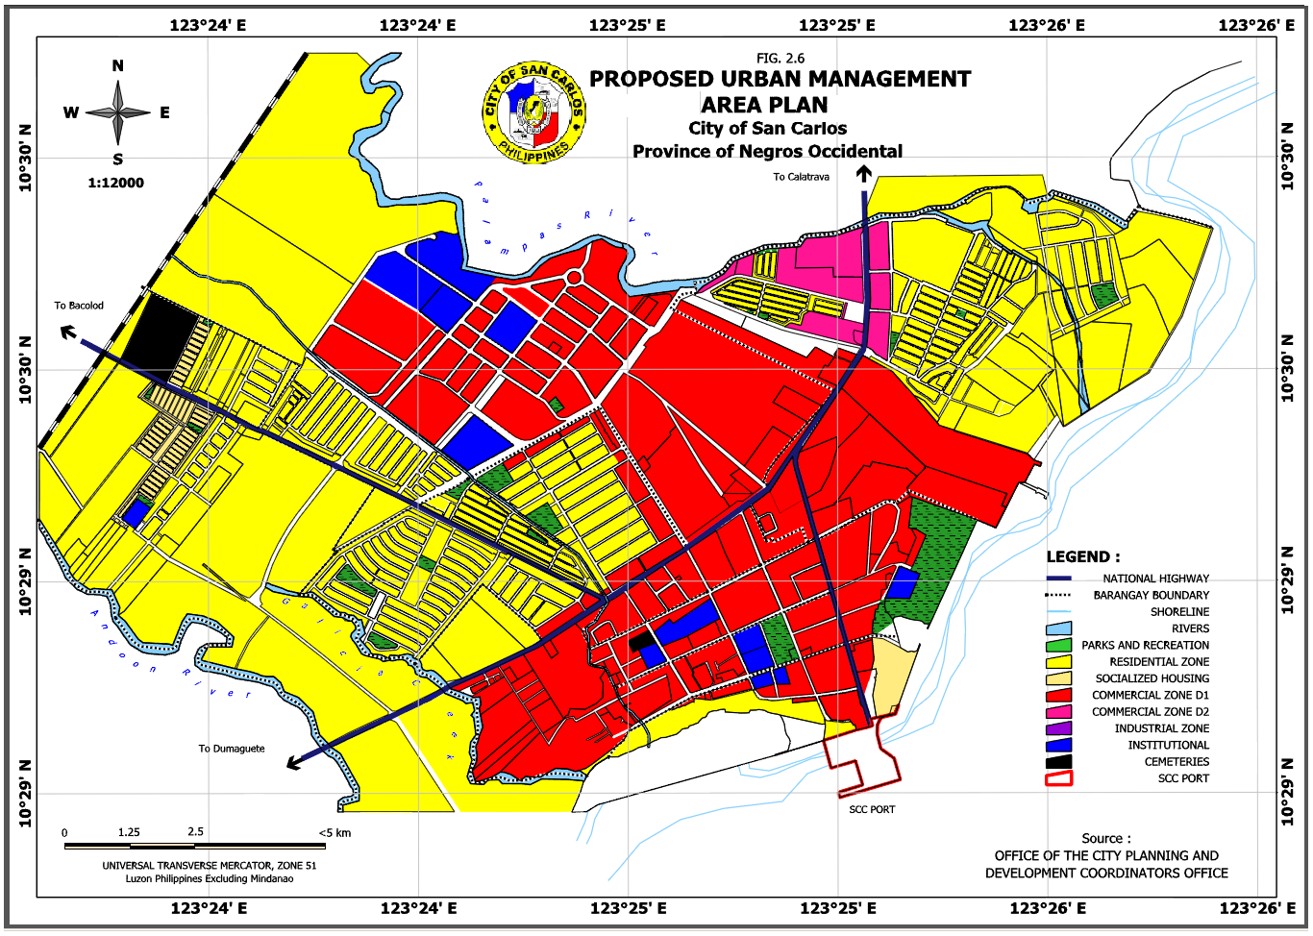

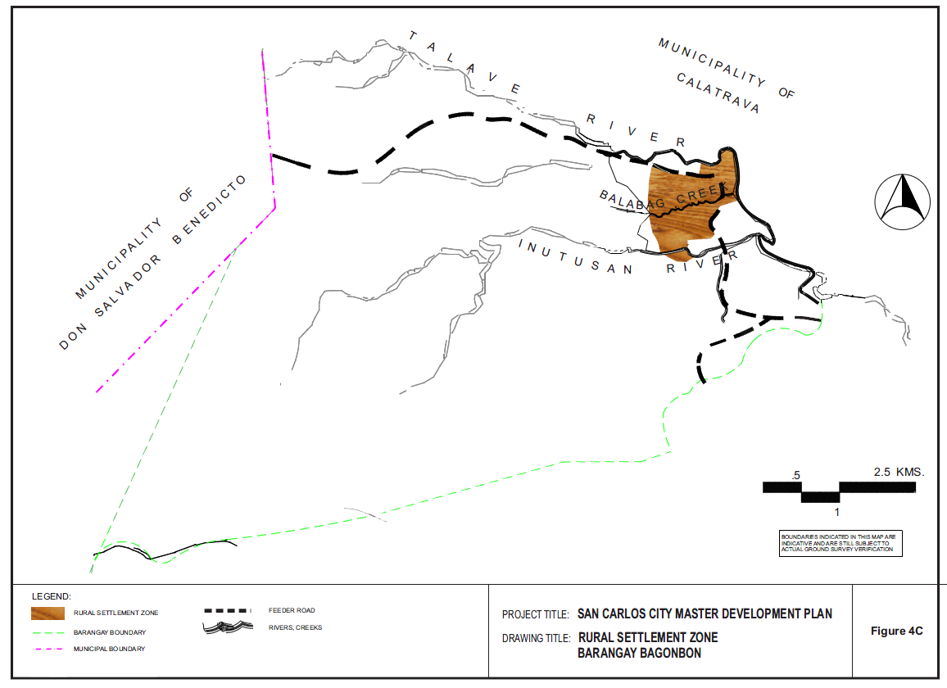

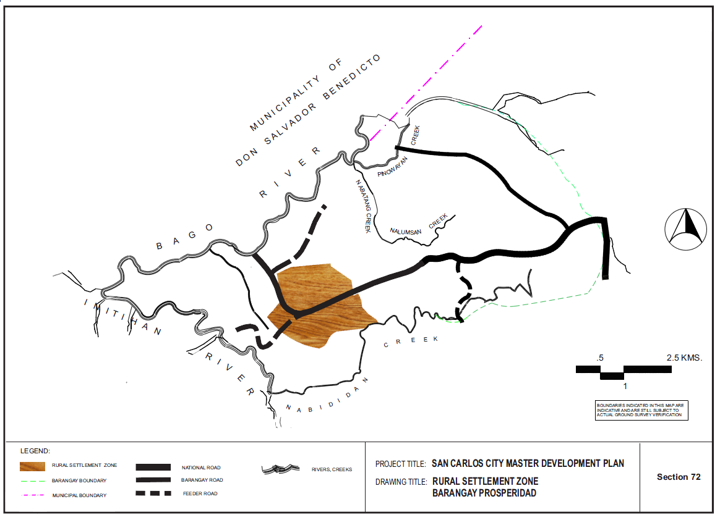

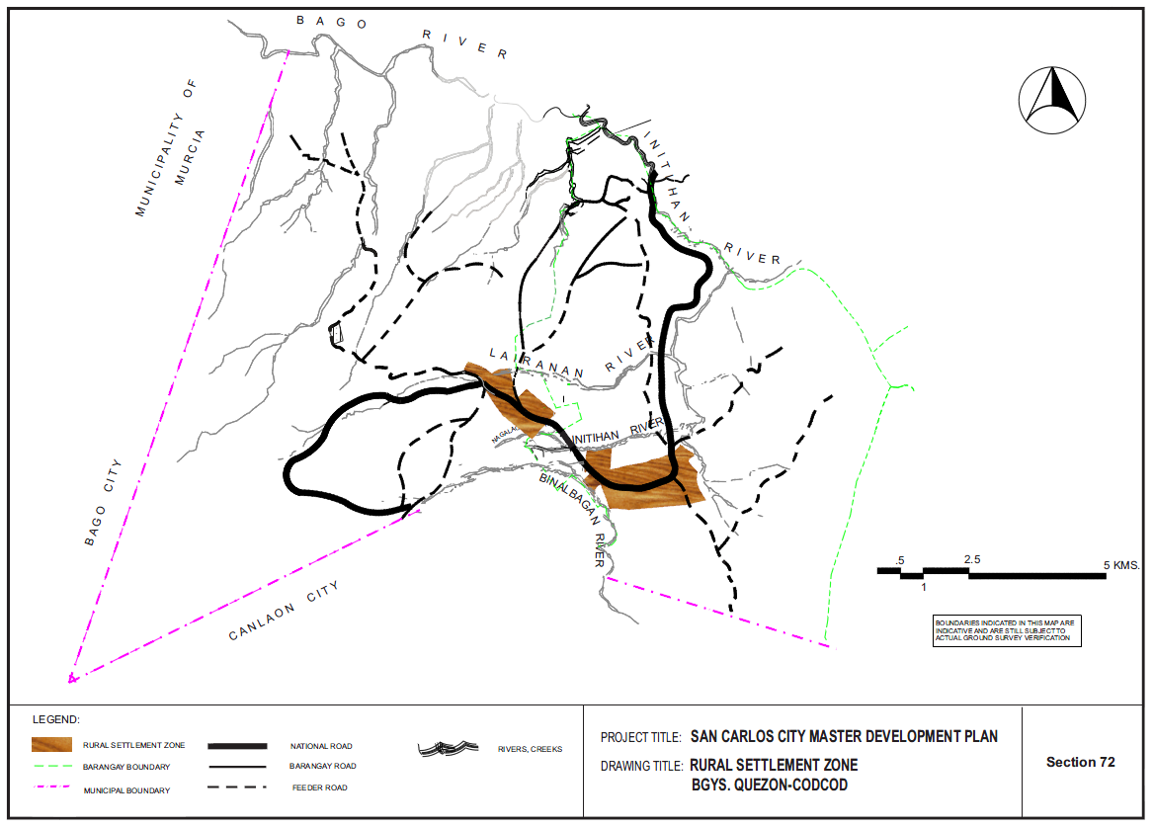

1. Population data was taken from Negros Occidental Social and Economic Trends (NOSET); growth rate was computed manually.
2. This was the region’s population used when the Western Visayas Regional Development Plan was prepared. Population increased to 7,102,438 per the year 2010 census of the National Statistics Office.
3. This was the population size used at the time the Provincial Development and Physical Framework Plan was prepared. Negros Occidental’s population as of the latest 2010 census declined to 2,396,039.