**CHAPTER THREE:**

**SPATIAL ISSUES & CHALLENGES**

1. **SPATIAL ISSUES & CHALLENGES**
   1. **INTRODUCTION**

This chapter consolidates the internal and external findings that affect the land use strategies in the updated CLUP. It takes stock of what is happening in San Carlos City, focusing on land and other natural resources. More specifically, this chapter highlights the physical constraints and opportunities for future development as inputs to the formulation of the CLUP.

Discussions in this chapter revolve around four sub-themes: 1) Constraints and opportunities posed by natural resource and geophysical endowments of San Carlos City, 2) Issues related to utilization and conservation of such resources, 3) estimation of the supply and demand for urban land, and 4) identification of the City’s comparative/ competitive advantages.

Descriptions of status are grouped into four Policy Areas:

1. Settlements
2. Infrastructure
3. Production

3) Protection

Settlement include the Social Sector and Institutional Sector; Production include the Economic Sector; Protection the Environment Sector; and Infrastructure, the Engineering sector. Barangays were grouped into contiguous clusters and land configuration as follows:

* Cluster 1 – Island Barangays (Ermita & San Juan)
* Cluster 2 – Coastal North (Poblacion – Barangays. 1-6 & Punao)
* Cluster 3 – Coastal South (Barangays. Buluangan, Guadalupe & Rizal)
* Cluster 4 – Upland (Barangays. Codcod, Quezon, Prosperidad, Nataban, Bagonbon & Palampas
  1. **WEAKNESSES, PRIORITY ISSUES & CONCERNS**

The identified weaknesses, priority issues and concerns of the City that should be addressed in the updated CLUP are presented in Tables 3.1 to 3.4 and briefly discussed below:

* + 1. *CLUSTER 1 – ISLAND BARANGAYS*

Refugio (Sipaway) Island has the two island barangays. The main concern for the island barangays in the CLUP is for improved transportation systems and environmental protection. Given the projection for climate change, the island is vulnerable to storms, high winds and flooding.

Settlements

* Provide dependable and reliable means of transportation for residents for them to have access to main land during strong winds and wave
* Training for the proper use and maintenance of these facilities
* Enforcement of policy on non-construction on the easement area and close monitoring by the assigned offices

|  |  |  |  |  |
| --- | --- | --- | --- | --- |
| **TABLE 3.1: ISSUES AND CONCERNS: SETTLEMENTS** | | | | |
| **Cluster** | **Issue Observed** | **Explanation** | **Implication** | **Policy Options** |
| **Cluster 1 (Island Barangays – Ermita & San Juan)** | * Prone to strong wind and big waves | * Geographical location which is open to Tañon Strait | * Loss of human lives and destruction of properties | * Settlements should be away from risk areas * Risk reduction initiatives * Construction of break waters * Mangrove re-forestation |
| * Lack of sanitary facilities | * Most of the household don’t have access to sanitary toilets | * Household-members are prone to enteric diseases | * Implement water-less urinals * Training for the proper use & maintenance of these facilities * Address by training the attitudinal & social aspects of this kind of toilet |
| * Lack of potable water | * Potable water is not readily available in the island | * Households are prone to water-borne diseases * High-cost of drinking water since households buy from the mainland | * Proceed with the expansion of the piped water supply from the mainland * Planning regulation * Proper Infrastructure Planning |
| * Transportation during bad weather is affected | * Geographical location of the island barangays; * Main source of transportation is through motorized commercial pump boats that usually transport passengers during daytime unless hired by “Pakyaw” System | * Basic commodities from the mainland cannot be transported due to bad weather * Inaccessible to immediate medical response during emergencies * Medical intervention cannot be delivered on time | * Immediate preparation of basic commodities * Promote home gardens & food banking * Stand-by water vehicle (water ambulance) fitted with communication & hospital for emergency cases |
| * Sipaway Island has no police outpost | * No detailed police personnel | * Slow response time during emergencies | * Intensify police visibility in the island |
| **Cluster 2 Coastal North (Poblacion – Brgys. 1-6 & Punao)** | * Portion of settlements in the coastal areas of Sitio Talave and Maloloy-on of Brgy. Punao & Purok Molave of Brgy. One & Brgy. 6 ) are highly susceptibility to flooding | * Private landowners relocate their workers/laborers to lands that are deemed unproductive, e.g., flood-prone areas * Sugar farm workers are resettle in this area for other sources of food, e.g. fishing activities * Residents here are mostly informal settlers | * Damage to residents & infrastructure during floods * Residents are predisposed to hazard situation due to floods | * Formulation of legislation to prohibit private landowners to relocate their workers/laborers to environmentally-constrained areas * Relocate settlements to an area where they will still have other sources of income |
| * There is low to moderate susceptibility to flooding in the City Proper; most areas of the city gets flooded when there are long, heavy rains * Some communities (ie. Behind Margarita, Greenville, Maloloy-on & other human settlement areas) have no proper sewage drains & connection to city drains | * Poor/old drainage system * Solid wastes are dumped into the drainage canals | * Transportation is hampered during floods * Adverse effects on the economic activity in the city | * IEC among residents on proper solid waste disposal * Rehabilitation and upgrading of drainage canals and channels |
| **Cluster 3 Coastal South (Brgys. Buluangan, Guadalupe & Rizal** | * Settlements in the coastal areas of Hda Galicia, San Jose, San Antonio, Guadalupe Proper, Mabuni, Panoolan, Sto. Nino, Trozo and Fortuna are of high susceptibility to flooding | * There is an advantage of ready supply of food (fishing) * Private landowners relocate their workers/laborers to lands that deem unproductive, e.g., flood-prone areas * Retirees of sugar farms resettle in this area for other sources of food, e.g. fishing activities | * Water pollution; contamination of the coastal system * Increase in water-related diseases among residents | * Strict implementation of Land Use Plan * Relocation of settlements |
| **Cluster 4 Upland (Brgys. Codcod, Quezon, Prosperidad, Nataban, Bagonbon & Palampas)** | * Portion of Brgy. Codcod is vulnerable to ashfall if Mt. Kanlaon erupts | * Geographical location * Presence of livelihood opportunities in the area | * Damage to lives & property * Incidence of Respiratory diseases | * Set-up Community Emergency Evacuation Plan & Community Early Warning System * IEC on Preparedness & Mitigation * Organize & capacitate Barangay Disaster Risk Reduction Committee (BDRRC) * Regular allocation of budget |
|  | * Lack of domestic & potable water |  |  | * Adopt rain catchment & farm water retention pond facilities * Seek out natural water sources * Look for study & adopt low cost filtration systems from locally made clay materials or other technologies |
|  | * A portion of settlements in Brgy. Codcod, Brgy. Bagonbon Proper is on an area with high susceptibility to landslides | * Acquired/inherited properties are located in this environmentally-constrained area * Residents refuse to leave insisting that they have not been affected by any major landslides or soil erosions | * Adverse effect as people continue to be at risk * Loss of life and property * Uncontrolled development which results to loss of productive land resources and other uses | * Since the Barangay Center is located here, it will be difficult to clear the area of structures and settlements. Hence, engineering interventions should be implemented where possible |
|  | * No proper sewerage system of La Vista in Brgy. Prosperidad that has a possibility of water seepage contaminating the river |  |  |  |

|  |  |  |  |  |
| --- | --- | --- | --- | --- |
| **TABLE 3.2: ISSUES AND CONCERNS: INFRASTRUCTURE** | | | | |
| **Cluster** | **Issue Observed** | **Explanation** | **Implication** | **Policy Options** |
| **Cluster 1 (Island Barangays – Ermita & San Juan)** | * Fully Concreted Road Network | * Major priority program of LGU | * Convenience and accessibility | * Periodic maintenance policies |
|  | * Sufficient Mobility Access | * Easy access of people due to frequent availability of both land & sea transport | * Demand driven | * Regulate Land Traffic Management |
|  | * Existence of Secondary School | * Addresses the educational needs of the student-population in the area | * Higher learning opportunities | * Strict compliance to DepEd standards |
|  | * Marine Sanctuary Preserved | * Pursuant to existing ordinance | * Biodiversity preservation | * Amendment of the ordinance whenever deemed necessary |
|  | * Adequate Availability of Piers | * Properly and strategically located to organize transportation services | * Optimum utilization | * Periodic maintenance policies |
|  | * Limited Power Supply | * Depends solely on generator set with a daily six-hour operation (from 6pm to 12 midnight) and explore alternative energy and tapping energy from mainland to Refugio Island | * Low probability of investment for more infrastructure establishment | * MOA with existing power provider/outsourcing |
|  | * Absence of Water Facilities | * No aquifers available; community resorts to rainwater harvesting | * Costly considering the proximity from the city proper | * Prioritize surface water utilization |
|  | * Absence of Covered Court, Fishport & Market | * No implementation due to budgetary constraints | * Disorganized and not well in-placed recreation or service facilities | * Inclusion in the Annual Appropriations Ordinance |
|  | * Less Communication Facilities | * There are identified dead spots in the area caused by poor and no signal range from any network | * Underdeveloped, poor communication system lines | * Extend communication services |
|  | * Sporadic infra establishments | * Solely lands are non-agricultural | * Disarrayed system of establishments | * Zoning Ordinance Revision |
| **Cluster 2 Coastal North (Poblacion – Brgys. 1-6 & Punao)** | * Insufficient Drainage Facilities | Current Capacity could not cope with surface run-off due to extreme rainfall | Flooding within the poblacion & other inundated areas within the city proper | Adopt a comprehensive drainage master plan |
|  |  |  |  |  |
| **Cluster 3 Coastal South (Brgys. Buluangan, Guadalupe & Rizal** | * No public roads | * Concreted but ROW is not acquired |  | * Transfer of ROW to the government whatever mode of transfer |
|  |  |  |  |  |
| **Cluster 4 Upland (Brgys. Codcod, Quezon, Prosperidad, Nataban, Bagonbon & Palampas)** | * National road is not concreted |  |  | * Make representation with DPWH; Utilization of CDF of Congressman |

|  |  |  |  |  |
| --- | --- | --- | --- | --- |
| **TABLE 3.3: ISSUES AND CONCERNS: PRODUCTION** | | | | |
| **CLUSTER** | **ISSUE OBSERVED** | **EXPLANATION** | **IMPLICATION** | **POLICY OPTIONS** |
| **Cluster 1 (Island Barangays – Ermita & San Juan)** | 1. Land   None   1. Coastal Area 2. Fishing without mayor’s permit 3. Use of banned fishing gears/illegal fishing activities | Use of land for agricultural purposes is limited to growing of coconut, mango and few livestock   * Financial constraints * Negligence on the part of the fisherman   Lack of information/awareness on sustainable fishing methods | * None or minimal * Loss of revenue on the part of the LGU * Proliferation of fishermen who do not secure permits resulting to the lack of regulation by the LGU * Destruction of coastal resources resulting to low fish catch | * Strict adherence to land use policies * Strict implementation of fishery ordinance * Strict implementation of fishery law and city ordinance |
| **Cluster 2 Coastal North (Poblacion – Brgys. 1-6 & Punao)** | 1. Land   Use of residential area for commercial purposes   1. Backyard livestock raising in urban areas 2. Pollution caused by industrial waste from Ethanol Plant (abuse of natural resources) | * Financial Interest * Used as a means to gain additional income for the family * Mishandling of excess industrial wastes | * Public disturbance * Public disturbance * Hazardous to health * Predispose to respiratory diseases to the inhabitants of the barangay * Pollution of coastal area | * Strict implementation of rules and regulations * Formulation of policy prohibiting rearing of piggery and poultry in barangays 1-6 * Strict Regulation * Proper monitoring as to compliance with the proper disposal of industrial wastes * Regulation on the part of DENR & LGU and strict implementation of pollution laws * - Possible use of Environmental Guarantee Fund to mitigate the pollution effects |
| **Cluster 3 Coastal South (Brgys. Buluangan, Guadalupe & Rizal** | 1. Land   Decreasing yield of sugarcane   1. Conversion of sugarcane land to fish ponds and other purposes 2. Slash and burn farming within forestal area and private lands with more than 18% slope | * Misuse of farm inputs such as but not limited to fertilizers and chemicals * Inappropriate farming practices like burning of sugarcane trash, irrigation techniques, etc. * Due to higher land valuation and higher monetary returns * Due to financial considerations and lack of employment opportunities | * Continued deterioration of agricultural lands resulting to lower yield per unit area * Decreasing land area for agricultural use * Degradation of forest land and private lands due to severe erosion * Siltation of coastal area within the opening of the rivers | * Continuous Research and Development initiatives for sustainable agriculture * Regulated conversion of prime agricultural lands through policy intervention * Full implementation of forestry laws and strong advocacy on the importance of the environment |
| **Cluster 4 Upland (Brgys. Codcod, Quezon, Prosperidad, Nataban, Bagonbon & Palampas)** | 1. Land  * Decreasing yield of agricultural crops * Misuse of agricultural inputs like fertilizers and chemicals | * Non sustainable agricultural practices that depletes the land of its productive capacity * Emergence of new pests that are resistant to the present chemicals used in farming especially on vegetable production | * Low income of farmers * Low productivity of agricultural land * Health hazards for consuming public | * Promotion of sustainable agricultural practices like organic agriculture * Responsible and judicious use of new chemicals and fertilizers * Strict implementation of policies in the use of farm inputs like chemicals * Alternative crops like fruit trees, fuel wood * Efficient use of irrigation water (eg. Drip irrigation) * - Mechanization of sugarcane harvesting |

|  |  |  |  |
| --- | --- | --- | --- |
| **TABLE 3.4: ISSUES AND CONCERNS: PROTECTION** | | | |
| **Observation** | **Explanation** | **Implication** | **Policy Options** |
| * There are already detected heavy key toxic chemical pollutants in Cluster 2 such as : |  |  |  |
| * Ammonium (mgN/L) 43.65 * Nitrite (mgN/L) 0.1225 * Sulfate (mg SO4/L) 28.48 * Oil & Grease (mg/L) 10.325 * Cadmium (mg Cd/L) less than 0.0025 * Zinc (mg Zn/L) 0.06 * Lead (mg Pb/L) less than 0.0750 * Copper (mg Cu/L) 0.027 * Nickel (mg Ni/L) less than 0.015 * Mercury (mg Hg/L) 0.275 * Potassium (mg K/L) 298.25 * Arsenic (mg /L) < 0.01 * Boron (mg/L) 0.30 * Cyanide (mg/L) < 0.002 | * Due to the point key pollution source such the SCC abattoir, SCC hospital, SCC ESWM Center leachate | * If not properly addressed it will contaminate another water bodies that might endanger water quality | * Legislate policy for waste water management master plan * Expedite the creation of local ENRO * Formulate with the IRR of the local Environment Code *(to include easement)* * *Implement locational criteria for abattoir which is 50 meters away from market* |
|  |  |  |
|  |  |  |
|  |  |  |
|  |  |  |
|  |  |  |
|  |  |  |
|  |  |  |
|  |  |  |
|  |  |  |
|  |  |  |
|  |  |  |
|  |  |  |
|  |  |  |
| * Encroachment of settlements in river easements, road verge, coastal buffer zones, protected areas such MKNP, NNNP, mangrove forests – Cluster 1,2,3,4 (based on map overlay) | * The source of living of the existing settlements are located in the protected areas | * Adverse effects to the forest and biodiversity * Settlements around MKNP and NNNP are exposed to hazards such as volcanic eruption & landslide, respectively | * Integrate Forest Land Use Plan (FLUP) to CLUP * Provide a resettlement site with comprehensive livelihood programs outside the protected areas * Prepare a Community Emergency Evacuation Plan for settlements within the buffer zone of Mt. Kanlaon and landslide prone areas. * Take a proactive role by formulating park-zoning that enhances community participation with the concerned LGU’s * Promote the practice of co-management of the protected areas between the LGUs and the DENR. |
| * 47.72% coral cover and reefs are not in good condition – Cluster 1 (source: REA 2002-03) – *get updated data from Fisheries Section* | * As a result of the illegal fishing activities in the past and use of cyanide | * Marine biodiversity is at risk * Contributes to the effects of global warming | * Intensify implementation of existing policies towards marine biodiversity protection * Rehabilitate coral reefs and continue initiatives against “crown of thorns”/salanay * Provide alternative livelihoods to fisher folks and coastal communities |
| * 2 out of 9 endemic avian species are endangered along NNNP – Cluster 2,3,4 | * Continuous hunting activities that exploits the flora and fauna of the NNNP | * Potential extinction of these species | * Strengthen existing laws in the protection and preservation of the NNNP and its flora and fauna * Support existing captive-breeding through NFEFI |

Infrastructure

* Widening of narrow road sections, correction of gradients and observing regular maintenance policies while instituting traffic management
* Implement engineering interventions on water supply provision
* Enforcement of sanitation and environment codes
* Strict enforcement of City solid waste management ordinance
* Improve power generation using renewable resources and outsource through Independent Power Producers (IPPs).

Production

* Strict adherence to existing land use policies especially on activities that will contribute to the degradation of the coastal waters.
* Strict implementation of ordinance on utilization and conservation of mangroves, and full implementation of fishery ordinance.

Protection

* Amendment of the existing Zoning Ordinance through provision of relocation sites of affected HH
* integration of disaster risk reduction measures in the affected HH
* promote advocacy and active involvement among community members in the protection of coastlines
* strictly enforce local ordinance and other related fisheries law on marine protection
* improve the incentive program on Operation Anti-Salanay
* further research on the beneficial uses of salanay as organic fertilizer
* propagate the proliferation of nautilus or “tambuli”
  + 1. *CLUSTER 2 – COASTAL NORTH*

The updated CLUP recognizes the advantages of continuing the Poblacion’s development for the economy. More attention should, however, be paid to the environmental concerns particularly taking into consideration the mandate for disaster risk reduction. Also, a continuing problem in the City’s urban area that needs to be addressed is increasing number of informal settlers.

Flooding is also a concern in the Poblacion. Its occurrence is usually attributed to overflowing of rivers due to excessive runoff coupled with bad channel characteristics such as steep slopes and poor drainage capacity of the river system. According to CLUP 2000 - 2020, floods bring more damage to urban barangays especially during the high tide when floodwaters cannot flow directly to the sea. The barangays most affected are Barangays I, II and III that are found in the lowlands. Correspondingly, areas found along the riverbanks of the City’s major rivers have also been classified as flood-prone.

Settlements

* Relocation of informal settlers to better housing facilities provided by the LGU
* Strict monitoring and implementation of zoning ordinance at the Barangay level

Infrastructure

* Establishment of Water Quality Management Area Action Plans (WQMAs)
* Strict enforcement of the City’s solid waste management ordinance

Production

* Relocation to safe higher grounds beyond the national highway to the hillsides.
* Adherence to existing ordinance, building codes, etc.
* Non-conversion of agricultural lands.
* Strict implementation of existing forestry laws.

Protection

* Review/Draft policy concerning maintenance of linear park at the business district
* Strict enforcement of the City’s SWM Ordinance
* Introduce bio-engineering measures
  + 1. *CLUSTER 3 – COASTAL SOUTH*

The coastal south barangays include areas very near to the urban development as well as more remote barangays. They include coastal as well as upland areas. These areas are populated by fisher folk. These are low areas and have possibility of flooding. Residents may have to be moved to higher ground. One of the major problems of the population is lack of access to potable water as many of the sources are suffering from salt water intrusion. Policies will support the protection of the environment against further damage by strict implementation of fishery protection as well as protection against deforestation in the higher areas.

Settlements

* Provision of alternative livelihood through conduct of training and seminar.

Infrastructure

* Establishment of WQMAs
* Strict enforcement of the City’s solid waste management ordinance

Production

* Possible relocation to higher grounds.
* Non-conversion of agricultural lands.
* Strict implementation of fishery ordinance.
* Strict implementation of forestry laws.

Protection

* Review/Draft policy concerning maintenance of linear park along business district
* Strict enforcement of the City’s SWM Ordinance
* Introduce bio-engineering measures
  + 1. *CLUSTER 4 – UPLAND*

Much of the emphasis for the upland area is for environmental protection. Part of the area includes the national park land where a major concern is the informal settlers. Ideally land outside the protected area could be provided and a source of livelihood established. The upland area is also considered for tourism development.

Settlements

* Revisit existing zoning ordinance and update and then strict implementation
* Revisit existing zoning ordinance to ensure that settlements do not encroach into the upland particularly the national park and ensure that strict implementation of the said ordinance.

Infrastructure

* Establishment of WQMAs
* Strict enforcement of the City’s solid waste management ordinance

Production

* Non-conversion of agricultural lands.
* Strict implementation of forestry laws.

Protection

* Integrate Forest Land Use Plan (FLUP) to the CLUP
* Provide a resettlement site with comprehensive livelihood programs outside the protected areas
* Prepare a Community Emergency Evacuation Plan for settlements within the buffer zone of Mt. Kanlaon and landslide prone areas
* Develop the full potential/protection of natural tourism attractions
* Take a proactive role by formulating park-zoning that enhances community participation with the concerned LGUs
* Promote the practice of co-management of the protected areas between the LGUs and the DENR.
  1. **URBAN LAND SUPPLY AND DEMAND** 
     1. *SUPPLY*

Lands that are suitable of urban development are those that are relatively free from severe environmental hazards and constraints. These areas extend to about 19,114.12 has. and may be found on the eastern footslopes between Tañon Strait and NNNP and at the valley between NNNP and MKNP. Most of these areas are used for agriculture and their locations are presented in **Figure 3.1** Development Opportunity Map.

Portions of these suitable areas have already been classified for urban use, such as the San Carlos Development Corridor and Rural Settlement Areas, in CLUP 2000 – 2020 and in previous LGU legislations. It is estimated that the net area suitable for urban development is about 11,347.58 has. These are constitute the available supply of lands for urban development and are shown in **Figure 3.2** Available Areas for Urban Expansion.

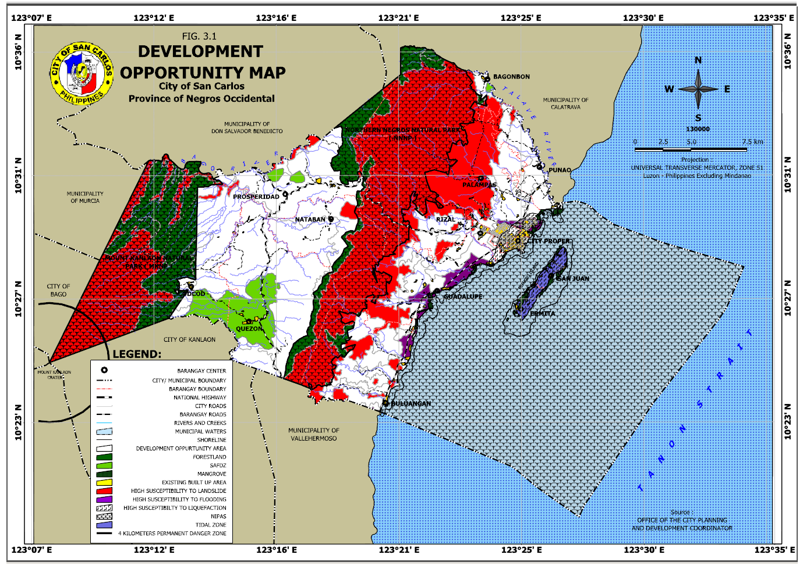

**I**

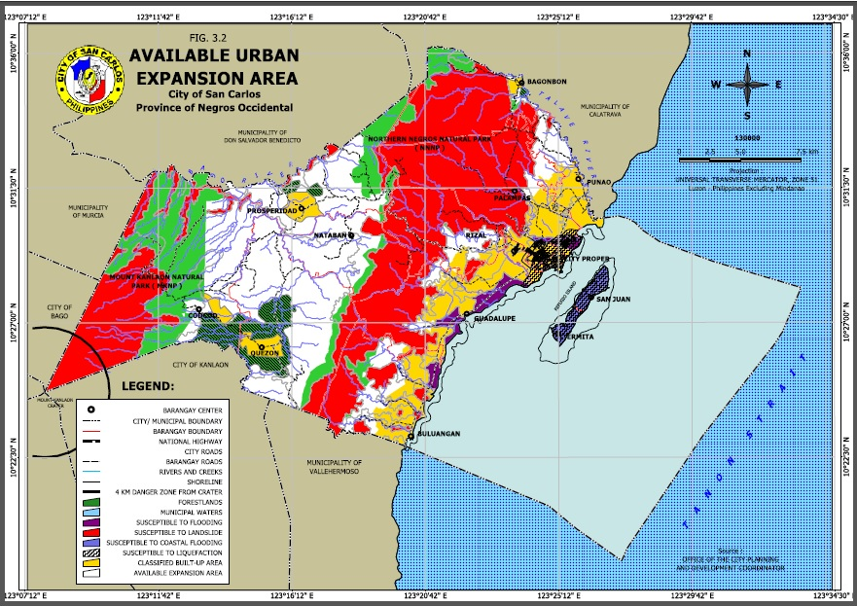

* + 1. *DEMAND*

Demand for urban land within the plan implementation period of 2014 – 2023 may be estimated by dividing the City into the major planned settlement areas of CLUP 2000 – 2020. This will include (1) the San Carlos Development Corridor comprising the Urban Core or Poblacion barangays and the Urban Expansion Area, (2) Rural Growth Centers comprising Prosperidad, Quezon-Codcod, and Bagonbon, and (2) Refugio (Sipaway) Island Settlements comprising Barangays Ermita and San Juan. The following were the assumptions made in projecting urban land demand:

* San Carlos Development Corridor
* Urban Core
* All (100%) of the projected additional population will be residing/ using space in any of the six Poblacion barangays
* Compact urban growth shall be promoted by adopting a policy of increasing densities to 150 persons per hectare
* Urban Expansion Area
* About 80% of projected additional population will be residing/ using space in the designated built-up areas of these barangays
* Compact urban growth shall be promoted by adopting a policy of increasing densities to 75 persons per hectare
* Rural Growth Centers
* About 80% of projected additional population will be residing/ using space in the designated built-up areas of these barangays
* Compact urban growth shall be promoted by adopting a policy of increasing densities to 50 persons per hectare
* Refugio (Sipaway) Island Settlements
* About 80% of projected additional population will be residing/ using space in the designated built-up areas of these barangays
* Compact urban growth shall be promoted by adopting a policy of increasing densities to 50 persons per hectare

The following table presents the projected demand for urban land up to 2023:

|  |  |  |  |  |  |
| --- | --- | --- | --- | --- | --- |
| **TABLE 3.5: PROJECTED DEMAND FOR URBAN LAND** | | | | | |
| **Location** | **Urban Population** | **Additional Urban Popn (2023)** | **Current Density (2010) pn-ha** | **Targeted Density (2023) pn-ha** | **Urban Land Demand (has)** |
| **San Carlos Development Corridor** | | |  |  |  |
| **Urban Core** |  |  |  |  |  |
| Poblacion | 100% | 3,402 | 101 | 150 | 22.68 |
| **Urban Expansion Area** | |  |  |  |  |
| Guadalupe | 80% | 879 | 2 | 75 | 11.71 |
| Palampas | 80% | 755 | 2 | 75 | 10.06 |
| Punao | 80% | 485 | 3 | 75 | 6.47 |
| Rizal | 80% | 930 | 4 | 75 | 12.40 |
| **Sub-totals** |  | **6,451** |  |  | **63.33** |
| **Rural Growth Centers** | | |  |  |  |
| Prosperidad | 80% | 421 | 2 | 50 | 8.43 |
| Quezon-Codcod | 80% | 1,989 | 1 | 50 | 39.79 |
| Bagonbon | 80% | 447 | 2 | 50 | 8.94 |
| **Sub-totals** |  | **2,858** |  |  | **57.15** |
| **Refugio (Sipaway) Island Settlements** | | |  |  |  |
| Ermita | 100% | 219 | 12 | 50 | 4.39 |
| San Juan | 100% | 296 | 12 | 50 | 5.92 |
| **Sub-totals** |  | **515** |  |  | **10.31** |
| **Totals** |  | **7,413** |  |  | **82.57** |

* + 1. *SUPPLY-DEMAND ANALYSIS*

The City has a vast supply of urbanizable land with a comparatively low demand for the next ten years. Even the more than 5,000 hectare San Carlos Development Corridor, a classified urban area, still only has a built-up area of about 790.68 has. This means that there are still more than 4,000 hectares of land of still un-developed urban land. Moreover, the City Government can exercise its authority to re-classify a maximum of 10% of agricultural lands. Considering that the 11,347.58 has of land identified suitable for urban development is presently (used) classified as agricultural, this means that an additional 1,135 hectares of land can still be (provided) re-classified to urban uses (with urban development potential).

It could be observed that the estimated demand shown above was controlled by assuming a policy of compact urban growth translated into increasing population densities beyond the present level. Nonetheless, the assumed increases are still within the low density scenario if compared to the HLURB’s guidelines for residential areas, as shown below:

|  |  |
| --- | --- |
| **TABLE 3.6: RESIDENTIAL AREA DENSITY RANGES** | |
| **Type of Density** | **Density (persons per hectare of residential area)** |
| Low | 150 |
| Medium | 151 – 250 |
| High | More than 250 |
| *Source: CLUP Guidebook, Vol. 2, 2007 edition, HLURB* | |

Notwithstanding the abundance of open spaces, the City Government is ensuring that these are not wasted by un-planned growth. This updated CLUP carries forward the planning principles espoused in the Master Development Plan for the Corridor which, among others, calls for the development of a compact City Proper while conserving valuable surrounding open space.

The large area available for urban use also means that the City Government could seek to attract significant investments such as, for example, industrial estate or tourism estate development.

* 1. **COMPARATIVE/ COMPETITIVE ADVANTAGES**

Following is a broad identification of the City’s major comparative and competitive advantages:

* + 1. *COMPARATIVE ADVANTAGES*

As an ideal Port City

San Carlos has a fine natural harbor protected by Refugio (Sipaway) Island. Its long coastline extending up to 36 kilometers and its thriving island barangays in Refugio (Sipaway makes it an ideal Port City.

San Carlos lies in a region with two large inter-island water bodies; the Sibuyan and the Visayan Seas which include a number of bays and coves that provide good anchorages and potentially good port areas. The 12 fathom deep Tañon Strait on the east and the depth of Tañon Strait makes San Carlos an ideal location for port development and shipping facilities. This geographic location is an opportunity for growth which may be explored.

As an Eco-tourism Destination

There are three key natural resource endowments which give San Carlos a comparative advantage in terms of being an eco-tourism destination. The first two are the MKNP and NNNP which support the largest expanses of forest left in the Visayas Region and that still harbor pristine and natural habitats with a unique assemblage of flora and fauna, many of which are endemic to Panay and Negros Island as well as the WVBZ. The third is Refugio (Sipaway) Island which is an unspoiled white-sand beach coral island that is only 3.5 kms off the coast of mainland San Carlos and has at least 14 km of coastline.

* + 1. *COMPETITIVE ADVANTAGES*

One of the World’s Most Livable Cities

The City takes pride in being awarded as one of the most livable cities in the world. Such stature should be maintained in order to attract more inward investments while ensuring that the factors that contribute to the City’s livability are further enhanced.

City of Renewable Energy

San Carlos has the advantage of being a leader in the country’s renewable energy sector, first with the Bio-ethanol plant and second with the Bio-mass facility. This will not only address energy requirements but is expected to provide substantial economic opportunities to linked agricultural and service sector activities.

Capital of Earth Construction of the Philippines

The City is also known internationally as being environment-friendly through its use of earth-based construction technology in many of its infrastructure projects. Similar to renewable energy, cutting-edge and innovative sustainable construction technologies are expected to play key roles in the future development of cities.

San Carlos Development Corridor

The vast 5,600 hectare San Carlos Development Corridor presents an opportunity to demonstrate sustainable urban development. This are provides a high degree of flexibility for government planners and land use regulators to create compact, mixed-use communities that are conveniently accessible to high-quality open spaces.