**CHAPTER 5:**

**THE CHOSEN SPATIAL DEVELOPMENT STRATEGY**

1. **THE CHOSEN SPATIAL DEVELOPMENT STRATEGY**
   1. **INTRODUCTION**

This chapter elaborates on the spatial strategy or urban form that shall guide the location of future land uses in relation to the existing ones. The present CLUP exercise does not supplant or replace the salient features of the predecessor CLUP 2000 - 2020. Rather, it seeks to extend, amplify, or modify its predecessor, as the case may be. This is to ensure continuity and rationality of public and private investments considering that physical development projects invariably take a long time to gestate and that once the projects are established these will have a fairly long economic life, adding to the community's fixed assets, defining the shape, intensity and direction of the built environment and altering the landscape of the City more or less permanently.

* 1. **SPATIAL DEVELOPMENT OPTIONS**

Using the information available from the assessment of buildable lands and the thematic maps, several land use options were developed:

* OPTION 1 – Linear Extension of the Urban Corridor
* OPTION 2 – Old Barangay Expansion – Prosperidad & Quezon
* OPTION 3 – One new big settlement in the confluence of Prosperidad, Quezon & Nataban
  + 1. *OPTION 1 – LINEAR EXTENSION OF THE URBAN CORRIDOR*

General Description

Also known as the ribbon or strip development, the linear urban form is characterized by concentration of development along both sides of major transportation routes such as roads or navigable rivers. Residential, commercial, institutional, industrial and mixed-use developments intensify along these areas through time. But the extent of development will be limited within reasonable distance from the road or river easements. This form is patterned after what Kevin Lynch calls the Urban Star simply because of its strong feature of “a dominant core surrounded by centers distributed along main radials”. In the case of San Carlos City, such development pattern is characterized by the core in addition with the linear expansion described by the existence of the Poblacion and corridor development which will intensify along the north and south coastal clusters traversing the City. These corridors include the national highway’s access to Bacolod and Dumaguete through the coastal route and the Translink Highway connecting Bacolod City via the hinterland section. Spatial Development Option 1 is presented as **Figure 5.1.**

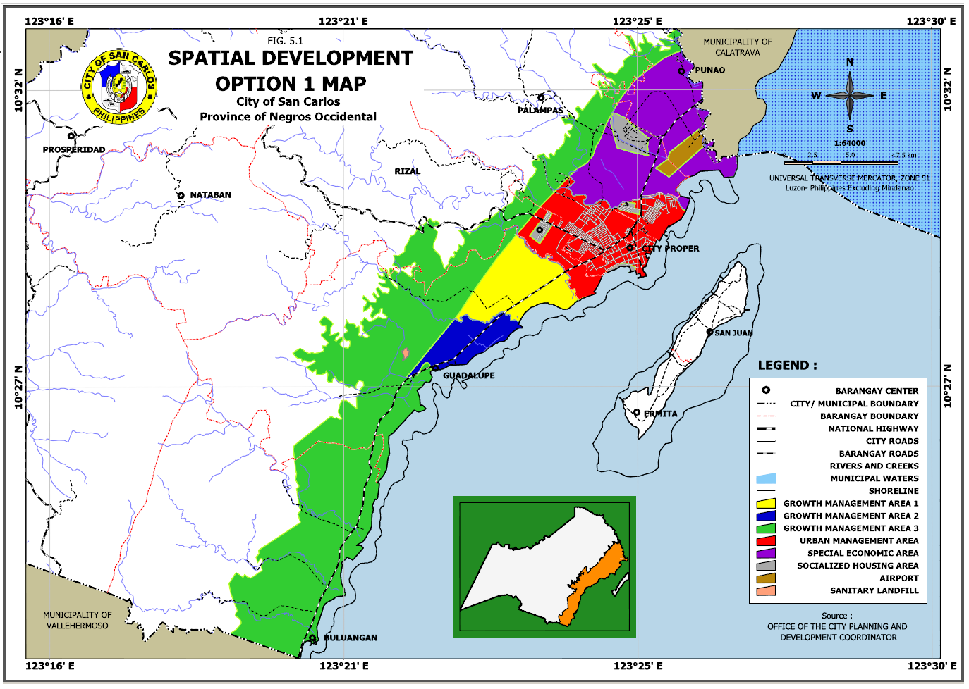

What it takes to realize this urban form

* Cost of new roads and other infrastructure

Minimal national government investment required for construction of new arterial roads but high local government investment needed for construction of new local roads parallel to arterial roads (to include the development of three Circumferential roads namely; C1, C2 & C3) to separate local traffic from through traffic.

Moderate investment required to upgrade existing utilities.

* Community adjustment to risks

Approximately 25% of the development area will be located in areas prone to environmental hazards such as ground shaking, liquefaction and flooding (including the effect of sea level rise), particularly along the Coastal North, Coastal South and Refugio (Sipaway) Island barangays.

Proper density controls and appropriate engineering designs and mitigation will be strictly enforced in these vulnerable areas.

* Preservation of protected croplands and fishponds

Encroachment on environmentally critical areas and productive agricultural lands continue to threaten the natural environment, thus strong land use policy adjustments and IEC campaigns will be required. Existing agricultural areas will be converted for urban expansion, thus requiring strong government and community interventions.

* Strict government enforcement of regulations

Existing laws (e.g., water, air, environment, sanitation, and building codes) and local ordinances may be difficult to enforce in already built up areas. However, in new development areas, it would be easier to enforce provisions of local and national laws.

* People’s compliance with regulations desired

Compliance with regulations will be difficult especially if problems already exist. With better information, however, future developers will find it easier to comply with regulations.

Implications when this urban form is realized

* Access of people to city-wide services

Easy access of people to City-wide services especially for the island barangays which will be fully provided with potable water system and other utility related services.

Availability of basic social services such as education, health, housing, sports, recreation and others will be limited along the major routes.

* Amount of air and water pollution produced

High vulnerability of residents to air, water and noise pollution as development will occur along the major routes along the urban centers.

Domestic and industrial wastewater contamination is expected in the Coastal North and Coastal South cluster barangays due to the extension of the urban corridor.

* Sustainable use of natural resources

Areas already severely damaged may be difficult to rehabilitate. Aquaculture operations become unsustainable if not adequately regulated.

Over withdrawal of ground water may create water shortage or aggravate salt water intrusion.

* Traffic problems reduced

Traffic Congestion within the City center is minimized due to the establishment of circumferential roads and other major arteries (local and national road widening).

Traffic management schemes are likewise to be intensified in order to deal with traffic problems.

* Overall attractiveness of the City

Attractiveness of the City is high with effective building density and design restrictions/controls, coupled with a mix of compatible uses.

* Potential for increased LGU revenue

Increased in local government revenues will accrue from real property taxes due to optimum use of lands.

* Prospects for more jobs and higher income

Increase in households’ income will depend on their ability to see market opportunities in areas of population concentration.

* + 1. *OPTION NO. 2: BI-NODAL URBAN FORM (OLD BARANGAY EXPANSION–PROSPERIDAD & QUEZON)*

General Description

The bi-nodal urban form will redirect development away from the City center toward identified urban growth areas. It matches the Galaxy form of Kevin Lynch, which is characterized by clusters of development with each cluster having its own specialization. Under this alternative, two additional self-contained growth areas will be developed outside the Poblacion area, namely: 1) Prosperidad Growth Center, which lies on the western edge of San Carlos City, adjoining the Translink Highway to Bacolod City which will play host to agri-industry and light industry initiatives engaged in primary processing activities and to specialize in tourism and recreation; and 2) Quezon Growth Center, which will serve the southwest area in supporting the surrounding agricultural priority programs and encourage settlement growth and resettlement away from Mt. Kanlaon National Park. The two growth centers will have residential components accompanied by related social infrastructure. The Bi-Nodal Urban Form will improve transport system and possibly provide alternative means of transportation, that is, a cable car system within the vicinity of Quezon-Codcod area. Spatial Development Option 2 is presented as **Figure 5.2.**

What it takes to realize this urban form

* Cost of new roads and other infrastructure

High cost of public investment on road and other infrastructure in the initial stage as there is a need to link the identified growth centers:

* Huge capital expenditures on road building and improvement and utilities maintenance,
* Development and improvement of circumferential routes or new sections that will link barangays to the rest of the City, and
* Provision of alternative means of access, possibly cable car traversing major rivers and steep terrains.
* Community adjustment to risks
* Inhabitants are relatively safe from natural and man-made disasters as hazard-prone areas are intentionally avoided.
* Preservation of protected croplands and fishponds
* High degree of preservation of croplands will occur in the new growth areas with minimal and controlled land use conversion on flat lands will be expected to cater eventual other land use development.
* Strict government enforcement of regulations
* City-wide programs and activities to foster social cohesion and integration among City inhabitants will be needed.
* People’s compliance with regulations desired
* Full people’s compliance with regulations necessary
* Proper mix of social/income classes will have to be promoted to prevent the formation of enclaves.

Implications when this urban form is realized

* Access of people to City-wide services
* Greater access of people to City-wide services due to decentralized frontline offices of city hall, public markets, shopping centers, tertiary schools and even a hospital
* Amount of air and water pollution produced
* Areas of concentration of air and water pollution are easily identified and therefore mitigation measures can focus on these areas.

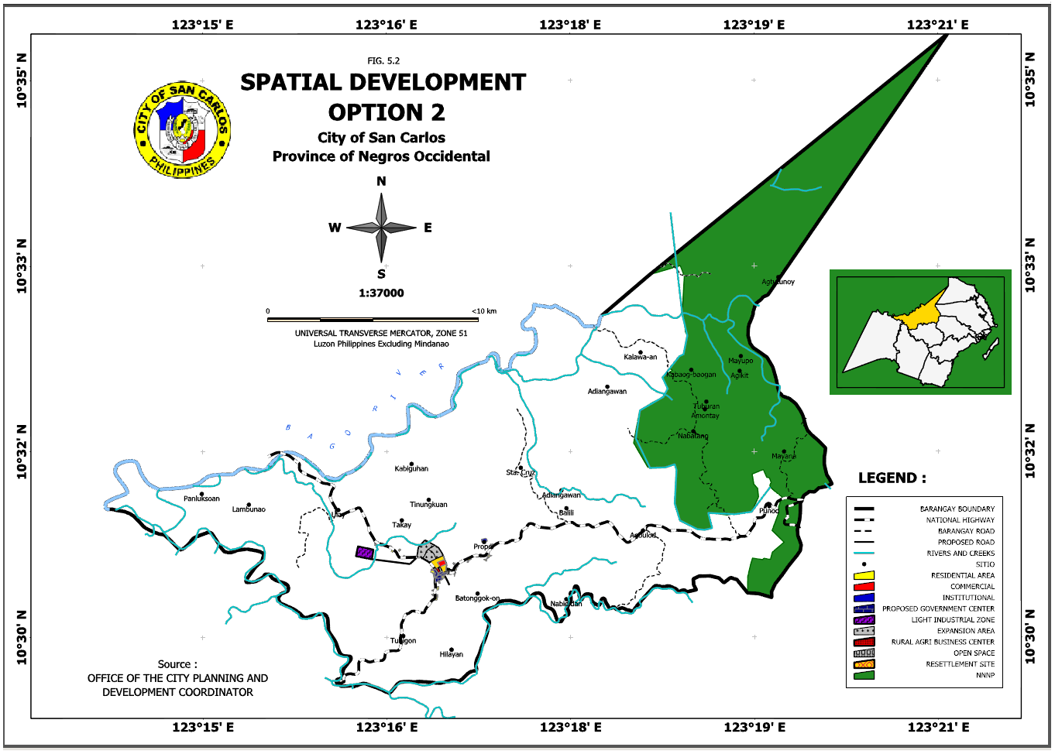

* Sustainable use of natural resources
* More open space and wildlife habitats can be recovered and preserved.
* Traffic problems reduced
* New urban nodes intercept inbound traffic from the west relieving traffic in the City center
* Overall attractiveness of the City
* Large open spaces and visual breaks and sceneries along road network contribute to overall attractiveness of the City.
* Potential for increased LGU revenue
* Decentralized city services help intensify local revenue collection.
* Prospects for more jobs and higher income
* More jobs generated resulting in higher household income due to increased investments in the new urban nodes.
* San Carlos City’s leading role in the north maintained
* New growth centers with specialized functions and the availability of more expansion areas for tertiary schools, a hospital, shopping centers, non-pollutive industrial estate, and residential subdivisions will contribute to maintaining San Carlos City’s leading role in North Negros.
  + 1. *OPTION 3: ONE NEW BIG SETTLEMENT IN THE CONFLUENCE OF PROSPERIDAD, QUEZON & NATABAN*

General Description

Also known as the ribbon or strip development, the linear urban form is characterized by concentration of development along both sides of major transportation routes such as roads. Residential, commercial, institutional, industrial and mixed-use developments intensify along these areas through time. But the extent of development will be limited within reasonable distance from the road or easements. This form is patterned after what Kevin Lynch calls the Urban Star simply because of its strong feature of “a dominant core surrounded by centers distributed along main radials”. In the case of San Carlos City, such development pattern will intensify along its western edge adjoining the Translink Highway. The growing importance of the Translink Highway bolsters the expectation of Prosperidad to have medium to longer prospects as a Secondary Urban Growth Center. The reason for this consideration stems from a number of significant locational factors. First, Prosperidad is situated at the junction of the rural road network and the Translink Highway. This vital road infrastructure has implications on trading and transport of goods from production areas of Nataban and Quezon to the markets. Second, its location can facilitate a rural “hub” function beyond barangay boundaries. Third, Prosperidad is accessible to agricultural production areas with the possibility of establishing agri-industry and light industry initiatives that can engage in primary processing activities. The longer-term growth scenario envisions an industrialization component. Spatial Development Option 3 is presented as **Figure 5.3.**

What it takes to realize this urban form

* Cost of new roads and other infrastructure
* Minimal national government investment is required for maintaining the Translink Highway but high local government investment is needed for the development and improvement of local roads leading to the main arterial highway. Moderate investment is required to upgrade existing utilities.
* Community adjustment to risks
* The development area will not be situated in a location prone to environmental hazards such as landslide, ground shaking, liquefaction and flooding. Proper density control and appropriate engineering designs will be strictly enforced in vulnerable areas, if any.
* Preservation of protected croplands and fishponds
* The need for reclassification/conversion of agricultural lands is low as development will be confined along the Translink Highway and the rural road network.
* Strict government enforcement of regulations
* Strong political will may be needed to enforce limits within the designated urban development corridors.
* People’s compliance with regulations desired
* Moderate compliance with regulations will be required because only minimal changes will be introduced to the current development trend.

Implications when this urban form is realized

* Access of people to city-wide services
* Availability of basic social services such as education, health, housing, sports, recreation and others will be limited along the highway and major routes.
* Amount of air and water pollution produced
* High vulnerability of residents to air and noise pollution as development will occur along the major routes. Rise in levels of air and water pollution is expected in the northwestern part due to industrialization as Prosperidad becomes a major transhipment point and provide a context for local processing.

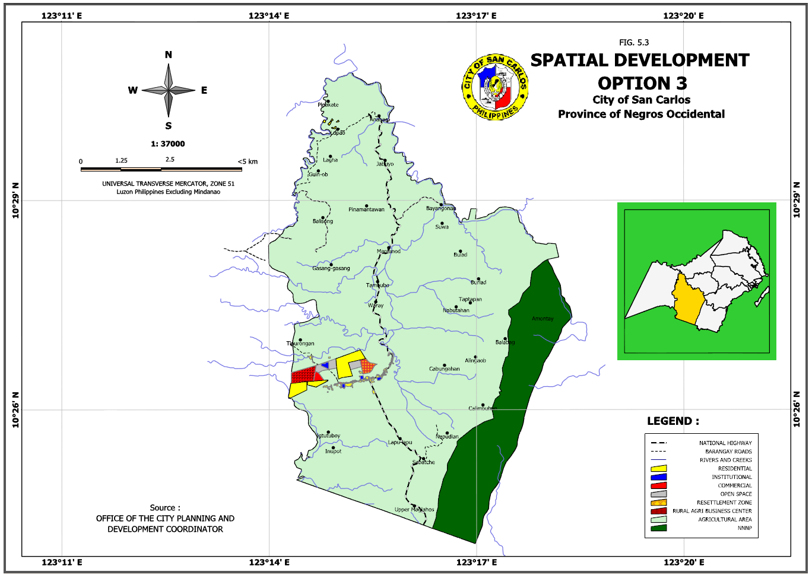

Sustainable use of natural resources

* Moderate impact on natural resources will be expected. Wide expanse of open spaces will be preserved beyond the built-up areas resulting in the protection of croplands.
* Traffic problems reduced
* Access is high for the movement of people and goods, provided roads are developed connecting along existing major arterial roads and the highway. Traffic congestion will be experienced in certain.
* Overall attractiveness of the City
* The image of the City will not be easily appreciated by the passers-by because, seen from the arterial roads, the City might appear to be a mere continuous row of structures. Hence, the design and provision of visual breaks in certain areas will be necessary.
* Potential for increased LGU revenue
* Increased in local revenues will accrue from the real property taxes due to optimum use of lands.
* Prospects for more jobs and higher income
* Increase in households’ income will depend on their ability to see market opportunities in built-up areas where population is concentrated and development happens.
* San Carlos City’s leading role in the north maintained
* This urban form will have little contribution toward maintaining the role of San Carlos City as leading business, educational and health services center of North Negros.
  1. **EVALUATION OF OPTIONS**

A description of each of the development options was supplemented with criteria under what it would take to achieve and the implications if it was realized. Each of the criteria was rated as high moderate or low for each of the options. The above described tool was used to survey among the various stakeholder groups in the City and the Goal Achievement Matrix (GAM) was developed. The groups surveyed included academe, women, government, business, CSO’s, farmers, fisher folks, informal settlers, NGOs/POs and youth. The scores for each were used to rank the three different options. The ranking was:

1. Linear Extension of the Urban Corridor (Option 1)
2. Old Barangay Expansion – Prosperidad & Quezon (Option 2)
3. One new big settlement in the confluence of Prosperidad, Quezon & Nataban (Option 3)

The following tables show the comparative characterization of alternatives and summary of GAM Scores:

**TABLE 5.1: COMPARATIVE CHARACTERIZATION OF ALTERNATIVES**

|  |  |  |  |
| --- | --- | --- | --- |
| **CHARACTERISTICS** | **Option1**  **Extension of the Urban Corridor** | **Option 2**  **Brgy Expansion of Prosperidad & Quezon** | **Option 3**  **New Settlement confluence Prosperidad, Quezon & Nataban** |
| **1) What it takes to realize this urban form** | | | |
| Cost of new roads and other infrastructure | Moderate | High | High |
| Community adjustments to risks | High | Moderate | Moderate |
| Preservation of protected croplands and fishponds | Moderate | High | High |
| Strict government enforcement of regulations | Moderate | High | High |
| People’s compliance with regulations desired | Moderate | High | High |
| **2) Implications when urban from is realized** | | | |
| Access of people to city-wide services | High | High | Low |
| Amount of air and water pollution produced | High | Low | Low |
| Sustainable use of natural resources | Moderate | Moderate | Moderate |
| Traffic problems reduced | High | Moderate | Moderate |
| Overall attractiveness of the city | High | Moderate | Moderate |
| Potential for increased LGU revenue | High | Moderate | Moderate |
| Prospects for more jobs and higher compensation | High | Moderate | Moderate |
| San Carlos City’s leading role in the North maintained | High | Moderate | Low |

**TABLE 5.2: SUMMARY OF THE GAM SCORES**

|  |  |  |  |  |  |  |  |  |  |  |  |  |
| --- | --- | --- | --- | --- | --- | --- | --- | --- | --- | --- | --- | --- |
| **PROJECT NAME** | **STAKEHOLDER RATING** | | | | | | | | | | **GRAND TOTAL SCORE** | **RANK** |
| **Academe** | **Women** | **Government** | **Business** | **CSOs** | **Farmers** | **Fisherfolk** | **Informal Settlers** | **NGO/ POs** | **Youth** |
| * 1. Linear Extension of the Urban Corridor | 2.71 | 0.63 | 1.93 | 2.80 | 2.65 | 1.73 | 2.44 | 2.00 | 2.25 | 2.30 | 21.44 | 1 |
| 2. Old Barangay Expansion – Prosperidad & Quezon | 1.92 | 1.75 | 2.30 | 2.60 | 2.20 | 2.08 | 2.16 | 1.95 | 1.55 | 1.98 | 20.49 | 2 |
| 3. One new big settlement in the confluence of Prosperidad, Quezon & Nataban | 2.30 | 2.35 | 2.30 | 2.20 | 0.00 | 1.92 | 1.60 | 1.80 | 1.55 | 1.98 | 18.00 | 3 |

* 1. **THE CHOSEN SPATIAL STRATEGY**

The grand total score for each of the options was close, especially between Options 1 and 2. It was thus decided to implement a combination of both Option 1 and Option 2. This will provide the efficient development of the urban area with the various benefits including increase in employment, increase in the attractiveness of the city and the increase in LGU revenue. Including Option 2 provides for flexibility and preparedness for rural development opportunities.

While the CLUP may be similar to past development plans, the land use plans now have more detail with regard to development planning to take into consideration disaster risk and thereby reducing the risks. This is especially important given the latest projections of disaster caused by climate change. There is a much higher awareness level of the implications of growth and development in areas of steep slope or in low lying areas that could prone to flooding.

The conceptual presentation of the chosen spatial strategy is presented in **Figure 5.4 Structure Plan.**

