CHAPTER SIX:

**UPDATED**

**COMPREHENSIVE**

**LAND USE PLAN 2014 - 2023**

1. **UPDATED COMPREHENSIVE LAND USE PLAN 2014 - 2023**
   1. **INTRODUCTION**

This updated CLUP mainly carries the policy directions provided in the predecessor CLUP forward. A major addition is the sub-delineation of the Coastal Area which is intended to provide a stronger mechanism for the LGU’s development and implementation of regulations in the said area. Developments which have occurred since the formulation of CLUP 2000 – 2020 were also included particularly in Poblacion.

Aside from land use policies, this chapter also mentions key transport plan projects identified in the previous CLUP but were yet un-completed or un-implemented. This is in recognition of the strong link between land and transport development.

* 1. **GOALS AND OBJECTIVES**

The goals and specific objectives of this updated CLUP 2014 – 2023 remains consistent with that of its predecessor, as provided below:

Goals

* To guide and manage land use development over the plan period
* To provide local administrators, private agencies and the public with a solid development framework on the basis of properly accommodating population and urban growth

Specific Objectives

* To allocate sufficient development land to meet the programmed needs of the City.
* To indicate where major areas of urban growth should be concentrated in the San Carlos coastal lowland.
* To indicate where settlement expansion should take place in the key rural settlements.
* To provide a stable land use context for urban renewal in the Poblacion.
* To ensure the cost-effective provision of transport, community and utility infrastructure through a concentrated pattern of land allocations for development.
* To encourage the development of green and open spaces within built-up and between environmentally sensitive land use activities;
* To prevent urban sprawl, particularly around the Poblacion, the coastal lowland and along the main transport corridors.
* To conserve land for agriculture and forestry purposes and provide a sound base for investment in these sectors.
* To conserve the City’s natural resources and environmentally critical areas, including the Northern Negros Forest Reserve, Refugio (Sipaway) Island and other sensitive coastal environments.
* To complement and add strength to the conservation of the Mount Kanlaon National Park, within the City’s boundary.
  1. **LAND USE CLASSIFICATION**

* + 1. ***LAND USE CLASSIFICATION 2014 – 2023***

This updated CLUP builds on the Policy Areas of the predecessor CLUP. Major difference lie in the following:

* Expanded area coverage of the Rural Settlement Area in Barangay Prosperidad and Growth Management Area 2 where the City Government reclassified areas equivalent to 6% of the Agricultural Areas that were zoned per CLUP 2000 – 2020 due to a policy of dispersing growth to rural service centers;
* Inclusion and delineation of sub-areas within the Municipal Waters
* Changes in nomenclature of land uses due to the updating of HLURB’s CLUP preparation guidelines

The various classifications the City’s Policy Areas are presented in the table below:

|  |  |  |
| --- | --- | --- |
| **TABLE 6.1: LAND USE CLASSIFICATION, CLUP 2014 - 2023** | | |
| **LAND USE CLASSIFICATION** | **AREA (HA)** | **SHARE %** |
| **I. FOREST AREA** | **20,068.00** | **44.45%** |
| 1. Mt. Kanlaon National Park Strict Protection Area | 2,165.00 |  |
| 1. North Negros Forest Reserve Strict Protection Area | 7,235.00 |  |
| 1. MKNP Multiple Use Area | 4,965.00 |  |
| 1. NNFR Multiple Use Area | 5,703.00 |  |
| **II. AGRICULTURAL AREA** | **17,298.50** | **38.31%** |
| 1. Agricultural Production Area | 14,763.34 |  |
| 1. Agricultural Protection Area | 2,535.16 |  |
| **III. RURAL SETTLEMENT AREA** | **1,640.89** | **3.63%** |
| 1. Barangay Codcod | 616.75 |  |
| 1. Barangay Quezon | 437.71 |  |
| 1. Barangay Nataban | 94.12 |  |
| 1. Barangay Prosperidad | 460.58 |  |
| 1. Barangay Bagonbon | 51.73 |  |
| **IV. SPECIAL DEVELOPMENT AREA** | **5,703.79** | **12.63%** |
| a. Growth Management Area 1 | 362.63 |  |
| b. Growth Management Area 2 | 237.36 |  |
| c. Growth Management Area 3 | 3,311.36 |  |
| d. Urban Management Area | 778.86 |  |
| e. Special Economic Zone | 1,013.78 |  |
| **V. UTILITIES, TRANSPORTATION & SERVICE AREA** | **18.73** | **0.04%** |
| **VI. Refugio (Sipaway Island)** | **419.89** | **0.93%** |
| **Total Land Area** | **45,150.00** | **100%** |
| **VI. MUNICIPAL WATERS** | **32,020.98** | **SHARE %** |
| 1. Mangrove | 304.08 | **0.95%** |
| 1. Marine Protected Area | 193.14 | 0.60% |
| 1. Fish Sanctuary | 69.74 | 0.22% |
| 1. Sealane | 4,298.67 | 13.42% |
| 1. Municipal Fishing Area | 27,155,35 | 84.80% |
| **TOTAL MUNICIPAL WATERS AREA** | **32,020.98** | **100%** |
| **TOTAL AREA ILAND AND MUNICIPAL WATERS** | **77,170.78** |  |

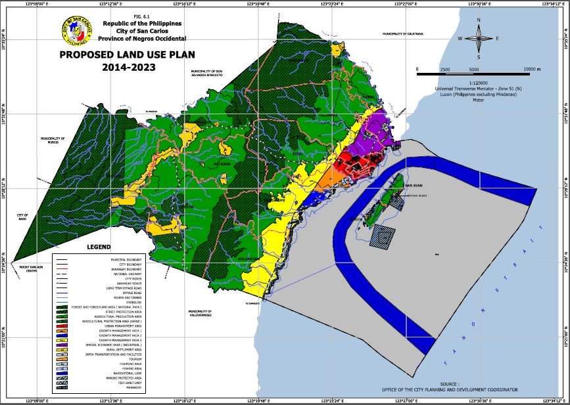

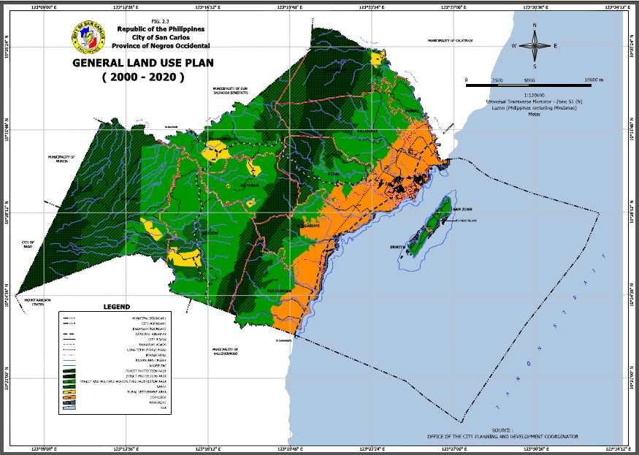

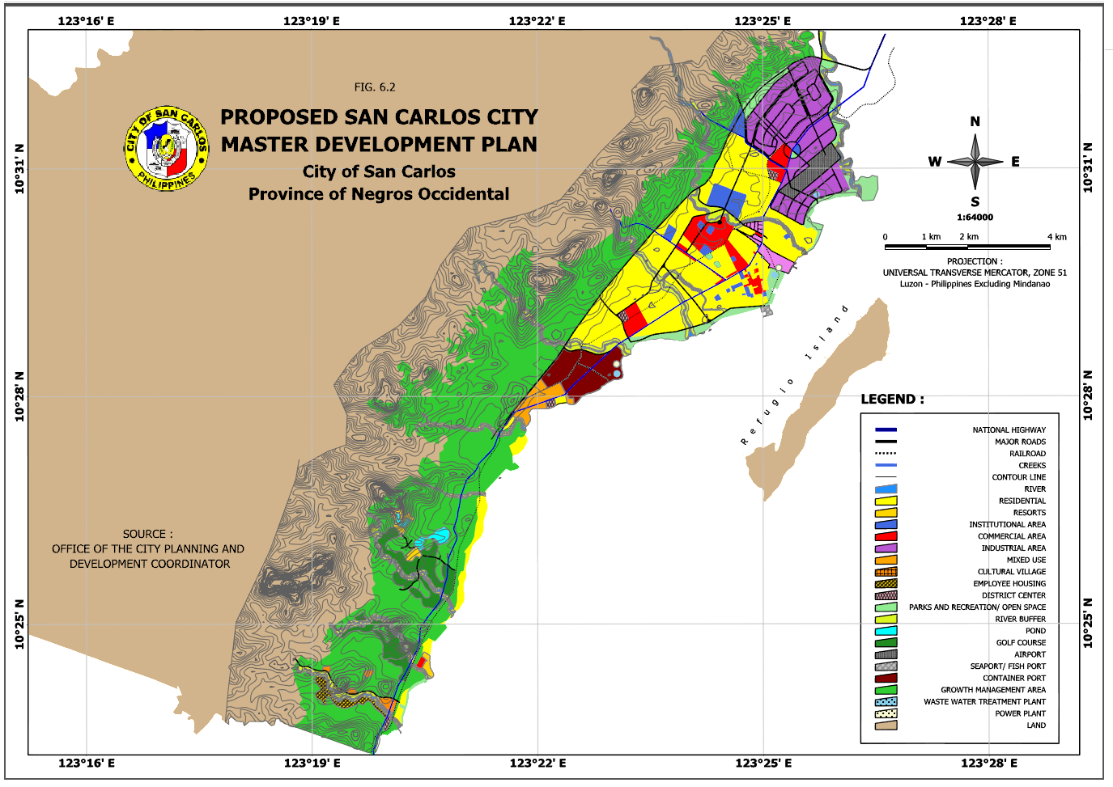

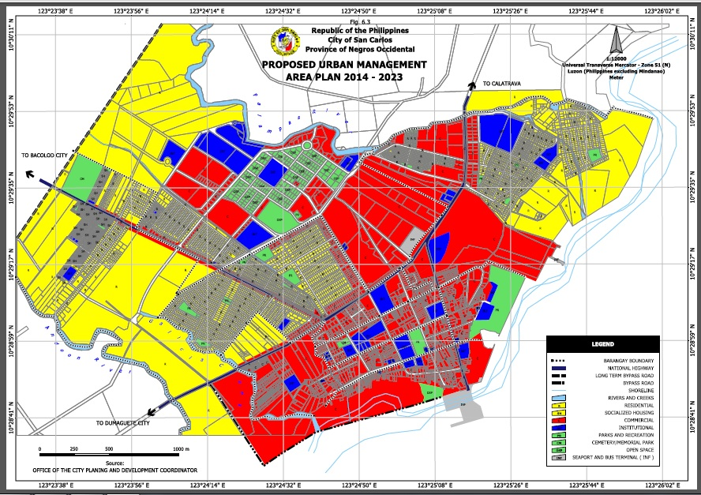

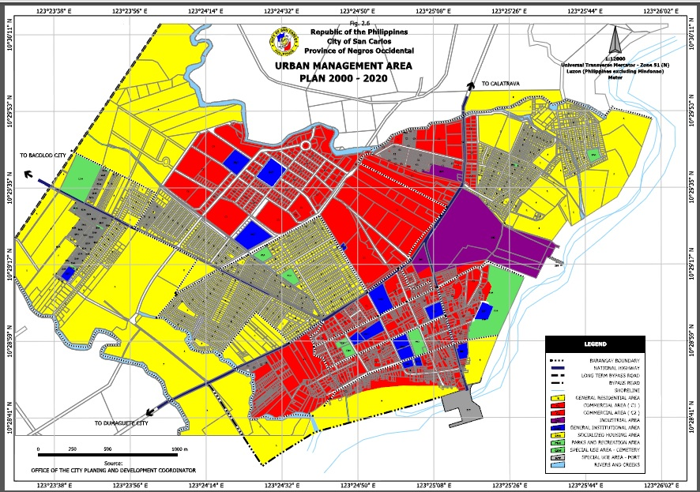

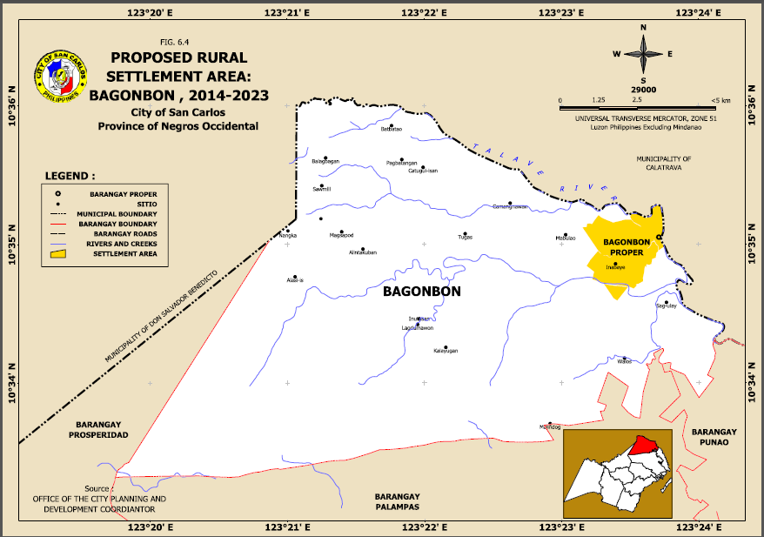

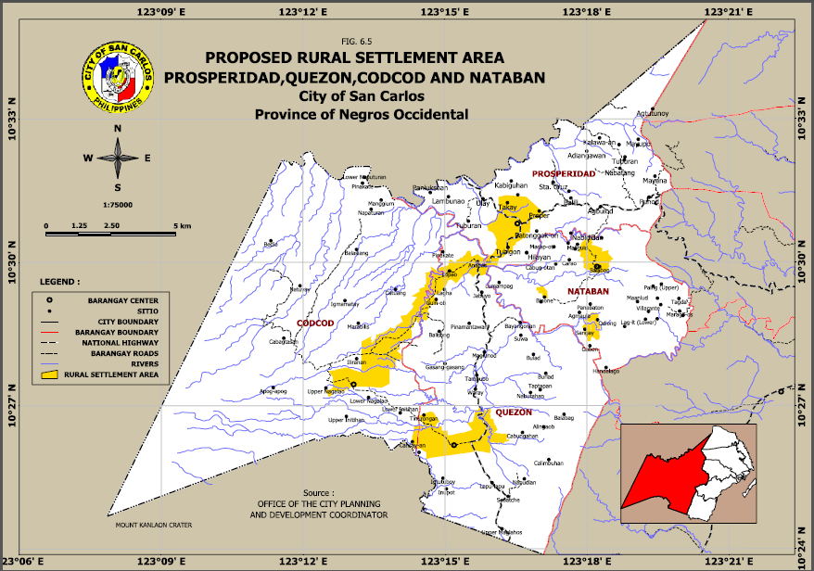

* + 1. ***COMPARATIVE LAND AREAS***

A comparison of areas per land use classification between CLUP 2014-2023 and CLUP 2000-2020 is provided in the table below:

|  |  |  |  |  |  |  |
| --- | --- | --- | --- | --- | --- | --- |
|  | **TABLE 6.2: COMPARATIVE AREAS, CLUP 2014 – 2023 & CLUP 2000 - 2020** | | | | | |
| **CLUP 2014 – 2023** | |  |  | **CLUP 2000 – 2020** |  | **CHANGE (%)** |
| **LAND USE CLASSIFICATION** | | **AREA (HA)** | **SHARE %** | **LAND USE CLASSIFICATION** | **AREA (HA)** |  |
| **I. FOREST AREA** | | **20,068.00** | **44.45%** | **COMBINES FOREST PROTECTION AREA & FOREST AND MULTIPLE AGRICULTURE PRODUCTION AREA** | **20,068.00** | **0%** |
| 1. Mt. Kanlaon National Park Strict Protection Area | | 2,165.00 |  | Mt Kanlaon. National Park (Protected Area) | 2,165.00 |  |
| 1. North Negros Forest Reserve Strict Protection Area | | 7,235.00 |  | North Negros Forest Reservation (Protected Area) | 7,235.00 |  |
| 1. MKNP Multiple Use Area | | 4,965.00 |  | MKNP (Forest and Multiple Agriculture Production Area) | 4,965.00 |  |
| 1. NNFR Multiple Use Area | | 5,703.00 |  | NNFR (Forest and Multiple Agriculture Production Area) | 5,703.00 |  |
| **II. AGRICULTURAL AREA** | | **17,298.50** | **38.31%** | **COMBINES AGRICULTURE PRODUCTION AREA & SAFDZ** | **18,433.50** | **-7%** |
| 1. Agricultural Production Area | | 14,763.34 |  | Agriculture Production Area | 15,898.34 |  |
| 1. Agricultural Protection Area | | 2,535.16 |  | (Formerly SAFDZ) | 2,535.16 |  |
| **III. RURAL SETTLEMENT AREA** | | **1,640.89** | **3.63%** | **RURAL SETTLEMENT AREA** | **505.89** | **224.36%** |
| 1. Barangay Codcod | | 616.75 |  | **a. Barangay Codcod** | 49.25 |  |
| 1. Barangay Quezon | | 437.71 |  | **b. Barangay Quezon** | 153.96 |  |
| 1. Barangay Nataban | | 94.12 |  | c. Barangay Nataban | 94.12 |  |
| 1. Barangay Prosperidad | | 460.58 |  | d. Barangay Prosperidad | 176.83 |  |
| 1. Barangay Bagonbon | | 31.73 |  | e. Barangay Bagonbon | 31.73 |  |
| **IV. SPECIAL DEVELOPMENT AREA** | | **5,703.99** | **32.63%** |  | **5,631.22** | **1%** |
| 1. Growth Management Area 1 | | 362.63 |  | a.Growth Management Area 1 | 362.63 |  |
| 1. Growth Management Area 2 | | 237.36 |  | b.Growth Management Area 2 | 237.36 |  |
| 1. Growth Management Area 3 | | 3,311.36 |  | c.Growth Management Area 3 | 3,315.37 |  |
| 1. Urban Management Area | | 778.86 |  | d.Urban Management Area | 687.36 |  |
| 1. Special Economic Zone | | 1,013.78 |  | e.Special Economic Zone | 1,028.5 |  |
| **V. UTILITIES, TRANSPORTATION &**  **SERVICE AREA** | | **18.73** | 0.04% | (New classification) |  |  |
| **SOCIALIZED HOUSING AREA** | |  |  | (Subsumed in UMA) | **91.50** |  |
| **VI. Refugio (Sipaway) Island** | | **419.89** | **0.93%** |  |  |  |
| **TOTAL LAND AREA** | | **45,150.00** | **100%** |  |  |  |
| VII.MUNICPAL WATERS | | 32,020.98 |  |  |  |  |
| 1. Mangrove | | 304.08 | 0.95% | (New classification) |  |  |
| 1. Marine Protected Area | | 193.14 | 0.60% | (New classification) |  |  |
| 1. Fish Sanctuary | | 69.74 | 0.22% | (New classification) |  |  |
| 1. Sealane | | 4,298.67 | 13.42% | (New classification) |  |  |
| 1. Municipal Fishing Area | | 27,155.35 | 84.80% | (New classification) |  |  |
| **TOTAL LAND AREA INCLUDING MUNICIPAL WATERS** | | **77,170.98** |  |  |  |  |

*Notes:*

1. *The City’s total land area is estimated at 45,150 has. This is composed of Items I, II, III, IV, V and sub-items a of item VI.*
2. *The City’s total municipal water area is estimated at xx has. This is composed of sub-items b, d, e, f and g of item VI.* 
   * 1. ***DEVELOPMENT CONTROL AREAS***

Developments in areas with identified environmental hazards shall be controlled. These include the following:

* Areas that are highly susceptible to landslides and with critical slopes
* Flood prone areas
* Areas affected by tidal flows/ surges
* Areas prone to liquefaction
  1. **POLICY DIRECTIONS**

This updated CLUP also continues the Policy Directions for each land use that were provided in the previous CLUP. Most of the provisions below were lifted from CLUP 2000 – 2020 with the exception of the newly identified Policy Areas within the Municipal Waters.

* + 1. ***NIPAS FOREST AREA***

The City of San Carlos adopts a Protection policy for its Forest Area, as briefly discussed below.

MKNP and NNFR Strict Protection Areas

# Area Characteristics

The area is covered by the Balabag Mountain Ranges and Mt. Kanlaon, and the Northern Negros Forest Reserve, with a combined area of about 9,400 hectares. These areas have been classified as protection areas under the NIPAS. Its coverage embraces steep terrains and highlands of Barangays Codcod, Prosperidad, Nataban, Rizal, Buluangan, and Bagonbon. The area is characterized by steep terrain of over 18%, and denuded hill slopes, rapid run-off and erosion. The area presents low development potential but high environmental conservation and landscape value.

# Policy Direction

Protection areas of the NIPAS Area are delineated to conserve environmentally sensitive areas, through soil, forest and watershed protection, together with the conservation and enhancement of visual amenity and areas of high landscape value. There will be a strong emphasis of forestry and reforestation projects together with optimizing eco-tourism opportunities. The interests of the indigenous communities in the Mount Kanlaon National Park will be maintained.

* FLUP

The Local Government Unit of San Carlos City and DENR, Negros Occidental formulated a Forest Land Use Plan (FLUP) for the City. The plan will form part to this CLUP document.

The City’s Forest Land Use Plan (FLUP) shall be made consistent with the provisions and intentions of this updated CLUP.

* Preferred Uses

Preferred uses should therefore normally be restricted to those associated with forestry, eco-tourism/countryside recreation and sustainable practices associated with indigenous communities.

MKNP and NNFR Mulitiple Use Areas

# Area Characteristics

These areas cover the slopes and hills between the NIPAS Protection Area and the predominantly agricultural areas, with slopes mainly ranging from 6 to 18%. A number of settlements are situated in the Multiple Use Area. The main source of living in the area has been logging, crop farming and some backyard livestock and poultry raising. The area is mainly devoid of forest cover. It is in part affected by NIPAS status (MKNP and NNFR).

# Policy Direction

The area shall act as a buffer to the NIPAS Protection Areas and for areas within the MKNP and NNFR, it is envisaged that a multiple use zone concept will be applied (as defined in the NIPAS rules and regulations). In this context the area presents potential for reforestation and agricultural development, including inter-cropping, and countryside recreation and tourism.

* FLUP

The Local Government Unit of San Carlos City and DENR, Negros Occidental formulated a Forest Land Use Plan (FLUP) for the City. The plan will form part to this CLUP document.

The City’s Forest Land Use Plan (FLUP) shall be made consistent with the provisions and intentions of this updated CLUP.

* Preferred Uses

Low intensity development in support of the forestry, agriculture and recreation/tourism are preferred. There will be tolerance of existing legitimate settlements/communities and planned expansion implied by the needs natural resource development.

* + 1. ***AGRICULTURAL AREA (AA)***

There are two policy areas within the AA, namely, Agricultural Protection Area and Agricultural Production Area. These policy areas define the sub-classifications of the AA, as briefly discussed below:

Agricultural Protection Areas (APtA)

These are the prime agricultural lands (irrigated and irrigable) that were delineated in CLUP 2000 – 2020 as the City’s SAFDZ.

# Area Characteristics

Agricultural Protection Areas areas have been identified in Brgys. Cocod, Quezon, Prosperidad and Bagonbon for agricultural conservation and development. These are primarily areas of good agricultural potential declared in accordance with the requirements of the NIPAS Act (1992), AFMA (1997) and MC No. 54 (1993) Prescribing the Guidelines governing Section 20 of RA 7160 (Local Government Code of 1991) authorizing cities and municipalities to reclassify agricultural lands into non-agricultural uses. These areas are non-negotiable for conversion and may not be re-classified into other uses.

# Policy Direction

Following AFMA provisions, these areas shall “serve as centers where developments in the agriculture and fisheries sectors are catalyzed in an environmentally and socio-culturally sound manner”. Priority will be given to agricultural investment in these areas and to their protection from non-agricultural development.

* Preferred Uses

Identified Agricultural Protection Areas shall be devoted principally to agricultural development.

Agricultural Production Areas (APdA)

The delineation of APdA is similar to that in CLUP 2000-2020 except for some areas in Brgy. Prosperidad, Quezon and Codcod that are re-classified into Rural Settlement Areas in this updated CLUP 2014-2023.

# Area Characteristics

The area consists of two main sub-components; the upland plateau and hill slopes, and the coastal lowland area. The upland plateau is characterized by smallholdings growing staple crops and a variety of vegetables and fruit. There are also substantial areas of non-productive land. The coastal lowland is mainly sugar cane plantation.

# Policy Direction

The Trankslink Highway and farm-to-market roads encourage sustainable agricultural development in both areas. Retention of its present use is encouraged with the intention of supporting policies on agricultural intensification and diversification as part of a program of rural development and improvement. Agro-processing will be encouraged in the APdA areas, together with a full range of agricultural research, training and support services.

* Preferred Uses

The preferred uses will be agriculture and agriculture related activities, and other uses, which will benefit the rural economy.

* + 1. ***RURAL SETTLEMENT AREA (RSA)***

Except for expansions in Brgys. Prosperidad, Quezon and Codcod, the RSAs’ delineation remains largely similar to that in CLUP 2000-2020.

# Area Characteristics

The proposed growth of the rural area will be concentrated around the existing village settlements and in particular priority Rural Growth Centres in Brgys. Prosperidad, Quezon/Codcod and Bagonbon.

# Policy Direction

The City had already invested in the rural settlements and the designation of the four priority Rural Growth Centers will facilitate cost-effective investment in comprehensively planned development and infrastructure. These settlements will be the economic and social hubs for the agricultural and forestry development programs and as such will also be the focus for population growth. To meet the implied demand for land, each of the four Rural Growth Centers will include a RSA, where properly serviced development can take place.

Preferred Uses

The preferred uses in RSA shall be low to medium density residential, socialized housing, commercial, institutional, recreational uses, agricultural processing, research and support, and light industry.

* + 1. ***SPECIAL DEVELOPMENT AREA (SDA)***

# Area Characteristics

The delineated SDA is similar to that provided in CLUP 2000-2020. The SDA covers the whole of the coastal plain, referred to as the San Carlos Development Corridor. The SDA accommodates the entire low-lying area from the coast until the edge of the hills where the topography changes drastically. The existing Poblacion and other major and proposed projects, particularly the Special Economic Zone (SEZ), are located in this area. The area includes all the urban Brgys 1-6 and parts of Brgys Buluangan, Guadalupe, Rizal, Palampas, and Punao.

The area contains a wide range of land uses and includes the Poblacion and several other coastal settlements. Outside the urban area, most of the land is devoted to sugar cane plantation farming and there are a few large landholdings favoring the planned development of the area. Bordering the coastline are a number of fishponds, many of which are not used. There is also a substantial area of mature mangrove, north of the Poblacion.

# Policy Direction

The SDA is divided into six secondary policy areas, where it is possible to indicate in broad terms the nature and extent of the proposed urban land uses. The secondary areas are 1) Growth Management Area 1, 2) Growth Management Area 2, 3) Growth Management Area 3, 4) Urban Management Area 3, 5) Special Economic Area, and 6) Utilities, Transportation and Service Area.

* Growth Management Area 1 (GMA-1)

The area is located immediately south of the Poblacion. The policy intent for GMA-1 is that it should be developed as a residential community with a full range of supporting commercial and community support facilities. In particular the area will contain a District Center, where the support facilities will be located. Industrial uses will not be favored in this area.

It is anticipated that the development of this area will be medium/long-term, so the continued investment in agriculture as an interim use is favored.

* Growth Management Area 2 (GMA-2)

The planned intention for this area to the immediate south of the Andoon River is to develop a deep-water port and port related facilities, together with industrial development, which can take advantage of a waterfront/port location.

The development of this area is viewed as a medium/long-term venture, responding to progress in industrial development and agriculture/agro-processing. Interim agricultural uses are therefore favored.

* Growth Management Area 3 (GMA-3)

GMA 3 lies south and west of the Poblacion and covers land areas between the coastline and the 100m contours. It also includes the Hacienda Estate at its southern end.

Much of the area is of high landscape value, with fine hill-slopes and mountain areas, together with an attractive coastline. It is therefore proposed to use the area for a combination of recreation/tourism development, high-end residential development and plantation agriculture. The recreation and tourism development will be concentrated in the Hacienda Estate area. The expansion of the existing rural settlements, particularly Buluangan will also be incorporated in the detailed planning for this area.

* Urban Management Area (UMA)

The area consists mainly of the Poblacion, the Central Business District (CBD) and planned new residential areas. It also includes the sugar mill site. The general policy intent is to expand the Poblacion and to upgrade the existing urban fabric.

New development will be concentrated in the CBD and in planned new residential areas to the south and west of the existing built-up area. The CBD is intended to accommodate a variety of commercial, community and residential uses at medium to high densities. An area to the north of the CBD is intended for secondary commercial and business uses (e.g. lumber showrooms, repair workshops and yards, building supply and lumberyards).

Three urban renewal areas are proposed to re-invigorate the Poblacion. Two will be focused on the upgrading of existing residential areas, the other on the improvement of the old Poblacion commercial and market center. It is assumed the sugar mill will remain in-situ, but in anticipation of other development on the site it is proposed that any further industrial development should be restricted to a light industrial category.

The UMA is further sub-classified into:

* General Residential Area
* Socialized Housing Area
* Commercial 1 Area
* Commercial 2 Area
* General Institutional Area
* Parks and Recreation Area
* Industrial 1 Area
* Utilities, Transportation and Service Area
* Cemetery

Other land use designations are made for institutional uses (e.g. City Hall), parks and recreation, commercial and cemeteries.

This general intent is shown on the UMA Plan, which incorporates a series of sub-policy areas, with specific land use intent and which set the context for the detailed definition of allowed uses in sub-zones listed in the Zoning Ordinance.

* Special Economic Zone (SEZ)

The SEZA is located immediately north of the Poblacion and is intended as a comprehensively planned industrial area, with a full range of supporting commercial, community and residential uses. Some 445hectareshave PEZA status and the total industrial land provision will be around 311 hectares.

Residential development will be planned in conjunction with the growth of the industrial area. Commercial development and community facilities will be concentrated in a planned District Center. The area will also include land set aside for a potential Government/Provincial Government Complex. The boundaries of the industrial land will be specified through substantial landscape buffer areas.

This is already the site of the Bio-ethanol and Bio-mass power plants.

The proposed airport will be located in the SEZA and will be developed in compliance with the standards and practices of the ICAO and the requirements of the Philippine Air Transportation Office.

* + 1. ***UTILITIES, TRANSPORTATION AND SERVICE AREA (UTSA)***

These are sites intended for major public utilities, transportation and services. These include the sites of the Bio-ethanol and Bio-mass power plants, Eco-Center, proposed San Carlos City Community Airport, San Carlos City Port, Buluangan Fishport, barangay fishports in Ermita and San Juan and San Carlos Transport Terminal.

* + 1. ***MUNICIPAL WATERS AREA (MWA)***

This is a new area designation in line with the ridge-to-reef approach per HLURB’s new planning guidelines.

# Area Characteristics

In all areas, the coastal resources are under threat from development and poor fisheries practices. The reef surrounding Refugio (Sipaway) Island is severely damaged. The CMA is sub-classified into the following areas:

* Mangrove
* Marine Protected Area
* Fish Sanctuary
* Sealane
* Municipal Fishing Area

# Policy Direction

The primary intention or the area is conservation and enhancement of the natural resources. Economic activity will therefore be driven towards sustainable fisheries development.

Preferred Uses

Preferred uses will be community based and include fisheries related livelihood and recreation and tourism. Uses, which enhance the environment and benefit the community, will be favored.

**6.4.7 *REFUGIO (SIPAWAY) ISLAND***

Area Characteristics

Being a small island, this is an environmentally-sensitive area that is susceptible to coastal erosion and flooding. The island hosts two barangays and the immediate concern is how to ensure sustainable development practices borne by residential expansion and influx of tourism activities.

Policy Direction

The primary intention for the area is also to conserve and enhance its natural resources as well as ensure the protection of settlements thereat. Developments within the island shall closely be related to those in the MWA.

Preferred Uses

Preferred uses will be community based and include fisheries related livelihood and recreation and tourism. Uses, which enhance the environment and benefit the community, will be favored.

* 1. **TRANSPORT PLAN**
     1. ***GENERAL***

Several relevant key Transport Plan proposals are carried over from the previous CLUP. These are still deemed important in realizing the overall goals and objectives of this updated CLUP. These are included in the City’s Comprehensive Development Plan (CDP).

* + 1. ***AIR TRANSPORT***

The proposed San Carlos Community Airport (located in the SEZ) will cater for both domestic passenger and freight traffic. It is included as a priority item in the CDP.

* + 1. ***PORT DEVELOPMENT AND SHIPPING***

Port Improvement

Improvement of the existing facilities at the San Carlos City Port, to include the provision of proper loading/unloading facilities and equipment for freight and passenger traffic, should be provided.

Deepwater Port

A second (and longer-term) deep water cargo port is proposed in San Antonio in response to planned economic growth in the City and the surrounding municipalities. Development of this facility will permit the existing port to be mainly for passenger use.

* + 1. ***ROAD DEVELOPMENT***

Completion of Port Access Road

The completion of this road is a priority to serve the port expansion area. This should be a “limited access” road in the interests of highway safety and reduced traffic congestion.

Poblacion Interim By-Pass Road

The project will provide an alternative route for access into the City and for through traffic. It will have the effect of diverting traffic from the potentially congested national highway in the existing and proposed urban area. This should be a “limited access” road in the interests of highway safety and reduced traffic congestion. A road line (right of way) will be maintained in advance of construction.

San Carlos Long-term By-Pass Road

This long-term project will provide a dedicated new road outside the urban area and will cater for both north-south through traffic and will intercept traffic from the Trans-link Highway. Access from this road into the City will be from a limited number of key junctions. The project is expected to be long-term as a response to City growth and a general increase road traffic usage. A preliminary road line (right of way) should be delineated to ensure long-term project feasibility.

National Highway Expansion

The City proposes to continue the development of the rural road system through the upgrading of the Prosperidad-Quezon, Quezon-Codcod and Punao-Bagonbon linkages to national highway status.

Rural Access Roads

Rural access roads will continue to be upgraded under the City’s ongoing program, with priority being given to linkages to the Rural Growth Centers and agricultural development areas. The program will include both new roads and the upgrading of existing farm to market routes.

Traffic Management

A traffic management program will be introduced in the UMA to meet the increased usage of the existing road network that is anticipated in response to City growth and a general increase in road usage.

* + 1. ***ROAD TRANSPORT FACILITIES***

Community Transport Program

As programmed in the predecessor CLUP and in conjunction with the rural access road improvement program, the development of the Rural Growth Centres and investment in agriculture and forestry the City will promote the introduction of regular community/public transport services. It is intended that the major rural settlements will eventually be connected to the national highway network and the main urban area by regular passenger services, through either private sector, or community led investment.

* + 1. ***RAIL TRANSPORT***

Plans for Rail Transport follows those programmed in CLUP 2000-2020. The existing sugar cane railway will be retained and opportunities sought to increase its usage for the carriage of sugar cane and other agricultural produce. The City will encourage the sugar mill operators to adopt a policy of preference for rail borne access, including potential financial benefits such as preferential market rates offered to users of the railway.

In the longer term the feasibility of its use as a passenger link between the proposed recreation and tourist facilities on the Hacienda Estate and the main urban area will be explored.

Non-railway development will not be permitted on any sugar cane rail alignment.