Chapter seven:

local institutional capability

# Local Institutional Capability

This profile of the institutional development sector is divided into four parts. The first part discusses the local planning structure – the LGU’s organizational structure, the local development council (LDC), and the Office of the City Planning and Development Coordinator. The second part discusses the local fiscal management: the status of financial health, the city’s source of revenue, extent of fiscal autonomy, and actual expenditures by general account. The third part lists the resolutions passed and ordinances enacted that are related to development. The fourth part is about the LGU-CSO-Private Sector Linkages.

## Local Planning Structure

Republic Act 7160 of 1991, otherwise known as the Local Government Code (LGC), has given autonomy to Local Government Units (LGUs) regarding the development of their territorial jurisdiction. Section 20(c) of the Code states “The local government units shall, in conformity with existing laws, continue to prepare their respective comprehensive land use plans enacted through zoning ordinances which shall be the primary and dominant bases for the future use of land resources: Provided, That the requirements for food production, human settlements, and industrial expansion shall be taken into consideration in the preparation of such plans.”

### The LGU’s Organizational Structure

This section describes the organization and human resources of the City Government of San Carlos. The structure and staffing of the different offices of the city government give hint into the capability of the City for managing its development activities.

The Local Development Council

In accordance with Section 106-108 of the Local Government Code of 1991, the City Development Council (CDC) was created in the City of San Carlos that assists the Sanggunian in setting the direction of economic and social development and coordinating development efforts within its territorial jurisdiction. Further, the said council was reorganized by virtue of Executive Order 98, series of 2010 that took effect on August 28, 2012. The new composition of the CDC of San Carlos City includes:

|  |  |  |
| --- | --- | --- |
| * Membership Composition | | |
| Chairman |  | City Mayor |
| Members |  | All Punong Barangays |
|  |  | SP Member on Finance, Budget and Appropriations |
|  |  | Representative of the First District of Negros Occidental |
|  |  | Representatives of duly accredited Non-Governmental Organizations (NGOs) |
| Secretary |  | City Planning and Development Coordinator |
|  |  |  |
| * Committees of the CDC | | |
| * + 1. Committee on Environment | | |
| * + 1. Committee on Institutional and Good Governance | | |
| * + 1. Committee on Social Development | | |
| * + 1. Committee on Economic Development | | |
| * + 1. Committee on Infrastructure | | |
|  | | |
| * Composition of the Committees | | |
| 1. Committee on Environment | | |
| Chairman |  | Punong Barangay |
| Members |  | Composed of two (2) Punong Barangays and Non-Government Organization |
| 1. Committee on Institutional and Good Governance | | |
| Chairman |  | Punong Barangay |
| Members |  | Composed of three (3) Punong Barangays and Non-Government Organization |
| 1. Committee on Social Development | | |
| Chairman |  | Punong Barangay |
| Members |  | Composed of two (2) Punong Barangays and Non-Government Organization |
| 1. Committee on Economic Development | | |
| Chairman |  | Punong Barangay |
| Members |  | Composed of three (3) Punong Barangays and People’s Organization |
| 1. Committee on Infrastructure | | |
| Chairman |  | Punong Barangay |
| Members |  | Composed of two (2) Punong Barangays and Non-Government Organization |

Based on the LDC composition, the Executive Committee is headed by the City Mayor as the Chairman with the head of Barangays, SP Member on Financial, Budget and Appropriations and Non-Government organizations’ (NGO) or people’s organizations’ (PO) representatives as members. This mandatory representation, however, requires an accreditation process. The rest of the committees formed are considered part of the functional committees tasked to assist the Executive Committee in their functions particularly in the formulation of long-term plans and annual investment plans for the City, appraisal of projects and coordination and evaluation of development project implementation.

The Council has a secretariat headed by the City Planning and Development Office which is responsible for the documentation of meetings, report preparation and other assistance as maybe required.

The City Planning and Development Office

Per the Local Government Code of 1991, the City Planning and Development Office (CPDO) is mandated to:

* Formulate integrated economic, social, physical and other development plans and policies for consideration of the local development council;
* Conduct continuing studies, research and training programs necessary to evolve plans and programs for implementation;
* Integrate and coordinate all plans and studies undertaken by the local government unit's various functional groups or agencies; and
* Monitor and evaluate the implementation of the different development programs, projects and activities in the local government unit concerned in accordance with the approved development plan

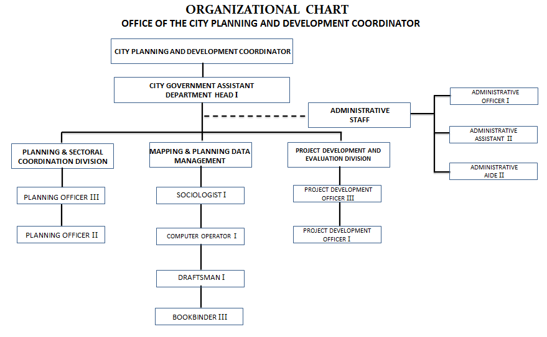The organizational structure of the CPDO is presented in the figure below:

**FIGURE 7.1 ORGANIZATIONAL STRUCTURE OF CPDO**

* 1. **LOCAL FISCAL MANAGEMENT**

### status of financial health

The City has been operating on a positive fiscal balance for the past three years. The following table shows the breakdown of revenues vis-à-vis expenditures of the City from year 2008 to 2011.

|  |  |  |  |  |
| --- | --- | --- | --- | --- |
| **TABLE 7.1 SAN CARLOS CITY NET FISCAL BALANCE (2008-2011)** | | | | |
| **Description** | **2011** | **2010** | **2009** | **2008** |
| Revenues | 635,085,082.22 | 583,434,544.02 | 534,657,736.07 | 429,284,878.03 |
| Expenditures | 452,292,159.33 | 421,441,004.38 | 376,596,096.53 | 315,892,873.57 |
| Net Balance | 182,792,922.89 | 161,993,539.64 | 158,061,639.54 | 113,392,004.46 |

Furthermore, the City did not have contractual obligations for debt servicing for the past three years.

* + 1. *REVENUES BY SOURCE*

The City has three major sources of revenues, namely, internally generated funds, internal revenue allotment and other subsidies. **Figure 7.2** shows the breakdown of revenues by major sources.

The internally generated funds of the City consist of income from local taxes, permits and licenses, services, business arrangements and other incidental income such as interest income. The internal revenue allotment (IRA) refers to the revenue received from the national government. Other subsidies include funds received from other local government units.

These revenue sources are being utilized optimally and within the limits prescribed by law.

**FIGURE 7.2 REVENUE BY SOURCE**

Over the past three years, there has been a consistent upward trend of internally generated funds of 40% in 2009, 5% in 2010 and 14% from 2011. **Figure 7.3** shows the graphical representation of the upward trend pattern of the City’s internally generated funds over the period of 2008 – 2011.

**FIGURE 7.3 TRENDING PATTERN OF THE CITY’S INTERNALLY GENERATED FUNDS**

Of the three major sources of revenues, internally generated funds provides between 18-22%. The internal revenue allotment, which comprises the biggest revenue stream of the City, contributes between 65%-77%. Other subsidies give below 1% of the City’s inflow.

Based on the revenue source mix by the City, as can be gleaned from the table below, it can be observed that the City’s self-reliance on its own internally generated funds is not very high considering that it can support up to the extent of one-fourth of the total annual expenditures.

|  |  |  |  |  |
| --- | --- | --- | --- | --- |
| **TABLE 7.2 SAN CARLOS CITY REVENUE SOURCE-MIX** | | | | |
| **Revenues by Source** | **2011** | **2010** | **2009** | **2008** |
| Internally Generated Funds | 22.59% | 19.87% | 18.88% | 13.46% |
| Internal Revenue Allotment | 77.31% | 71.88% | 65.15% | 54.13% |
| Other Subsidies | 0.10% | 0.11% | 0.15% | 0.01% |

* + 1. *EXTENT OF FISCAL AUTONOMY*

The City had obtained increasing Internal Revenue Allotment allocations from 2008-2011. The IRA represents 65%-77% of the City’s revenues. Table 3 shows the breakdown of the City’s IRA from 2008-2011.

**Figure 7.4**

**San Carlos City’s Internal Revenue Allotment, 2008-2011**

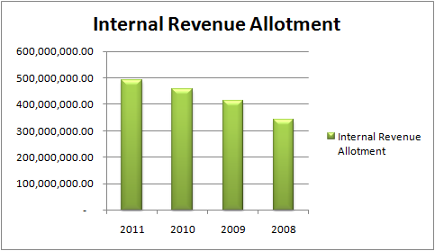

* + 1. *ACTUAL EXPENDITURES BY GENERAL ACCOUNT*

The City’s expenditures comprise two major accounts, namely, personnel services and maintenance and other operating expenses. The table below shows the breakdown of actual expenditures from 2008-2011.

|  |  |  |  |  |
| --- | --- | --- | --- | --- |
| **TABLE 7.3**  **ACTUAL EXPENDITURES BY GENERAL ACCOUNT, 2008-2011** | | | | |
| **Public Expenditures** | **2011** | **2010** | **2009** | **2008** |
| Personal Services | 216,342,915.73 | 192,326,894.28 | 170,902,945.28 | 147,174,118.11 |
| Maintenance & Other Operating Expenses | 235,949,243.60 | 229,114,110.10 | 205,693,151.25 | 168,718,755.46 |
| **Total** | **452,292,159.33** | **421,441,004.38** | **376,596,096.53** | **315,892,873.57** |

* 1. **DEVELOPMENT LEGISLATION**

* + 1. *INVENTORY OF RESOLUTIONS PASSED/ ORDINANCES ENACTED, BY SECTOR, BY YEAR*

There were 375 resolutions passed and 28 ordinances enacted for the Year 2010 while 464 resolutions and 12 ordinances were acted for the Year 2011.

Most of these resolutions pertain to the program of works and detailed estimates of various programs and projects of the City, the authority granted to the City Mayor for contracts/agreements of which the City is involved with, approval of budgets, concurrence with the CDC resolutions, financial assistance, etc. Ordinances were enacted particularly on creation or reorganization of organizational structure and staffing pattern of the City Government, budget appropriations of the City and the barangays, amendments/realignments of existing ordinances, etc.

* 1. **LGU-CSO-PRIVATE SECTOR LINKAGES**

The following are the linkages of the San Carlos City Government with different partner agencies and with corresponding SP Resolutions:

1. Resolution No. 11-160 – MOA With The Department of Labor and Employment (DOLE) for the Implementation of Capacity Building Services for Livelihood in Pursuant to Administrative Order No. 262, Series of 2008;
2. Resolution No. 11-282 – MOA By and Among the Julio And Florentina Ledesma Foundation, Inc. (JFLFI); Ramon Aboitiz Foundation, Inc. (RAFI); and the City Government of San Carlos to Facilitate the Application of the San Carlos Enviro-Blox in the Country particularly in the Visayas Region;
3. Resolution No. 11-246 – MOA with the Provincial Government of Negros Occidental Relative to the Financial Assistance Granted to Brgy. 1 Womens Association and Rizalian Women’s Association For Alternative Livelihood Project;
4. Resolution No. 11-37 – MOA with the Department of Labor and Employment (DOLE) pursuant to the Establishment and Promotion of a Skills Registry System (SRS) In the City off San Carlos;
5. Resolution No. 11-259 – MOA with the Department Of Science And Technology – Region VI and the Carlos Hilado Memorial State College (CHMSC) for DOST’s Grant of Basic Food Processing Tools and Equipment to the City Government of San Carlos for its Micro-Enterprise Development Program;
6. Resolution No. 11-105 – MOA with the Provincial Government of Negros Occidental for granting Financial Assistance of P55,000.00 to Prosperidad 4-H Club for its Cutflower Production Project;
7. Resolution No. 11-211 – MOA with the DSWD Field Office VI for the Implementation of Cash-For-Training/ Work (CFT/W) Program for the Small-Scale Farmers and Fisherfolks in the City Of San Carlos who were affected during the Lean Season;
8. Resolution No. 11-407 – MOA with the Department of Agriculture, Region VI for the Farm Tractor Assistance through its Agri-Pinoy Corn Program;
9. Resolution No. 11-356 – MOA with Barangay Rizal Multi-Purpose Cooperative (BARIZMULPCO) for a Loan Agreement of P250,000.00 Payable in Thirty-Six (36) Equal Installments at Six (6%) Percent Per Annum on the Diminishing Balance, Chargeable Against Capital Outlay; CLSO (Various Loans Outlay) CY 2011 and Authorizing the City Mayor to Sign the Memorandum of Loan Agreement Relative Thereto.